Ways to Support your Well-Being
If you have any worries or concerns about your mental well-being please do share it with the Inclusion team who will do all they can to support you.
Places to go for support
Lambeth has a page dedicated to mental health advice and support
https://www.lambeth.gov.uk/adult-social-care-and-health/health-and-wellbeing/mental-wellbeing
As a Lambeth resident you also have access to Qwell. You can access their support from the website …. Qwell.io
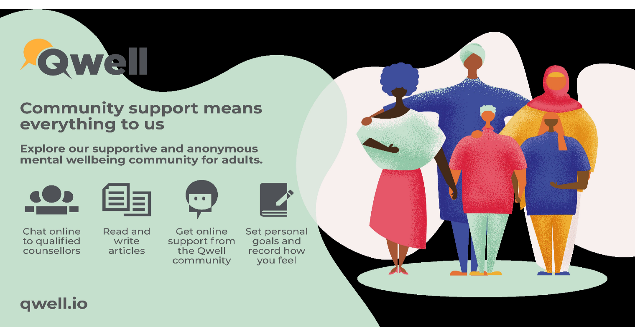
The NHS website has some really useful support and advice
https://www.nhs.uk/oneyou/every-mind-matters/
Also, your GP will be able to offer support and advice
Download a free well-being app (approved by the NHS)
MyPossibleSelf
Use the simple learning modules to manage fear, anxiety and stress and tackle unhelpful thinking
Catchit
The app will teach you how to look at problems in a different way, turn negative thoughts into positive ones and improve your mental wellbeing
FeelingGood
This app is designed to make you feel better about yourself using cognitive behavioural therapy
There is also lots of good apps or playlists for meditation and mindfulness for example Headspace or guided meditations on apps such as YouTube or Spotify. Try some out and find what really suits you.
Five strategies to support your mental well-being
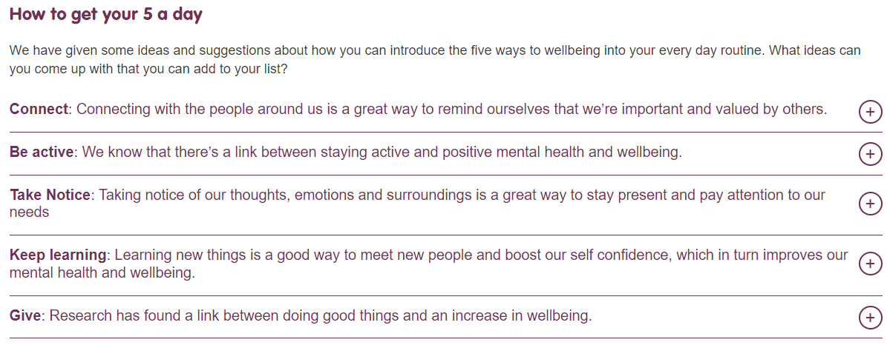
Some charities such as Contact a Family or The National Autistic Society can offer support and run parent support groups.

Supporting your Child’s Well-Being
If you have any worries or concerns about your mental well-being please do share it with the Inclusion team who will do all they can to support you.
Mindfulness
These are just suggestions please do try them first and see if you think they are appropriate
The BBC has a good Mindfulness page
https://www.bbcchildreninneed.co.uk/schools/primary-school/mindfulness-hub/
Youtube
The Mindfulness Teacher has some good videos for short Mindfulness practices. But others are available.
https://www.youtube.com/@TheMindfulnessTeacher
Zones of Regulation
We use this resource in school. If you would like a set of the resources please ask Alberta Wilson, Inclusion Coordinator.
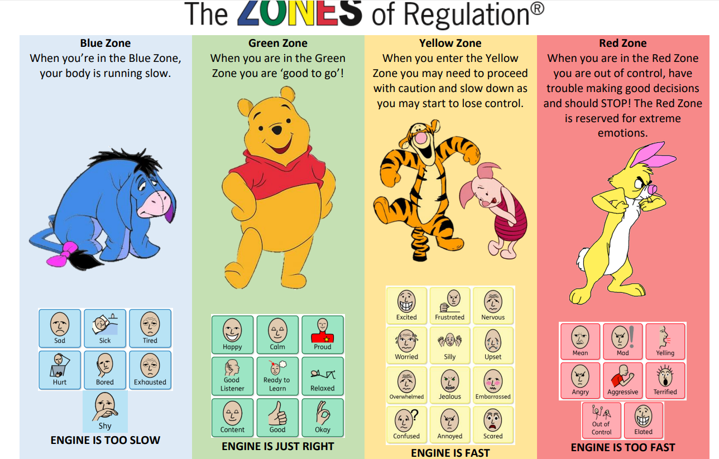
There are no good or bad zones. It helps them to identify how they are feeling and then choose an appropriate strategy for example if they are sleepy in the Blue zone they could choose to bounce.
Happiness boxes
This can really help with regulation. They decorate a bag or box to give them a sense of ownership. They then choose items to fill it with that they like. A favourite smell, a favourite toy, photographs of special people, a favourite book, hand cream so they can be given a hand massage, a blanket that they like to snuggle with, anything that makes them feel happy and loved.
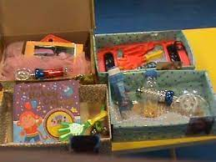
For older siblings they can access Kooth at Kooth.com
