
19th June 2026
Livity Life
The Livity School Weekly Newsletter
School News
Please remember to call the school office at 8.15am if your child is going to be absent.
Please see the back of the newsletter for important dates

Red Class
The Red Class pupils have loved making and decorating pig biscuits; enthusiastically rolling out dough, mixing and squeezing icing and adding their own creative touches. These activities support the development of fine motor skills, hand strength and coordination. It has been wonderful to see pupils’ confidence grow as they take pride in their achievements.
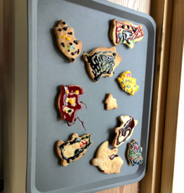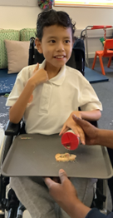

Yellow Class
We’ve had a lovely week here in Yellow Class. On Monday we had the first of a series of trips to Brockwell Community Greenhouses. We had the chance to water some vegetables and even tried planting some of our own vegetables. In cooking this week, we made our own frozen fruit yoghurt. The pupils chopped up their own choice of fruit and spread it out on a layer of yoghurt which we then froze. We then ate it for our afternoon snack. Delicious!
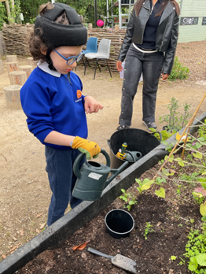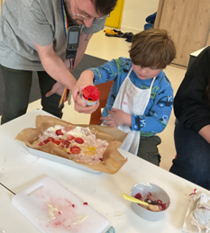

Dragonfly Class
This week, Dragonfly Class learnt about the Northern Lights through a sensory journey. The children expressed their preferences for the strokes and props during the sensory massage. We also recreated ocean textures in the tuff tray with edible materials and added animals for play.
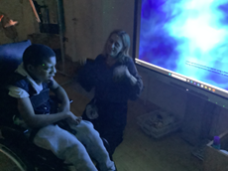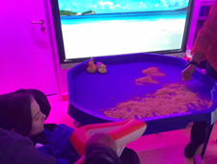

Pink Class
This week in Pink Class, we have been exploring new and interesting textures during our mark making lessons. Some of our favourites included soaked chia seeds and ketchup. The children have been busy practising for our Sports Day, learning the different games and races.
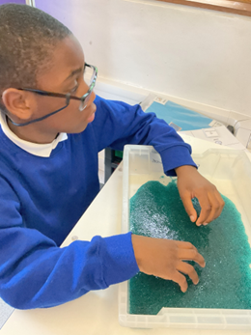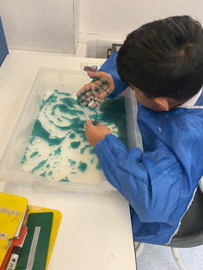

Blue Class
This week in Blue Class, we went to magic breakfast. It was the perfect opportunity for the children to practise and develop their communication skills. During magic breakfast, we used symbol supported choice boards to help the children indicate what they would like to eat and whether they would like more. Some children used their communication devices, whilst others used their communication books to make choices and express their preferences. The children engaged well with the activity, communicating independently throughout the session whilst exploring and tasting a variety of different foods.
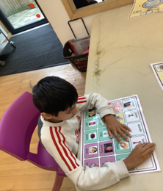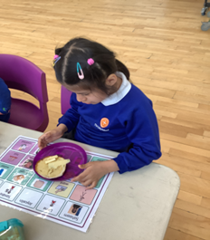

Orange Class
Orange Class have worked hard this week on their independence skills. They have been practising washing up and have been taking turns to wash the plates after snack time. Orange Class have also continued to practise their mark making skills using special pens that activate bright colours when they write on the special mat.
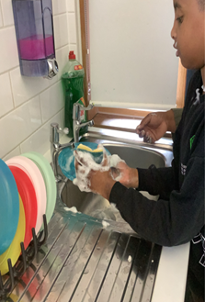
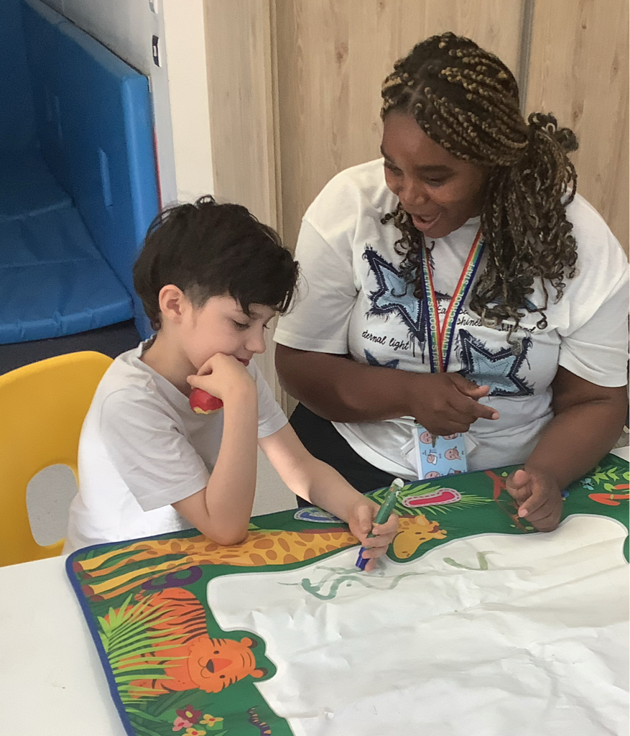

Bumblebee Class
This week Bumblebee Class have been exploring some of the characters from the story 'Snail and the Whale'. The pupils have been comparing pictures of real-life animals to their story counterparts and been practising labelling the pictures. The pupils also took part in various ocean activities such as exploring different materials that float when placed in water. In cooking the pupils created chocolate ocean cupcakes, using blue buttercream to create ocean waves and decorating with jelly sharks. Bumblebee Class also made paper plate whales this week in art.
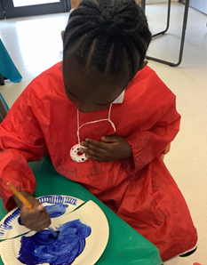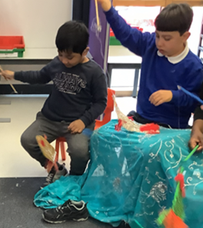

Gold Class
This week, the pupils in Gold Class used their preferred communication system to write the name of the sea creatures from our story, ‘Commotion in the Ocean’. The pupils identified different animals and were then able to sequence the sounds and apply their phonics knowledge to write the names of the animals. The pupils have also worked on additions and subtractions and matching numbers to their value. The pupils are working on 1 more and 1 less of a given number.
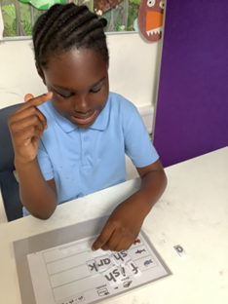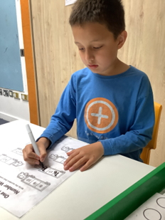

Green Class
This week, Green Class have been busy creating special cards to celebrate Father’s Day. We also had lots of fun making our own bubble foam. The children thoroughly enjoyed exploring the foam with their hands, discovering its unique texture and scent. There were plenty of smiles and laughter as pupils squeezed, splashed and investigated the foam.
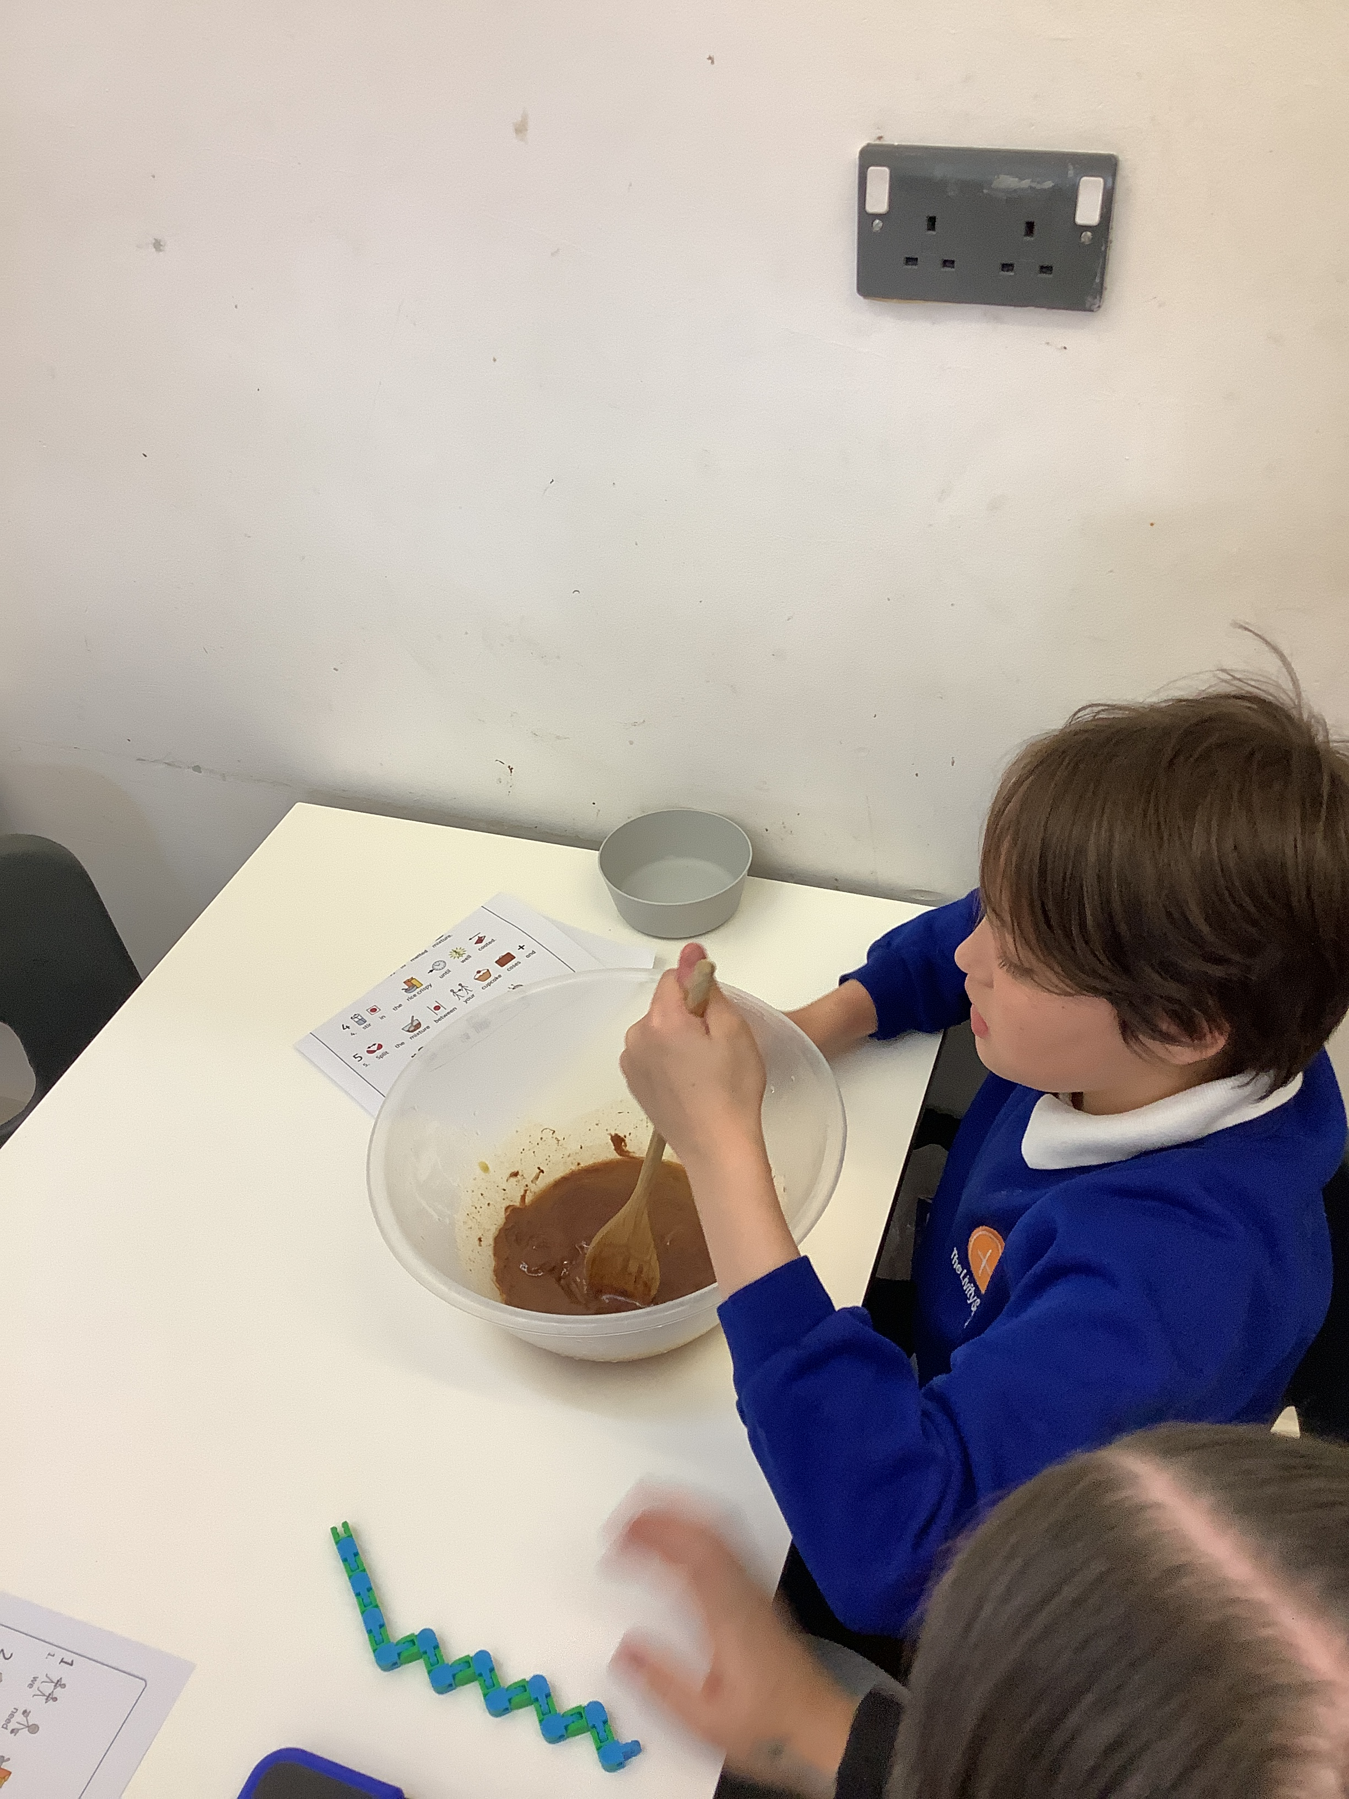
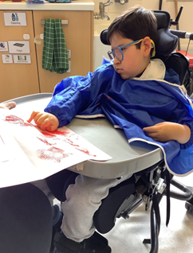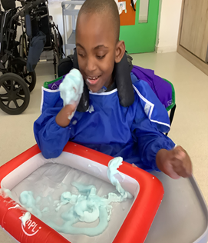

Rainbow Class
On Wednesday Rainbow and Unicorn classes visited the Nature Garden again. This time we explored different ways of balancing and moving safely across balance beams. We also took part in some imaginative play with the sandpit and used the pedal bikes to race each other.
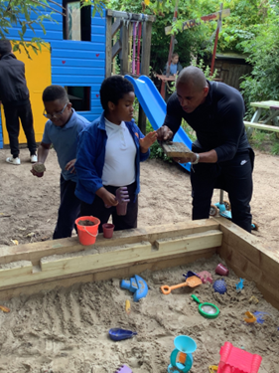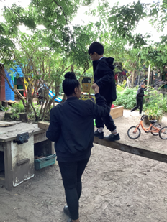

Purple Class
Purple Class really enjoyed making chocolate cakes this week. They melted the chocolate in the microwave and then followed the steps to add the different ingredients and create their tasty treat. They also used ribbons in their Movement Works session to role play moving kites through the air.
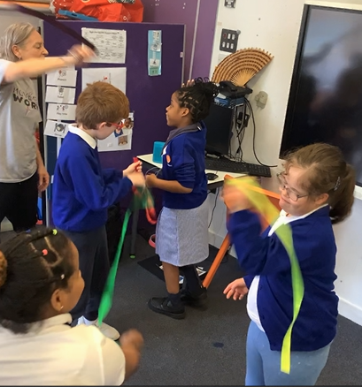

Butterfly Class
This week in Butterfly Class the children have been exploring different art techniques to create cards for family members. They have also been working on activities as part of our Habitats topic and made an edible ocean with various ingredients such as crushed biscuits for sand.
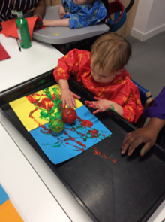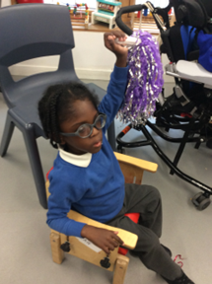

Silver Class
This week, the Silver Class pupils focused on developing their handwriting skills. They used a range of mark-making tools to practise letter formation and improve their pencil control. Some pupils also answered comprehension questions about a story they had read, helping them to develop their understanding, communication, and recall skills. These activities supported the children in developing their fine motor skills, concentration, confidence in writing and early reading comprehension. It was lovely to see the pupils engaged and working hard throughout the week.
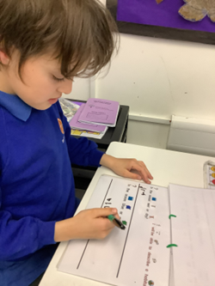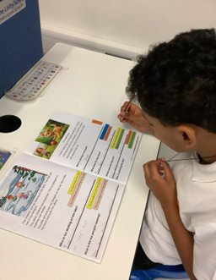

Unicorn Class
This week in Unicorn Class we have been creating ocean landscapes in creative lessons. We have been organising our own resources and combining different materials to create a new effect. We have also been following a science checklist, making sure we make a sensible prediction, follow the method and record our results.
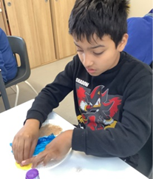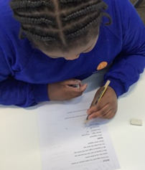

Ladybird Class
This week Ladybird Class have been busy developing their fine motor skills by learning to cut out shapes and then stick them on to paper to create a flower. Ladybirds have also been practising their tripod grip whilst engaging in a letter tracing activity during their morning free flow.
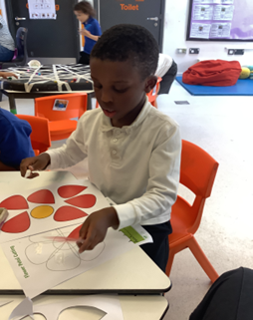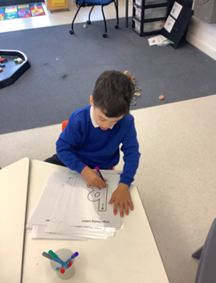

Don’t Forget
All our term dates are available on our website
https://www.thelivityschool.co.uk including the 2026/27 dates
Term Six Ends Friday 17th July at 1pm

School returns Thursday 3rd September for pupils
International Day 12.30 until 2.30 Friday 3rd July

Parents Evening for nursery to year 5 parents as this is an opportunity to meet your child’s teacher for next year. After school on Tuesday 7th July, more details to follow.

Graduation Ceremony for year 6 pupils
Wednesday 8th July at 9am

Sports Day
Wednesday 24th June
9.30 – 10.30 Orange, Blue and Pink
11.00 – 12.00 Gold and Silver
1.15 to 2.15 Rainbow and Unicorn

Wednesday 1st July
9.30 – 10.30 Red, Green, Dragonflies and Butterflies
11.00 – 12.00 Ladybirds and Bumblebees
1.15 to 2.15 Purple and Yellow

