
13th March 2026
Livity Life
The Livity School Weekly Newsletter
School News
Red Nose Day Friday 20th March. Please wear something red.
Please remember to call the school office at 8.15am if your child is going to be absent.

Red Class
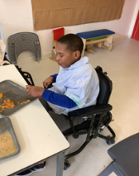
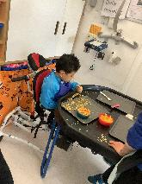
Red Class had a great Fun with Food session. One pupil engaged with spaghetti hoops, exploring the texture and consistency through touch and smell, whilst another pupil explored peaches, experiencing new textures, smells and tastes. These activities provided support in the development of sensory processing, curiosity and tolerance of different food textures.

Yellow Class
We’ve been as busy as ever in Yellow Class. Towards the end of last week, we celebrated World Book Day and put on our best costumes. All the pupils looked amazing! This week we’ve had a big focus around sharing and reciprocal play. The pupils have really enjoyed working and playing together.
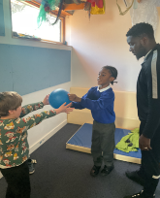
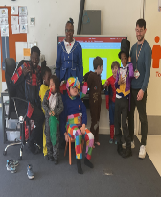

Dragonfly Class
This week, the Dragonfly children explored our new sensory tunnel trail in class. In our sensory cooking lesson, the children made fruit salad. They explored all the ingredients with their senses and mixed them to create a very colourful dessert. They also had fun with the props of our new sensory story, ‘We are Going on a Bear Hunt’.
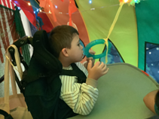
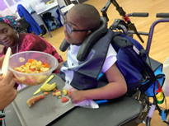

Pink Class
Last week in Pink Class, the children had the opportunity to dress up as different roles for Careers Week. We dressed up as firefighters, the police, doctors and pilots. The children enjoyed participating in different activities relating to these careers.

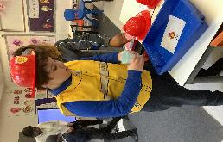

Blue Class
Last week in Blue Class we celebrated Careers Week. The children enjoyed dressing up in different community workers such as builders and postal workers. They took part in role-play activities and explored different jobs through play. The school cook came to visit the class to see the flapjacks the children had made and kindly gave them stickers to celebrate their hard work. We also had a special visit from a dog from Battersea Dogs and Cats Home called Toast. The children learned about what Toast likes to eat and that he enjoys going for walks and swimming. The children were very excited and had the opportunity to gently stroke Toast. They thoroughly enjoyed the experience and were very engaged during the visit.
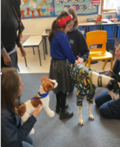
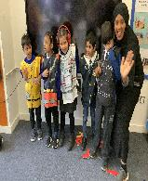

Orange Class
This week Orange Class loved their Attention Autism bucket time. They got very excited to find out what interesting object was inside. Our favourite moment was when the balloon was pumped up and then released. It flew all the way up to the ceiling. We have also been enjoying focusing on matching the correct number of objects to the correct numeral.
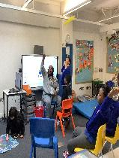
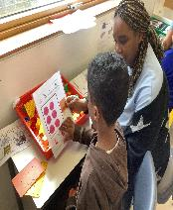

Bumblebee Class
This week Bumblebee Class have been getting more familiar with the Zones of Regulation. The pupils explored different soothing activities and practised using a mirror to look at the expressions on their faces. In literacy the Bumblebee pupils explored the different settings found in the story, ‘We’re Going on a Bear Hunt’, by looking at real-life pictures of the family’s journey. They also began looking at the different features the family describe the bear as having and explored labelling their own bear. They have also made delicious banana bread in cooking and learnt about the weather by creating foam rain clouds.
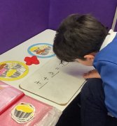
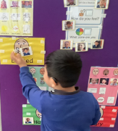

Gold Class
This week, the pupils in Gold Class completed additions and subtractions using objects and recalling number-bonds to solve equations. The pupils worked on sequencing numbers on a number line and matched the number value to the symbol. During our sessions in the sensory garden, the pupils collected leaves and sticks to sort out using symbols. We are making a bug hotel using recyled water bottles to fill with straw, sticks, leaves and cardboard.
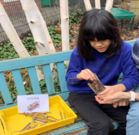
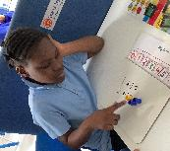

Green Class
This week, Green Class took part in sensology session that focussed on their favourite things. The children particularly enjoyed exploring their reflections in the mirrors and experiencing different tastes, including lemon and custard. We also had a special visit from Toast, a dog from Battersea Dogs and Cats Home. The children were very excited to meet him and some gently stroked him.
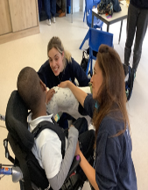
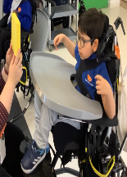

Rainbow Class
Last week we really enjoyed meeting Toast, a dog from Battersea Dogs and Cats Home. We listened to them tell us about what they do and the types of dogs there are. We learnt how to pat dogs calmly and safely and practised 'pet, pet, pause' when meeting Toast. We even made our own origami dogs in art as we enjoyed meeting Toast and have been talking about the visit a lot since.
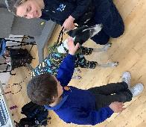
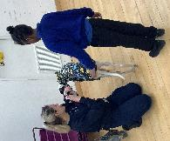

Purple Class
Purple Class have had another great week. We were very excited to see how much our seeds have grown when we went to Brockwell Greenhouses this week. We all took turns to water them and learnt about what they need to keep growing. We toured the gardens and learnt about the different plants and saw the beehives. We also had a great session in the hydro pool.
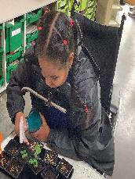
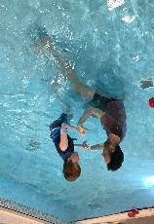

Butterfly Class
This week the children in Butterfly Class have been anticipating and responding really well during our skills session with the therapists. The children worked on taking turns through creative activities and did brilliantly. We have also been making Mother’s Day Cards to send home this week.
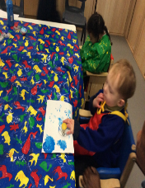
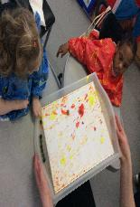

Silver Class
This week in Silver Class, our pupils revisited their learning about the days of the week, the months of the year and the different types of weather. The children took part in structured activities and songs to help them recognise and recall the days and months. The pupils were also encouraged to come to the front of the class and use the interactive whiteboard to select and show the correct day of the week and the correct month to their classmates. This helped to build their confidence, communication and participation in group learning. It has been lovely to see the pupils engaging with the activities and becoming more confident with familiar routines.

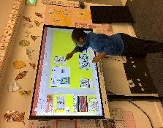
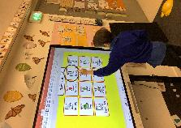

Unicorn Class
This week in Unicorn Class we have been taking part in a dance performance at Elm Court. The children have been working hard in rehearsals and have learnt three different dances alongside Elm Court pupils. We have also been working hard towards our targets in class, learning to tie our laces and developing our motor skills.
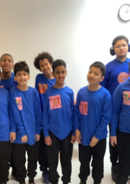
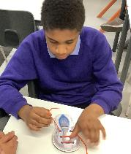

Ladybird Class
This week Ladybird Class have been learning to recognise different feelings and emotions whilst drawing simple facial expressions in flour. They have also been practising taking turns. Ladybirds have been developing their fine motor skills by using syringes while engaging in painting ‘The Three Little Pigs’.
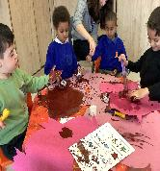
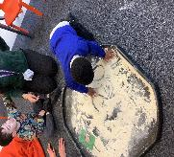

Don’t Forget
All our term dates are available on our website
https://www.thelivityschool.co.uk

Term Four Ends Friday 27th March at 1pm. Term Five Begins Monday 13th April.
Bank Holiday Monday 4th May – No school. Thursday 5th May – school closed to pupils as we are a Polling Station.
Term Five Ends Thursday 21st May.
Term Six Begins Monday 1st June.
Term Six Ends Friday 17th July.

Red Nose Day Friday 20th March
Please wear something red.
Family Group Makaton training
We are holding three Makaton workshops on 17th April, 1st May and 15th May at 9.30 until 11.30am. Spaces are limited so if you would like to attend, please contact Alberta or email admin@thelivity.lambeth.sch.uk
Parents and Carers’ Wellbeing Group
Mindfulness Colouring Thursday 19th March 9.30 until 10.30.

