
Date 12th December 2025
Livity Life
The Livity School Weekly Newsletter

School News
Tuesday 16th December at 9.30am The Livity Show
Wednesday 17th December – Christmas lunch
Please remember to call the school office at 8.15am if your child is going to be absent.

Red Class
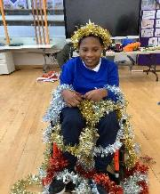
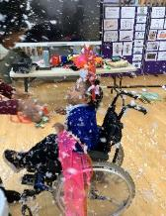
Red Class have had a wonderfully festive week at school! The children enjoyed a special visit from Mr Ruffles, who brought lots of excitement and smiles to the classroom. Highlights included one child dressing up as a Christmas tree with tinsel, baubles and stars. Another child wore reindeer antlers during the indoor snowfall, made from bubbles and soap. The children had a fantastic time exploring and playing in the fluffy festive snow.

Yellow Class
In Yellow Class this week we enjoyed a fantastic performance by Mr Ruffles. We all thought he was really funny! In cooking we made mulled apple juice, by adding cinnamon, cloves, orange peel and honey to some apple juice before warming it up. It was delicious and we enjoyed smelling all the spices.
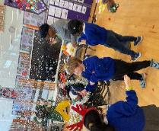
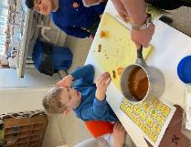

Dragonfly Class
This week, the Dragonfly children enjoyed a Christmas sensory story. They chose their favourite props and enjoyed playing and sharing them with their peers. They had fun during Mr Ruffles’ show. They helped Mr Ruffles with his magic tricks, danced with their peers whilst listening to the music and watched snow and confetti fall.
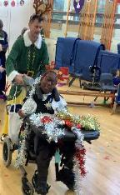
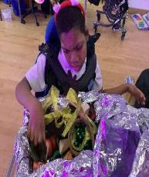

Pink Class
This week has been a great week for Pink Class. The pupils chopped vegetables and followed the steps to make rainbow pasta in their cooking lesson. They were able to explore the differently coloured ingredients and follow the instructions to make the tasty pasta.
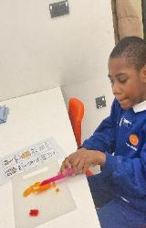
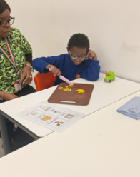

Blue Class
In Blue Class, during our cooking session, the children engaged in making chocolate stirrers. They used their communication books, PECS and AAC devices to follow instructions and choose what they wanted in their chocolate stirrers. They enjoyed tasting, touching and smelling the ingredients. The children also made their own placemat for the Christmas lunch by choosing pictures that they then cut and stuck onto a background.
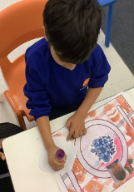
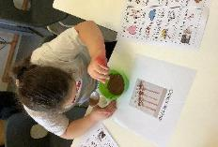

Orange Class
Orange Class have enjoyed making marshmallow slime. The children enjoyed touching and tasting the different ingredients separately, such as the vegetarian marshmallow, vegetable oil and cornstarch. The children liked mixing and kneading the mixture after the ingredients were placed together and cooked in
the microwave. The children then added food colouring to their slime. They enjoyed tasting and playing with the slime.
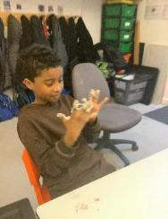
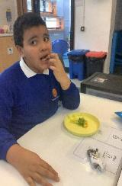

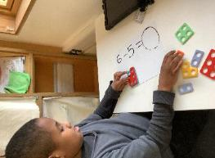

Bumblebee Class
This week Bumblebee Class have enjoyed exploring different types of fruit during their Understanding the World cooking lesson. They practised using their fine motor skills to cut and handle the fruit, creating their own magic fruit wands. Bumblebee Class have also been busy working on their number recognition. They have been exploring their turn taking skills in various activities and they have been using their communication skills to request materials in their creative learning, as we make Christmas props.
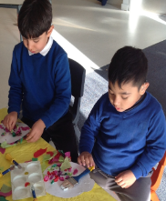
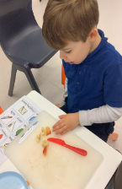

Gold Class
This week, the pupils in Gold Class used Numicons to solve additions and subtractions. The pupils learnt the concept of adding and subtracting using objects, to make the number bigger or smaller. During our gardening lesson, the pupils followed the steps to make a bird feeder with seeds. The pupils read the instructions and enjoyed mixing seeds, cornmeal and dripping it into a mould with a string to hang it on the trees.

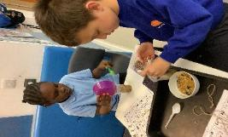

Green Class
This week, Green Class enjoyed a wonderfully engaging sensory session with Mr Ruffles. They took part in decorating themselves as Christmas trees and then embarked on an imaginative journey to the North Pole, where they experienced plenty of snow and festive fun.
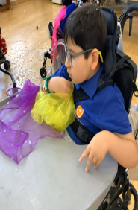
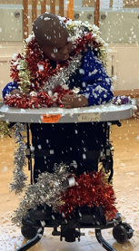

Rainbow Class
Rainbow Class have been enjoying our second week of our Create Dance workshops. We have been following the story 'Journey' by Aaron Becker and exploring the story through pictures, dance and movement. We have especially liked creating sea-like movements and moving around the classroom like the ocean!

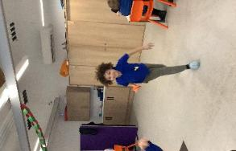
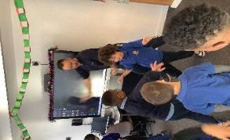

Purple Class
Purple Class really enjoy their cooking lessons. They are really good at following the steps to complete the recipe and enjoy mixing the ingredients together. Flapjacks are a favourite and they like personalising them by adding their favourite fruit.
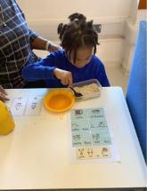
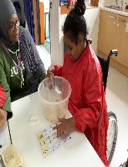

Butterfly Class
Butterflies really enjoyed their visit from Mr Ruffles. We held a lovely party and even had a snow machine. We liked exploring all of the party props and dancing to the music.
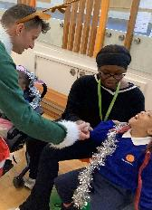
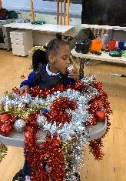

Silver Class
This week in Silver Class, some of our children have been working hard on phonics activities that focus on identifying missing letter sounds in CVC (consonant-vowel-consonant) words. These engaging activities help children listen carefully to the individual sounds in simple words such as cat, dog and sun and then identify which sounds are missing to complete the word. Through these phonics games and exercises, children are developing key early reading and writing skills.

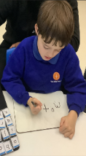
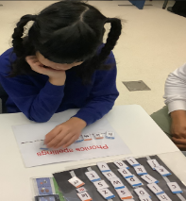
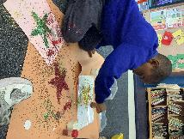

Unicorn Class
This week in Unicorn Class we have been continuing our work with the Create Project. We have been learning to reimagine story books into movement. We have been looking at different scenes, discussing the plot and then writing down an appropriate ending. We have been using reasoning to say what we think will happen next.
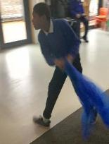
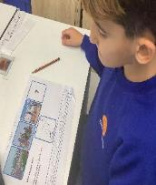

Ladybird Class
This week, Ladybird Class have been busy making Christmas decorations during their Attention Bucket session and using star stencils to make a shiny Christmas star. Ladybirds have been developing their fine motor skills by making fruity skewers by pushing grapes, strawberries and blueberries onto skewers. Then, they dipped them into a mixture of yoghurt and honey before eating them.

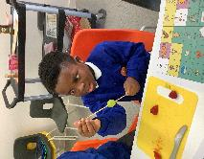

Don’t Forget
All our term dates are available on our website
https://www.thelivityschool.co.uk

Term Two Ends: 1pm Friday 19th December
School returns Monday 5th January.

