
15th May 2026
Livity Life
The Livity School Weekly Newsletter
School News
Please remember to call the school office at 8.15am if your child is going to be absent.

Red Class
Red Class this week enjoyed a creative art session, where they explored different Earth Day paintings using a variety of colours and materials. They also proudly created a beautiful painting to celebrate International Nurses Day, showing appreciation for their kindness and care. They were fully engaged, expressive and proud of their fantastic artwork. It was wonderful to see their creativity shine!
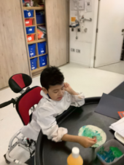
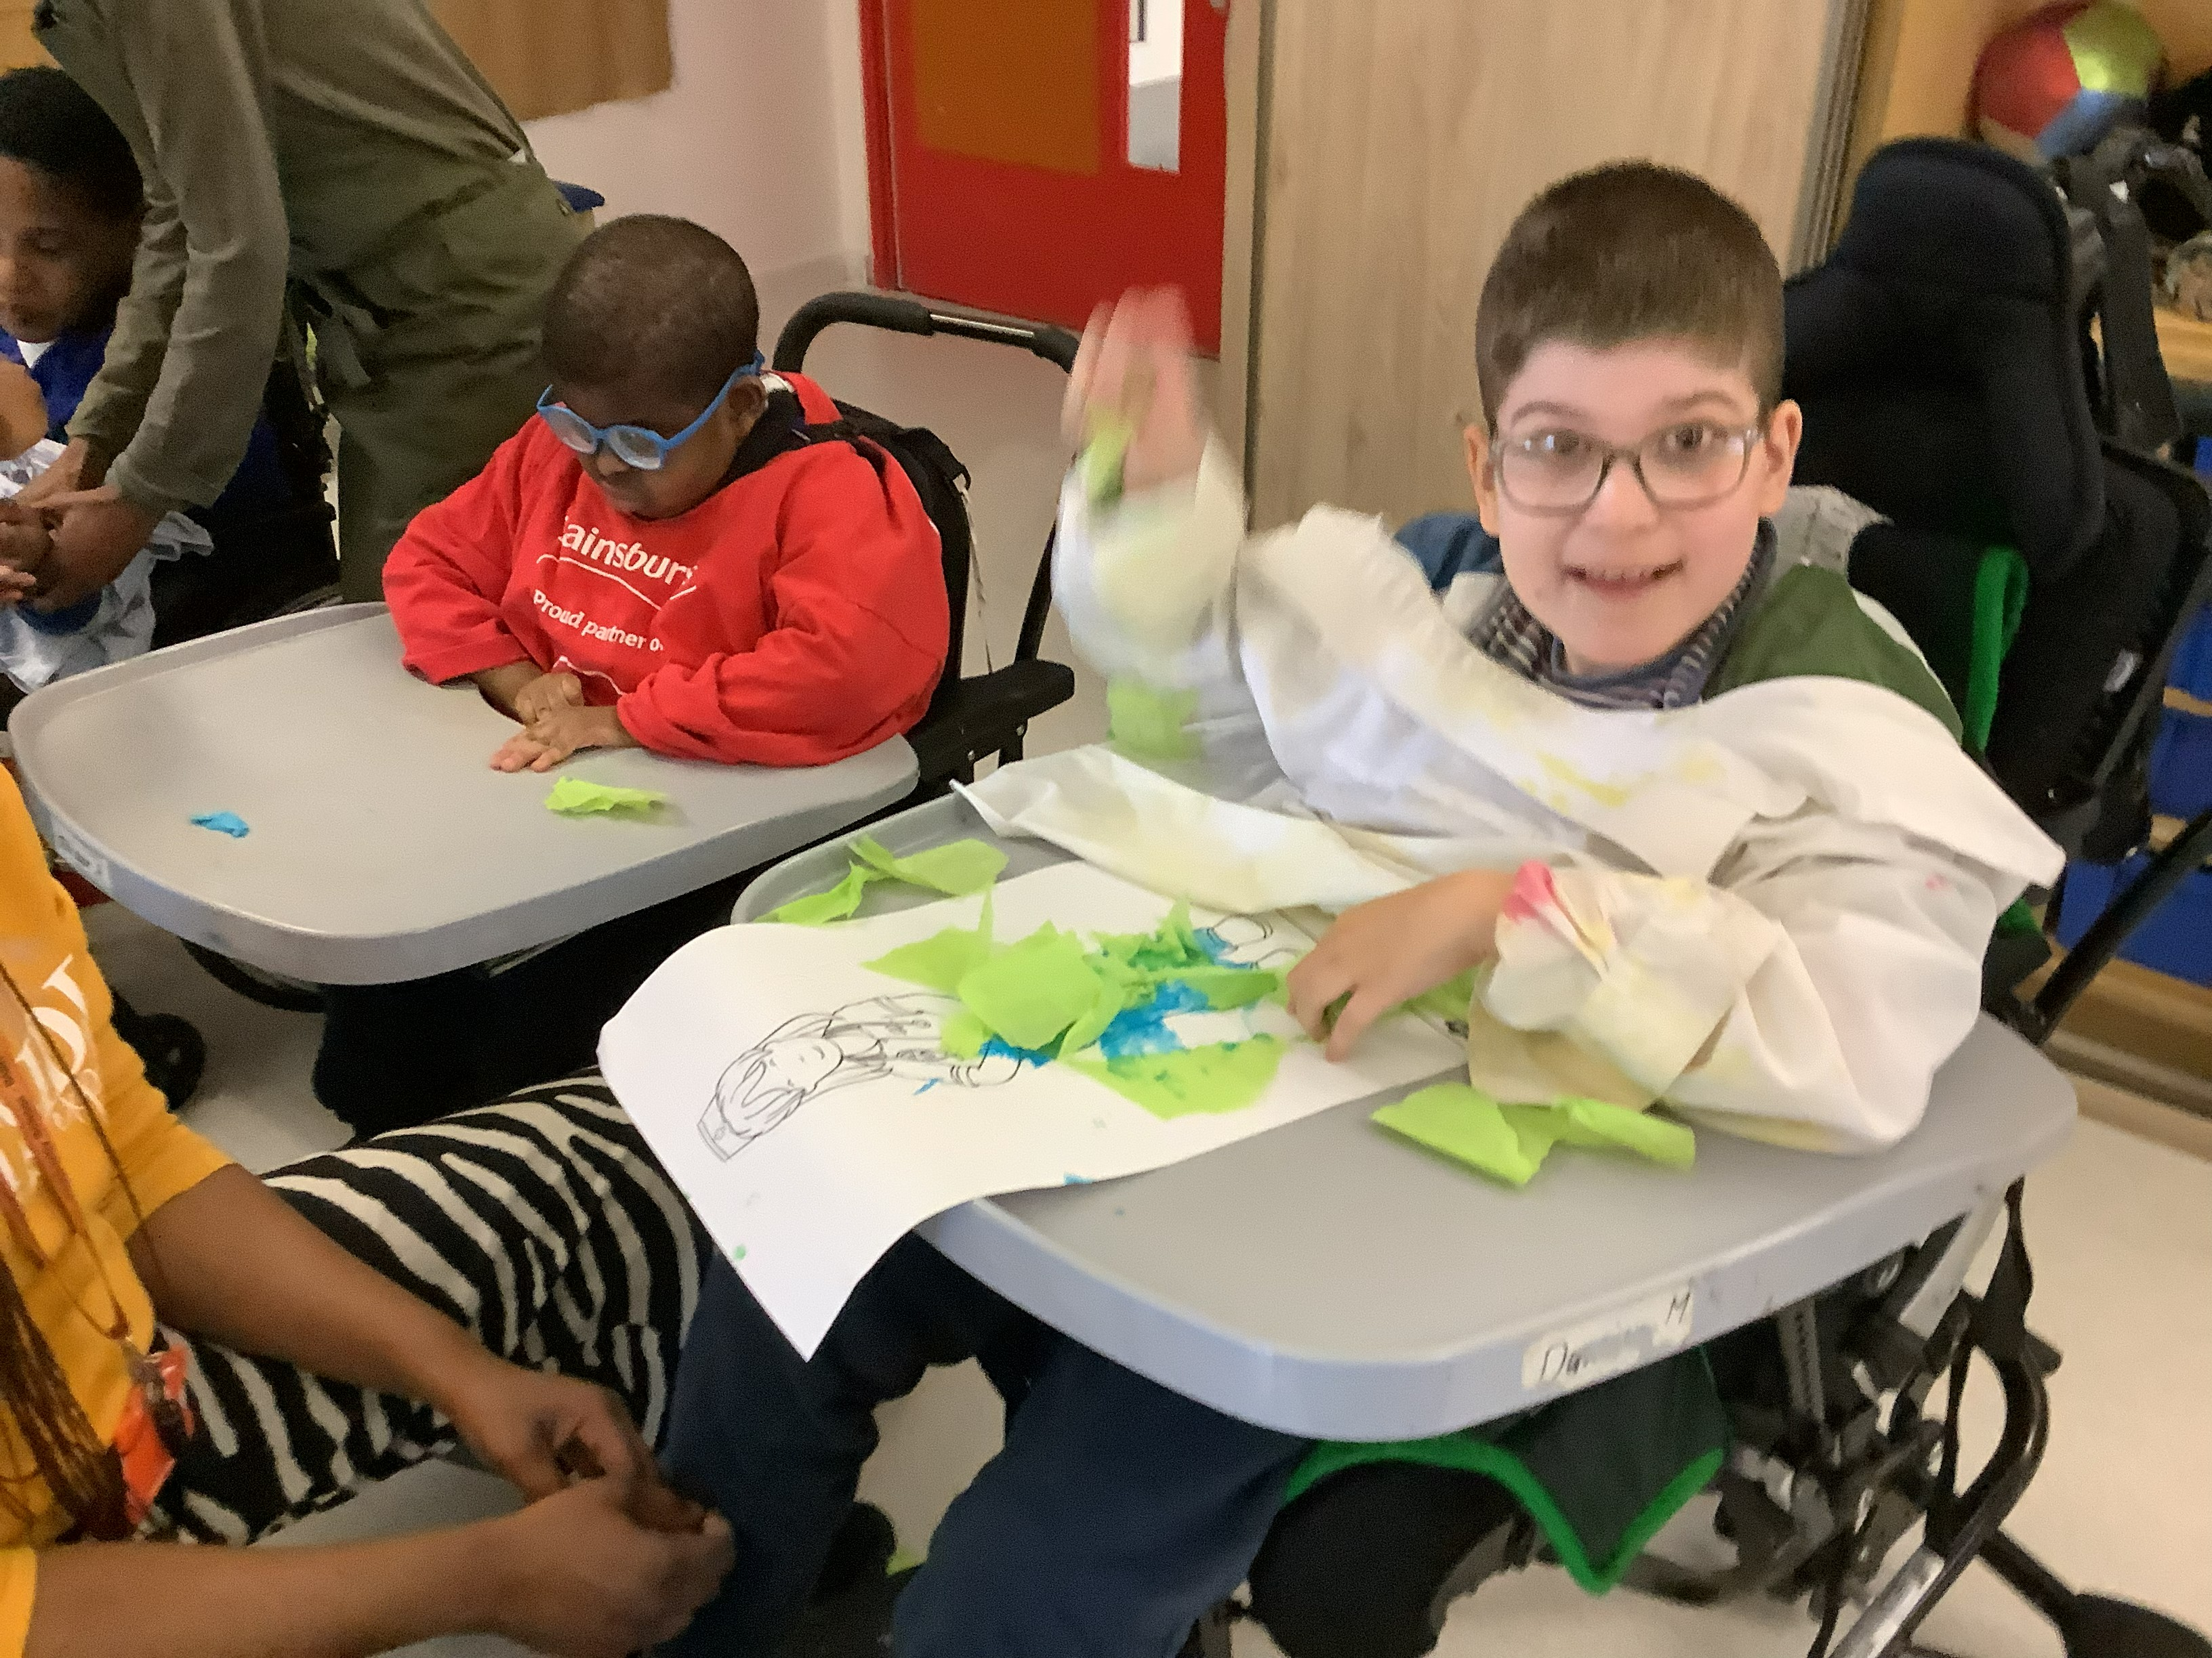

Yellow Class
We’ve had a fantastic week in Yellow Class. On Wednesday we went on a trip to the V&A Museum to learn about Japanese culture. The pupils walked around the museum and then did some Japanese inspired crafts. We have also been investigating different types of habitats. This week we’ve been looking at ponds.
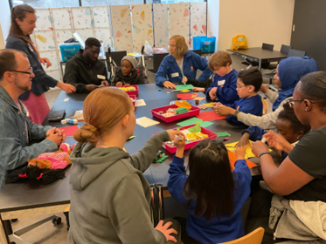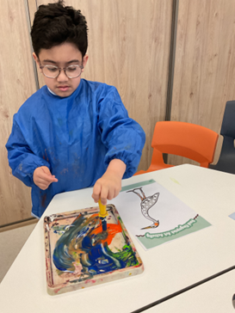

Dragonfly Class
This week, as part of Wellbeing Week, the Dragonfly children enjoyed foot spas and hand massages. They also focused on cause-and-effect activities using switches. They have continued learning about habitats, exploring sensory trays filled with natural resources related to the rainforest.
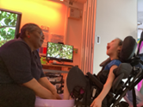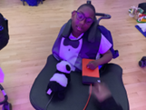

Pink Class
This week in Pink Class, the children have been exploring wobble boards during movement breaks. They have enjoyed testing their balancing skills and rocking from side to side. They have been developing their communication by choosing which colour they would like to use.
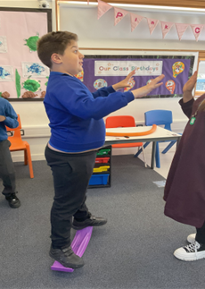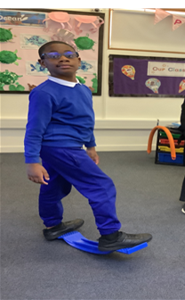

Blue Class
This week in Blue Class, we have continued reading our story ‘The Three Little Pigs’. The children are enjoying the story and each child made their own house. They explored different materials such as straw, shredded paper, cardboard and glue. They used their hands to feel and investigate how the materials looked and felt. The children showed great creativity and engagement throughout the activity. In P.E. this week, the children practised walking along the bench to help develop their balance and coordination skills. They were encouraged to move carefully and confidently whilst taking turns and following instructions.
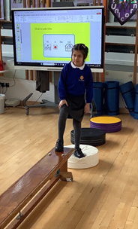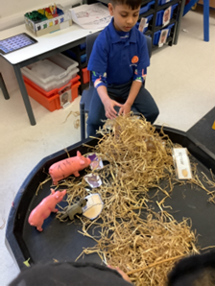

Orange Class
This week, Orange Class have been very focused on child led peer interaction and we enjoyed role playing looking after some dolls. This involved brushing their hair, dressing them and taking them for a walk in the buggy. The children really enjoyed taking care of the dolls and were able to interact with each other independently. Another focus for the class has been mark making and this week, we took one of our sessions into the sensory garden and used chalk to create colourful drawings.
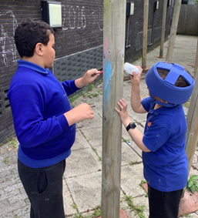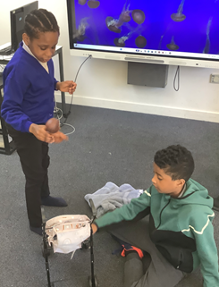

Bumblebee Class
This week Bumblebee Class have been working hard on their targets, pushing themselves in their learning! Some pupils have been exploring different problem-solving games, whilst others have been working on using different manipulatives to build number bonds to 10! In cooking, pupils chose a rainforest creature to use as inspiration for their own animal cupcake. The pupils also used various resources to take part in an experiment where they created their own rainbow!
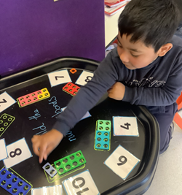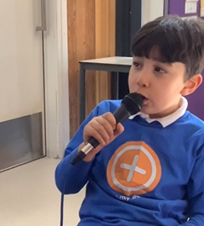

Gold Class
This week, the pupils in Gold Class worked on writing key words from our story, using their phonics knowledge. The pupils read and answered questions from ‘Rumble in the Jungle’ using Colourful Semantics. The pupils created the terrarium they designed last week using recyled bottles. They also watered the coleus plant that we have been growing in water to see its roots.
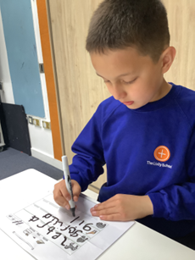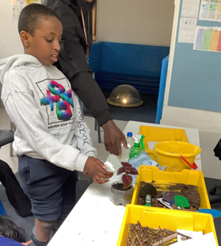

Green Class
This week, Green Class have enjoyed making their own guacamole during our sensory cooking session. We explored each ingredient individually, using our senses to touch, smell and even taste the different textures and flavours. We then mixed them together to create delicious guacamole. During our sensology session, we also explored large foil blankets. We particularly enjoyed listening to the different sounds they made and investigated the shiny textures through touch and movement.
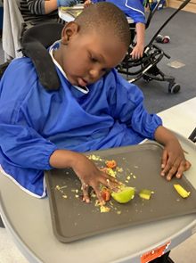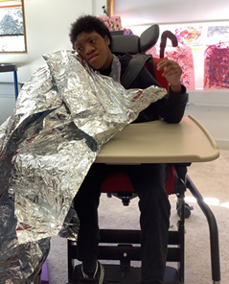

Rainbow Class
Rainbow Class have been making great progress in their weekly swimming sessions at the leisure centre. We have been practising blowing bubbles in the water whilst kicking our legs and have worked on swimming on our front and back. We have been using different floats to practise these techniques and last week practised swimming around the perimeter of the whole pool!
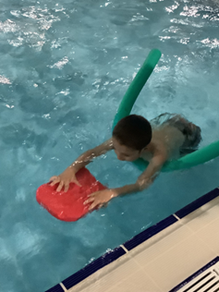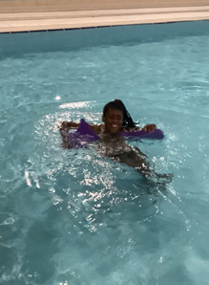

Purple Class
Purple Class have enjoyed making tortilla wraps this week. They chose their favourite fillings and followed the instructions to make their wraps as independently as possible. Some of the children have been using letter biscuits to spell their name and then iced the letters to practise their tracing skills.
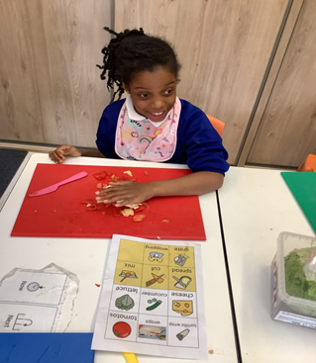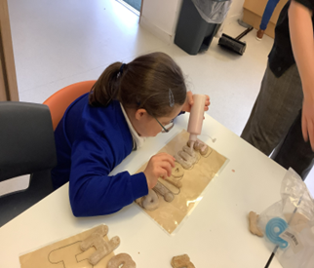

Butterfly Class
This week the children in Butterfly Class have been great in the hydrotherapy pool, making independent movements in the water. They have also used BIGmacks for communication, repeating chants from our story. Some children are engaging in walking or standing more confidently in different ways.
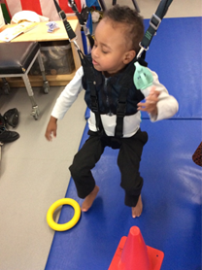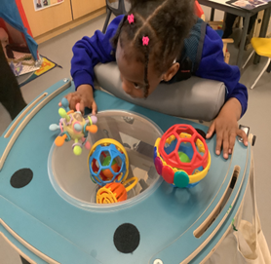

Silver Class
Silver Class pupils enjoyed an engaging outdoor learning session this week. We took our experiment session outside to make the most of the beautiful weather. With support from staff, the
pupils carried out an exciting rainbow Skittles experiment. They carefully placed Skittles on plates and watched with great interest as the colours dissolved and spread to create vibrant rainbow patterns. The pupils were enthusiastic and curious throughout the activity and it was wonderful to see them exploring and learning in the outdoor environment.
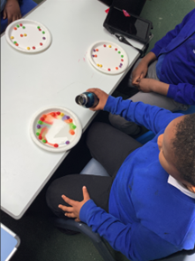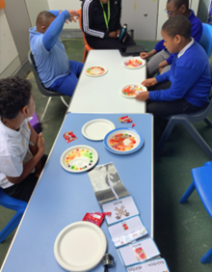

Unicorn Class
This week in Unicorn Class we have had a visit from the V&A Museum. We had a workshop on Japanese culture and the children decorated kimonos using mixed media. In P.E. we have been working on athletics in preparation for Sports Day.
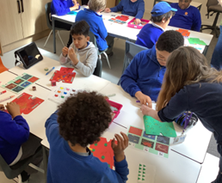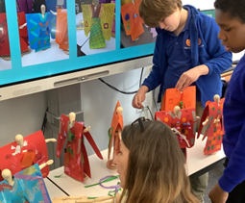

Ladybird Class
This week Ladybird Class have been busy cutting various shapes out of playdough. They have also enjoyed exploring the texture of cornflour whilst making footprints using dinosaurs. Ladybirds have also used their communication boards whilst making vanilla cupcakes during their cooking session.
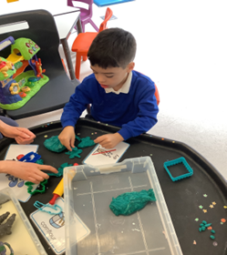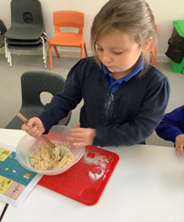

Don’t Forget
All our term dates are available on our website
https://www.thelivityschool.co.uk

Term Five Ends Thursday 21st May.
Term Six Begins Monday 1st June.
Term Six Ends Friday 17th July.

International Day is the afternoon of Friday 3rd July.

Family Group
Makaton training
We are holding a Makaton workshop on
12th June at 9.30 until 11.30am.
Spaces are limited so if you would like to attend, please contact Alberta or email admin@thelivity.lambeth.sch.uk
Phonics
Learn about the phonics system used in school
19th June 9.30 to 10.15am

