
8th May 2026
Livity Life
The Livity School Weekly Newsletter
School News
Please remember to call the school office at 8.15am if your child is going to be absent.

Red Class
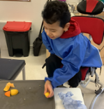
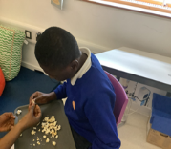
This week in Red Class, we’ve had an exciting focus on Fun with Food! One child explored oranges, engaging their senses whilst building their confidence with new textures. Another pupil made fantastic progress by holding a piece of popcorn. Both pupils have been developing their pincer grip and making great strides in tolerating different textures.

Yellow Class
This week in Yellow Class we have been working on collaborative play and communication with each other. In our cooking lesson we made salsa, which we enjoyed eating with some tortilla chips. Yum!
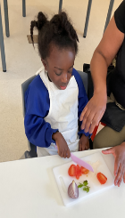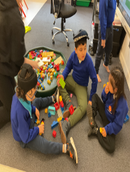

Dragonfly Class
This week, Dragonfly Class enjoyed our new sensory story ‘The Rainbow Fish’. The children chose their preferred props to use during the session and used BIGmacks to make comments from the story’s characters. In our sensory cooking lesson, the children made pizza. They stretched the dough and added their favourite ingredients. They manipulated small and medium sized ingredients, showing great hand-eye coordination.
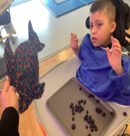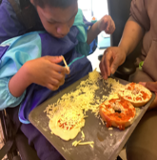

Pink Class
Pink Class have been working really hard on their new goals for the Summer term. The children experimented with milk and dish soap to create magic milk. They followed the instructions and each used their communication methods to choose which food colouring to add to the milk. The children watched as the dish soap pushed the food colouring around the bowl.
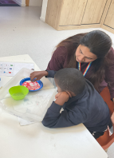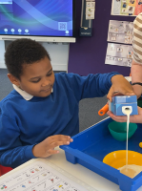

Blue Class
This week in Blue Class, the pupils created a wolf inspired by ‘The Three Little Pigs’. They used a range of communication methods to request resources such as scissors and glue sticks. The pupils practised their cutting skills and enjoyed sticking on the features, such as the mouth, teeth and ears to complete their wolf.
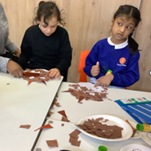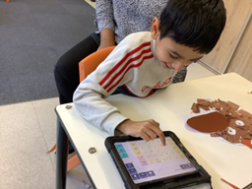

Orange Class
During our cooking session, Orange Class explored a few types of fruits such as apples, raspberries and bananas. The children were encouraged to smell, touch and taste the fruits and to use Makaton or symbols to request more. We then used the fruits to build a model cactus as we have been learning about the desert habitat. The bananas were too soft, but the apple slices were perfect. The adults helped us to use toothpicks to stack the apple slices together and used raspberries as flowers at the top of the cactus. Orange Class really enjoyed this activity.
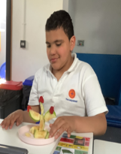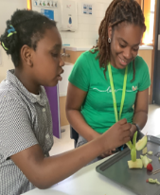

Bumblebee Class
This week Bumblebee Class have been doing some amazing work in maths, exploring their understanding of place value in various activities. Some pupils have been practising counting using number songs and objects, like a water tray and ducks to practise counting to the song Five Little Ducks. Other pupils in Bumblebee Class have been building upon their knowledge of number bonds using Numicon and number sentences. In literacy, pupils have been remapping key parts of our story 'Walking Through the Jungle', with some pupils beginning to explore Colourful Semantics to build on their comprehensive understanding. Bumblebee Class have also been making animal tracks, creating their own salt dough moulds. They then chose the animal toys they wanted to press in to the dough to create a set of tracks.
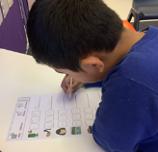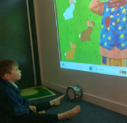

Gold Class
This week, the pupils in Gold Class enjoyed completing fine motor skills activities for our story, ‘Rumble in the Jungle’. The pupils decorated penne pasta with felt tip pens and threaded them through a string to make a colourful snake. During our gardening lesson, the pupils designed their own terrarium, by cutting and sticking its parts from a template. We are observing how our coleus plants are growing their roots in water. We will then be planting them in our terrarium, which we are making from plastic bottles. .
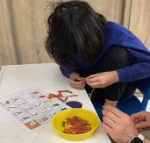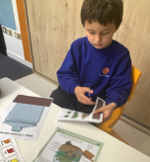

Green Class
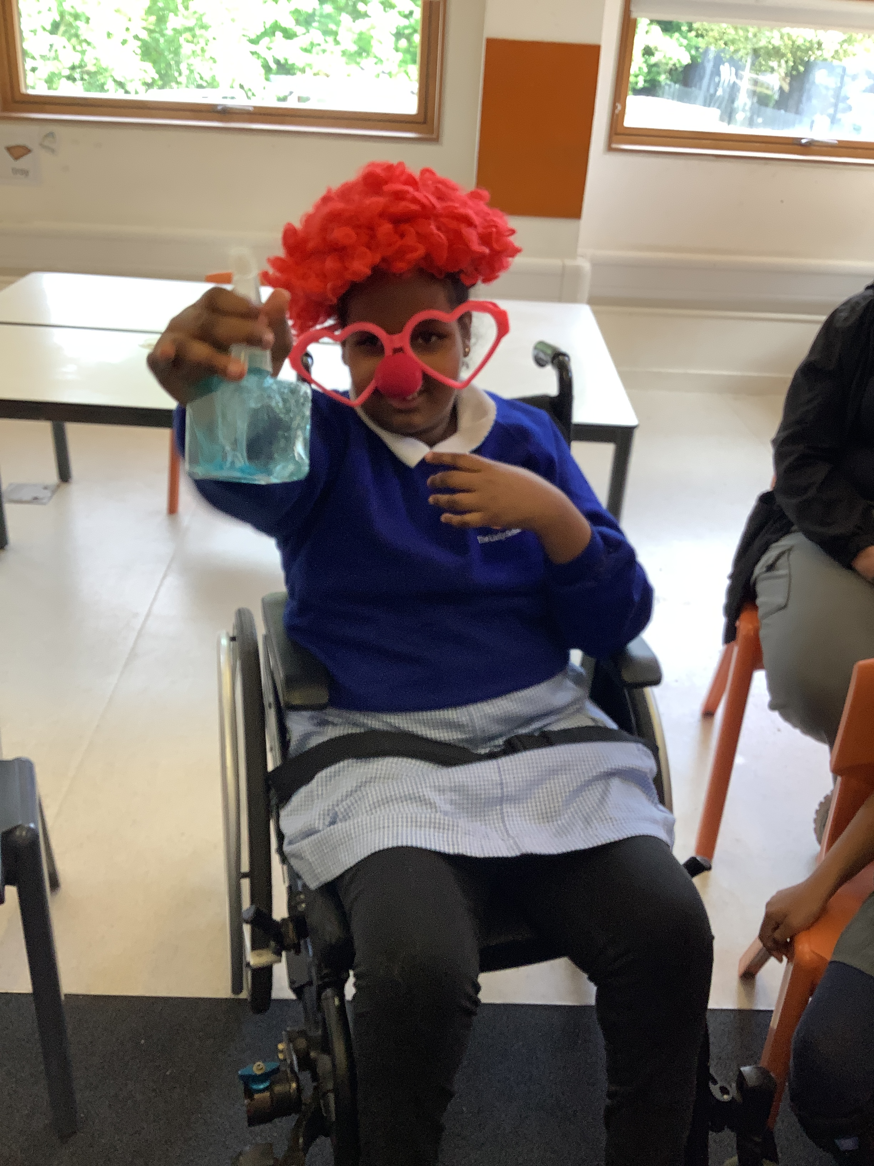
This week, Green Class have enjoyed exploring the colour yellow during our ‘Fun with Food’ session. The pupils engaged in a range of sensory experiences, exploring foods such as custard, pineapple and sweetcorn. One of the highlights of the week was making our own fruit salad. Everyone was encouraged to make choices after smelling and even tasting the fruits. We then mixed all the fruits together using our hands.
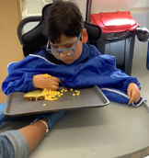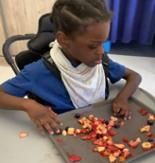

Rainbow Class
This week in Rainbow we have been working on our athletics skills, we practised relay races, hurdles and running. We are practising before our Sports Day next term and enjoying taking part in team games and cheering our friends on.
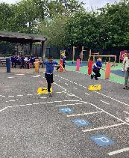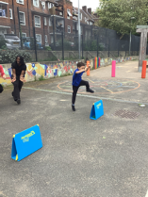

Purple Class
Some of Purple Class have been learning about the letter p in their phonics lessons. They have explored items starting with p, such as putting pink legs on a pig, posting purple pegs in a pot and enjoyed making paint pop. Other children have been fishing letters from water to match them and finding the missing letter to complete a word. We have continued to enjoy role playing during our Circus story.

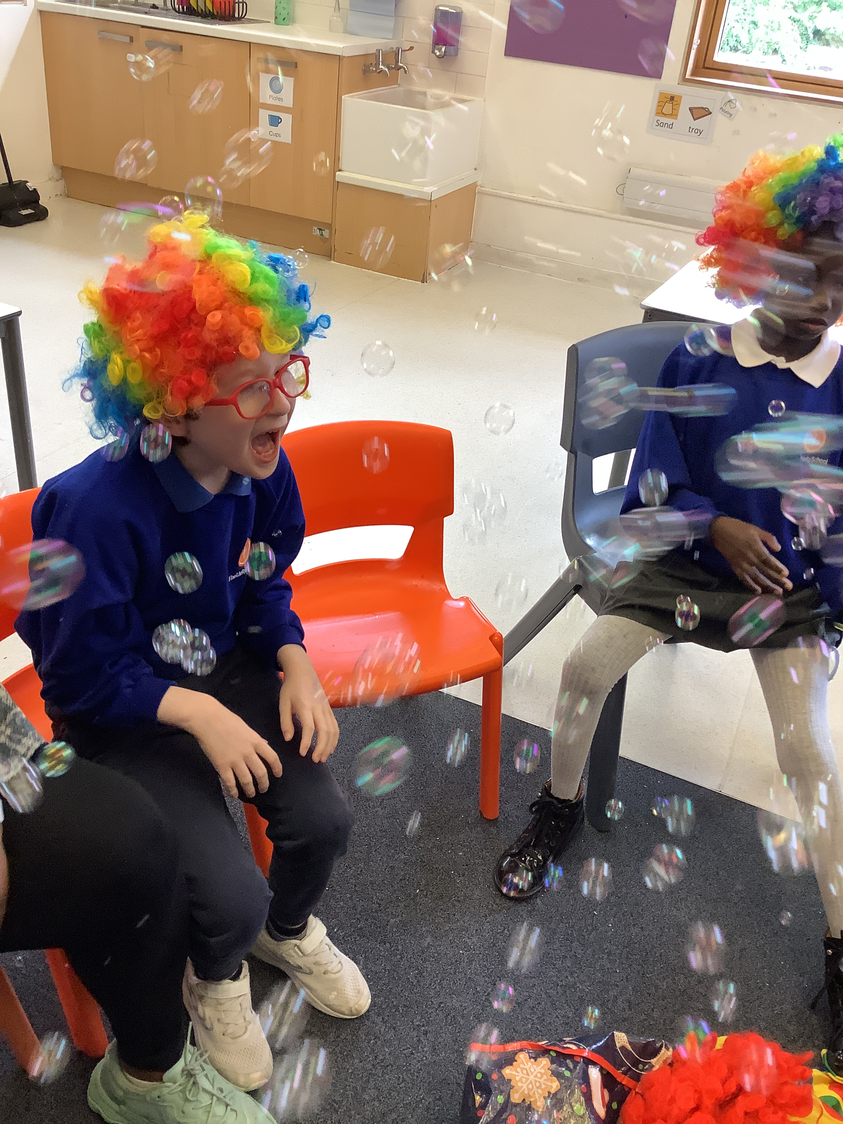

Butterfly Class
This week the children in Butterfly Class have had some great moments during music. They used instruments more independently and vocalised into the microphone. We have been actively moving during our physical session, especially to the warm up song about moving our whole bodies.
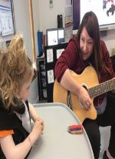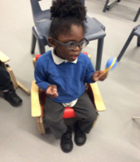

Silver Class
This week, Silver Class enjoyed making rainbow soup. They used a range of colourful vegetables, including purple cabbage, carrots, greens and beans. Through this activity, the pupils learned about the importance of eating a balanced diet and how different coloured vegetables provide a variety of nutrients to keep our bodies healthy. They also developed their observation and discussion skills whilst exploring the ingredients. Well done, Silver Class, for your great learning this week!
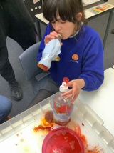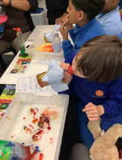

Unicorn Class
This week in Unicorn Class we have been conducting an experiment to test how animals stay warm in colder habitats. We have been simulating the effects of feathers, blubber and fur to help keep out the cold. We have also been working together on creative projects to recreate objects in front of us.
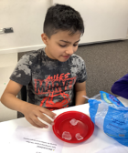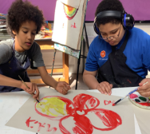

Ladybird Class
This week Ladybird Class have been taking turns to make glitter stars during Attention Bucket Stage 3. They have been developing their fine motor skills by spreading the glue with the spatula and sprinkling the glitter. Ladybirds have enjoyed learning to form the letters of the alphabet during their writing session.
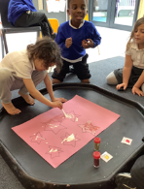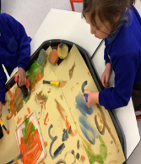

Don’t Forget
All our term dates are available on our website
https://www.thelivityschool.co.uk

Term Five Ends Thursday 21st May.
Term Six Begins Monday 1st June.
Term Six Ends Friday 17th July.

International Day is the afternoon of Friday 3rd July.

Family Group Makaton training
We are holding two Makaton workshops on
15th May and 12th June at 9.30 until 11.30am.
Spaces are limited so if you would like to attend, please contact Alberta or email admin@thelivity.lambeth.sch.uk

