
Date 5th December 2025 2025
Livity Life
The Livity School Weekly Newsletter

School News

The Livity Show Tuesday 16th December at 9.30am

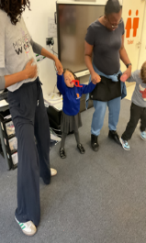
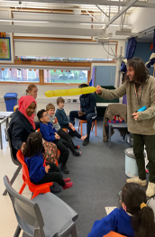
Please remember to call the school office at 8.15am if your child is going to be absent.

Red Class
Red Class have been exploring different textures in cooking this week. The pupils experimented with frozen broccoli and cauliflower. They also explored warm syrup and dried oats, clearly demonstrating their preferences. During the activity the children also practised their fine-motor skills by mixing and moving the ingredients.
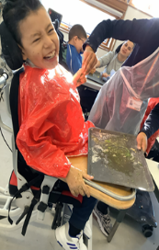
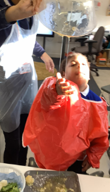

Yellow Class
It’s been another busy week in Yellow Class. As always, we had loads of fun in our Movement Works dance session, dancing and moving in different ways to the music. We’ve also been working on building our concentration through the Attention Bucket. The pupils were fascinated by the new toys and activities in the bucket and were then able to apply their concentration into the subsequent lesson.

Dragonfly Class
This week, Dragonfly children made coconut milk slime. They explored all the ingredients and mixed them, to create a new texture. They also had a dough disco session where they could show preferences in songs whilst manipulating dough. The children made snowball snacks during their cooking lesson, using their own communication method to request turns and express likes and dislikes.
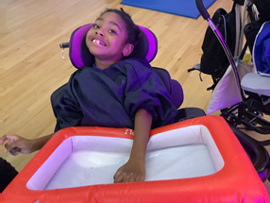
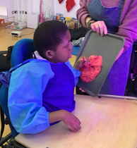

Pink Class
This week has been a great week for Pink Class. The children had an amazing time practising their fine motor skills. They completed different puzzles and used Lego bricks to build towers and showed great creativity and problem solving in their activity.
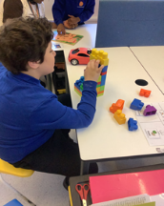
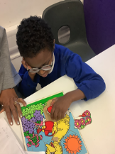

Blue Class
This week in Blue Class, the children enjoyed getting creative with paint and glitter, as they made their own festive reindeer. They also explored Autumn textures by printing leaves and experimenting with different Autumnal colours. They thoroughly enjoyed this activity.
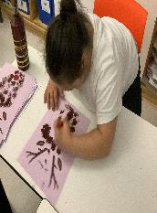
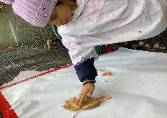

Orange Class
Orange Class have really enjoyed doing creative work in the sensory garden. They have used a variety of tools and paint to create prints and patterns. They also incorporated leaves in their pictures for added texture. Orange Class liked making their edible snowmen in cooking. They tasted the ingredients of carrot, cucumber and mozzarella before working on their fine motor skills by assembling the pieces on to a cocktail stick.

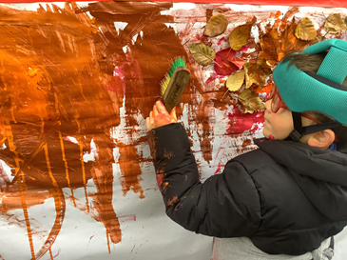
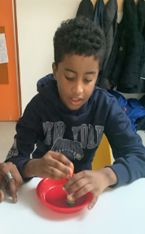

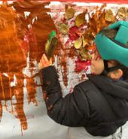

Bumblebee Class
This week Bumblebee Class have been busy exploring the story of ‘Hansel and Gretel’. In our maths learning, we have been using our fine motor skills to correctly sort numbered objects and count while we post. We have also been exploring our sounds in phonics and using our hands to create different letters from the alphabet.
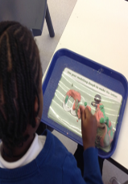
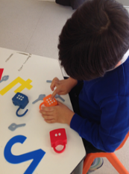

Gold Class
This week, the pupils in Gold Class worked on sound recognition and sequencing sounds in our phonics sessions, to write different words. The pupils are developing their ability to recognize the sounds that letters make and sequencing the sounds that they know to make words. During My Communication lessons, the pupils also used their phonics knowledge to write key words from our story and match the word to the correct picture.

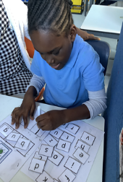
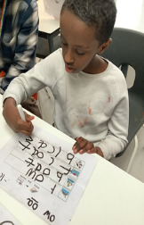

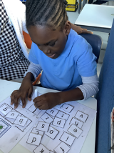
Green Class
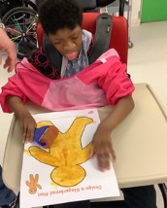
This week in Green Class, we have been exploring the theme of gingerbread. The warm, festive scent features in our Christmas sensory story, which the children have thoroughly enjoyed. We loved making our own gingerbread star biscuits, as well as painting and creating our very own gingerbread men.
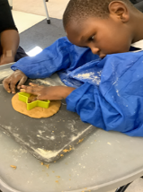

Rainbow Class
This week Rainbow Class visited the London Aquarium, where we saw lots of penguins, turtles, seahorses, jellyfish and sharks! We even got to touch real shark eggs and a tortoise shell. We especially loved walking through the tunnel with all the fish swimming above us.
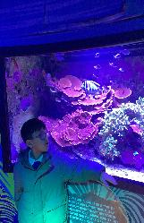
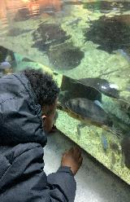

Purple Class
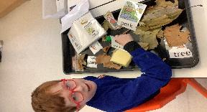
Purple Class have really been enjoying their story 'The Disgusting Sandwich' this week. They have explored the props connected to the story and used it with their own communication systems. They have also made their own sandwiches, making choices on what their filling should be and following the steps to make them. Jam was the favourite.

Butterfly Class
In the last week Butterfly Class have visited a seasonal sensory experience in Dragonfly Class. The children responded to the smells, textures and sounds in a wonderful Winter wonderland.
They have been using a number of skills creating seasonal artwork pressing, spreading, printing, sticking, picking up with fingers and using their pulling skills.
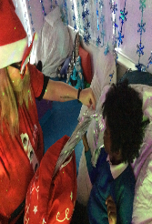
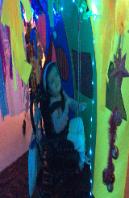

Silver Class
This week, the Silver Class children have had a wonderful learning experience. As part of our topic Belonging, the class visited the London Aquarium to explore sea life in its many forms. The children learned about how different sea creatures live, where they come from, and how they survive in their natural habitats. This visit was a valuable opportunity to deepen their understanding of the world around them and to connect their learning to real-life experiences.
It also helped us to successfully finalise our Belonging topic for this year, bringing our learning to a meaningful and memorable close.

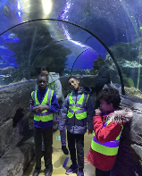
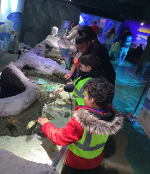

Unicorn Class
This week in Unicorn Class we have been working with the CREATE project, learning how we can tell stories through dance. We have also been working on putting together our own PowerPoints about different countries. We have researched weather, flags and populations and formatted that into our PowerPoints.
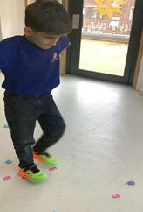
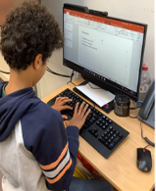

Ladybird Class
This week Ladybird Class have been engaging in making Christmas cards for their families. They have used a pre-cut sponge shape and a paintbrush to create a reindeer’s face. Ladybirds have also enjoyed engaging in Attention Bucket, where they have been making birthday cupcakes out of playdough. They have been using a visualized communication board to support their speech and understanding.
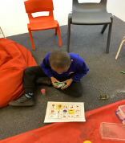
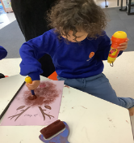

Don’t Forget
All our term dates are available on our website.
https://www.thelivityschool.co.uk

Term Two Ends: Friday 19th December at 1pm
Parent and Carers’ Wellbeing Group - 9.30 -10.30am
Friday 12th December
Mindfulness
Join us for an introductory session on Mindfulness, which will include a simple session for attendees.


Tuesday 16th
December
At 9.30am
The Livity Show

