
6th March 2026
Livity Life
The Livity School Weekly Newsletter
School News
Please remember to call the school office at 8.15am if your child is going to be absent.

Red Class
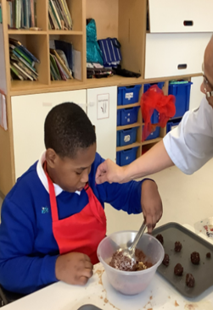
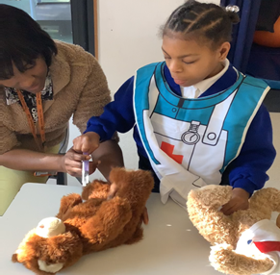
Red Class thoroughly enjoyed taking part in Careers Week! The pupils had lots of fun exploring different job roles by trying on a variety of costumes and colourful hats. We saw fantastic role play throughout the week. The School Cook also came to see our cooking session and gave us stickers. The children showed great imagination, cooperation and enthusiasm as they learnt about different careers.

Yellow Class
It’s been another busy week in Yellow Class. All the pupils have been working hard in our fine-motor sessions, practising their pushing, pulling, stacking and handwriting. In cooking this week, we made some delicious raspberry trifles!

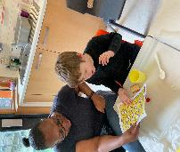
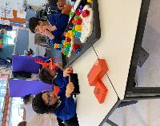

Dragonfly Class
This week, Dragonfly children tried on different uniforms to celebrate Careers Week at school. They also enjoyed a sensory cooking lesson and got stickers from our School Cook for their hard work. We also received a visit from Battersea Dogs and Cats Home in class. The children had the opportunity to meet Toast the dog and learn about how to care for animals.
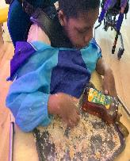
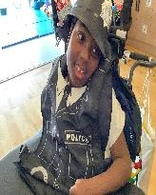

Pink Class
This week, the children in Pink Class enjoyed cooking porridge. Together they checked that the porridge wasn’t too hot or cold, just like Goldilocks from our story. The children followed visual and spoken instructions to chop different fruits, mix the porridge and put the fruit on top.
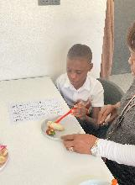
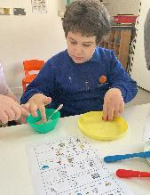

Blue Class
Blue Class enjoyed making flapjacks this week and they turned out very well. The pupils followed simple instructions with adult support and engaged in each step of the process. They explored the ingredients then stirred the mix, using their own forms of communication to make choices and request help when needed. They were excited to taste the flapjacks.
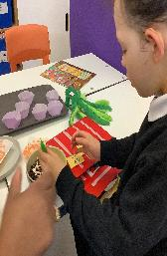

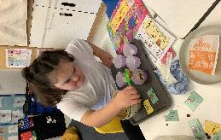

Orange Class
This week has been very exciting week for Orange Class! We enjoyed Careers Week by dressing up as different types of professions. Our favourites were the police officer and the scuba instructor outfits. We even learnt the scuba sign for turtle! We also got to meet a lovely dog called Toast from Battersea Dogs and Cats Home. We learnt how to pet dogs and found out they wag their tails when they are happy.
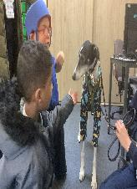

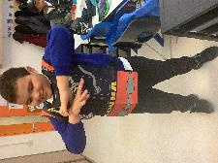

Bumblebee Class
This week Bumblebee Class have been learning about different types of jobs within the wider community. They explored what people do in their different jobs, the equipment they use and how they help us. They also got the opportunity to try on various career outfits, practising their vocabulary and having a go at role terminology. Bumblebee Class also got the chance to meet some furry friends during a visit from Battersea Dogs and Cats Home, practising their listening skills and using gentle hands. This week the pupils also made sensory bottles, inspired by our story ‘We’re Going on a Bear Hunt’. They explored using swishy grass, squelchy mud and swirling snow to create amazing sensory experiences!
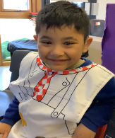
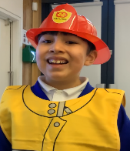

Gold Class
This week, the pupils in Gold Class read ‘Jack and the Beanstalk’. The pupils wrote key words from the story and retold it using Colourful Semantics. They can use visuals and the written words to read the story and answer questions about it. They are also completing activities during their mark-making and handwriting sessions to improve pencil control and hand-eye coordination, linked to phonics.
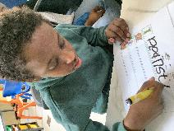
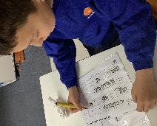

Green Class
This week, Green Class had a fantastic Fun with Food session, where we explored a variety of healthy green foods. The children were enthusiastic about tasting and smelling new flavours, with avocado and sliced green apples proving to be favourites. We also had great fun celebrating Careers Week. The children took part in a special role play session and dressed as firefighters, police officers, paramedics and chefs.
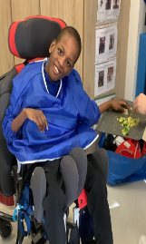
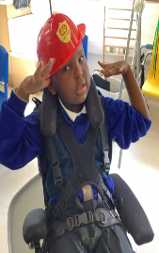

Rainbow Class
Rainbow Class enjoyed taking part in the technical rehearsal days for our upcoming dance show at Elm Court this week. We practised our different dances, songs and the costumes we will be wearing. We are looking forward to performing to our adults next week!
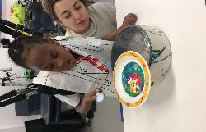
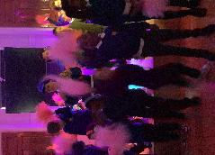
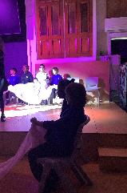

Purple Class
Purple Class enjoyed their trip to Brockwell Greenhouses this week. They helped to plant some seeds and learnt about what seeds need to grow. They then did a mini beast hunt around the plants.
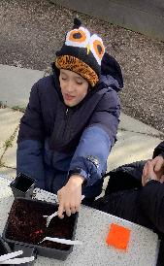

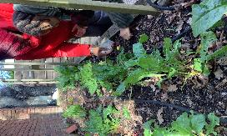

Butterfly Class
This week the children in Butterfly Class have explored Careers Week through a role play session and meeting the people who work at Battersea Dogs and Cats Home. The School Cook also came to visit us and see our class cooking. We had a fantastic World Book Day where we listened to our favourite stories from home and made our own bookmarks.

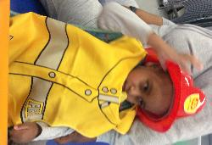

Silver Class
This week, Silver Class had a special visit from Battersea Dogs and Cats Home! The children were excited to meet Toast the dog and had a wonderful opportunity to interact and play with him. This experience supported the children in developing empathy and care for animals, practising gentle handling and social skills. It was a joyful and memorable experience for everyone, and the children were enthusiastic about learning how to care for our furry friends.
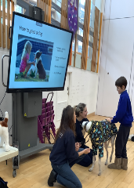
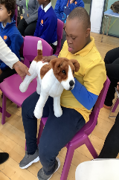

Unicorn Class
This week in Unicorn Class we have been writing up a method for an experiment, testing how gas can affect the movement of raisins in water. We included a prediction, a list of resources and our results. We have also been using IT to present ideas on our favourite stories.
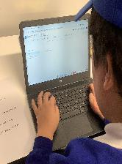
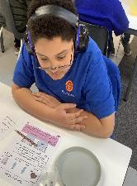

Ladybird Class
This week Ladybird Class have been using paintbrushes and different colours of paint to practise forming pre-writing shapes. As part of the Careers Week, Ladybirds have been learning about people who help us. They have also been dressing up as builders, doctors and firefighters.
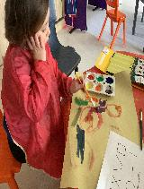
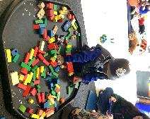

Don’t Forget
All our term dates are available on our website
https://www.thelivityschool.co.uk

Term Four Ends Friday 27th March at 1pm. Term Five Begins Monday 13th April.
Bank Holiday Monday 4th May – No school. Thursday 5th May – school closed to pupils as we are a Polling Station.
Term Five Ends Thursday 21st May.
Term Six Begins Monday 1st June.
Term Six Ends Friday 17th July.

Red Nose Day Friday 20th March
Please wear something red.
Family Group Makaton training
We are holding three Makaton workshops on 17th April, 1st May and 15th May at 9.30 until 11.30am. Spaces are limited so if you would like to attend, please contact Alberta or email admin@thelivity.lambeth.sch.uk
Parents and Carers’ Wellbeing Group
Mindfulness Colouring Thursday 19th March 9.30 until 10.30.

