
10th July 2026
Livity Life
The Livity School Weekly Newsletter
School News
Please remember to call the school office at 8.15am if your child is going to be absent.

Red Class
Red Class pupils have been enjoying their weekly cooking sessions, developing their communication, fine motor and independence skills. One pupil carefully scooped butter into the mixing bowl, demonstrating growing control and coordination, whilst another eagerly chose his preferred ingredient.
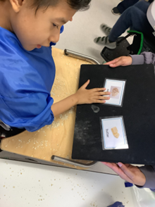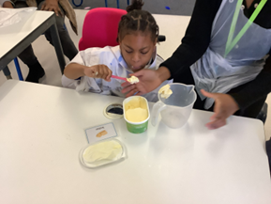

Yellow Class
We’ve had a brilliant week in Yellow Class. At the end of last week, we all celebrated International Day. Our pupils had a lovely time trying new food, dancing amongst the bubbles and parading with their flags. They looked wonderful in their traditional clothes. During this week we’ve made ice lollies in cooking which we enjoyed outside on our balcony.
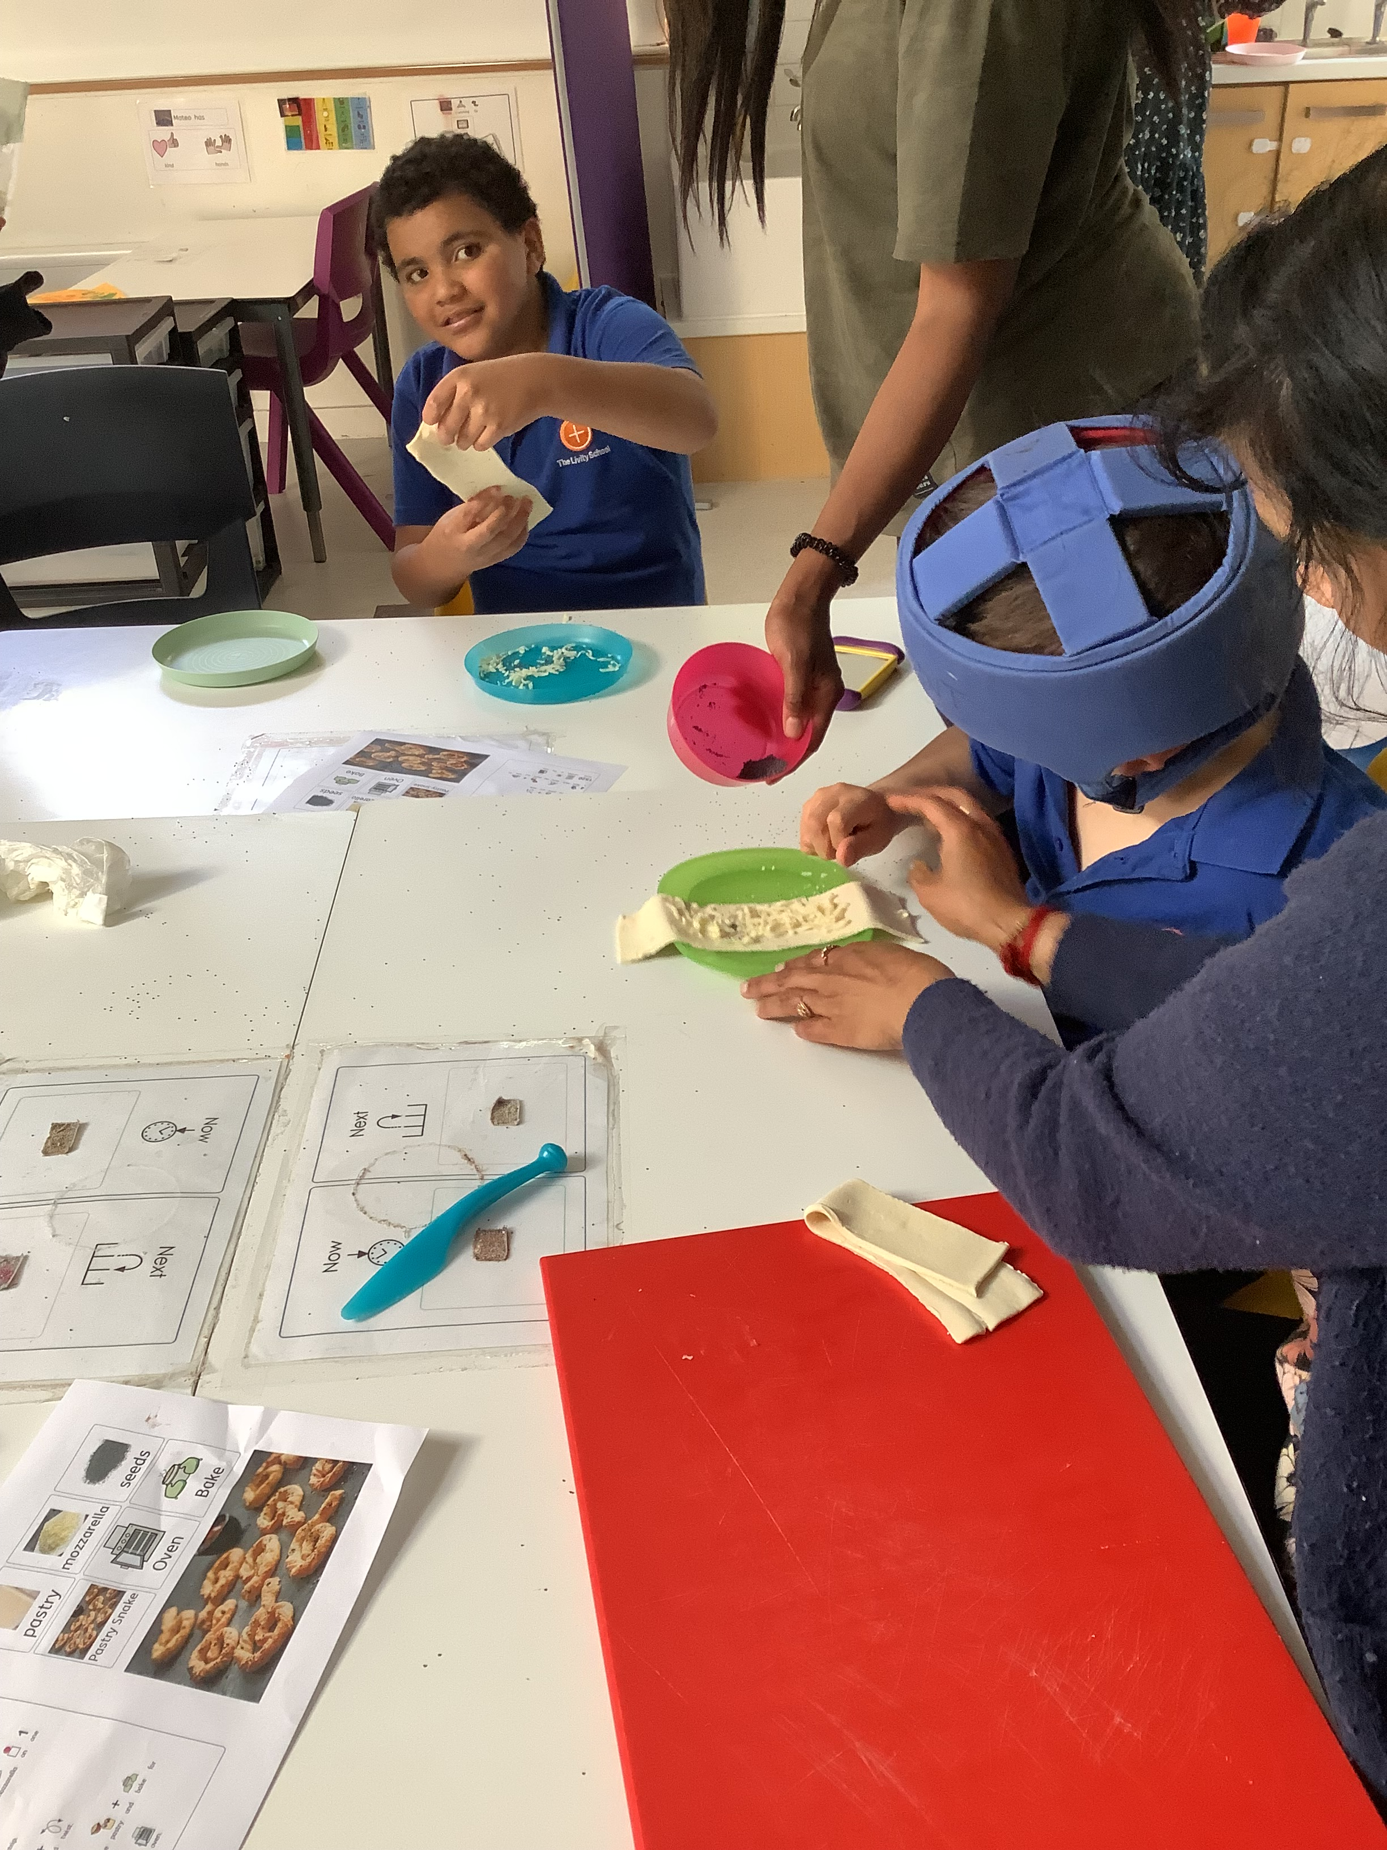
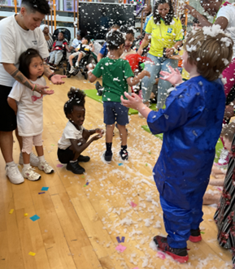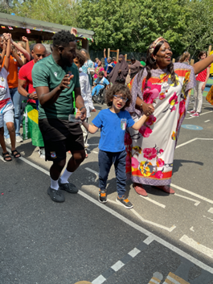

Dragonfly Class
This week, Dragonfly Class enjoyed their dough disco session. The children explored the dough and made different movements to the rhythm of familiar songs. They also enjoyed shared reading sessions during the week where they used their communication methods to make comments about the story and requests.
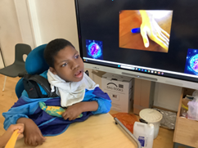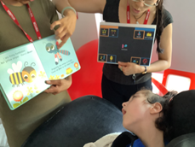

Pink Class
Last week in Pink Class, we enjoyed participating in International Day. We read books about other countries and liked creating our very own flags. The children enjoyed waving their flags during the parade in the morning and celebrating with families in the afternoon.
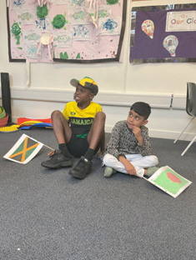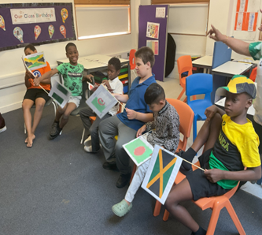

Blue Class
Last week, the children in Blue Class enjoyed celebrating International Day by creating their own flags. Each flag represented the child's home country, giving everyone the opportunity to share and celebrate their cultural heritage. The children proudly took part in a parade, showcasing their flags alongside the other classes. In class the children also learned about Africa, with a focus on Ghana. They enjoyed listening to a sensory story about Africa, exploring the different animals and cultures across the continent through an engaging, interactive experience. The children then made colourful bracelets inspired by Ghana and explored a tuff tray filled with African animals, encouraging imaginative play and discussions about the wildlife found in Africa.
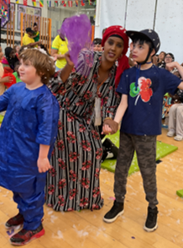

Orange Class
Orange Class really enjoyed International Day last Friday. We had a fantastic parade in the playground with our flags and then enjoyed all the wonderful events of the afternoon. We also enjoyed completing cooking activities.
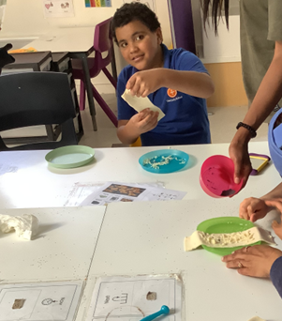

Bumblebee Class
This week Bumblebee Class explored lots of different Summer activities. We made delicious cakes to celebrate the end of the year and created a mini watermark in our EYFS playground! The pupils have used their fine motor skills to solve various puzzles, as well as taking part in counting games to practise applying their knowledge from the year. Bumblebee Class also had fun making ice cream art and choosing what their dream ice cream would look like.
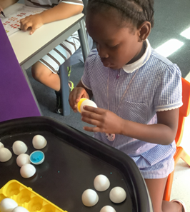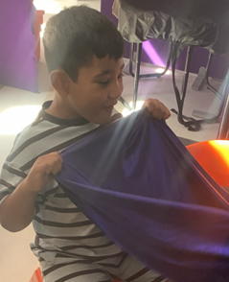

Gold Class
Last week, the pupils in Gold Class celebrated International Day. The pupils had a great time taking part in the parade and enjoyed waving the flags they created. After the parade, everybody enjoyed food and drinks from around the world.
The pupils in year 6 had their Graduation. They said goodbye to The Livity School and remembered all the hard work they have done.
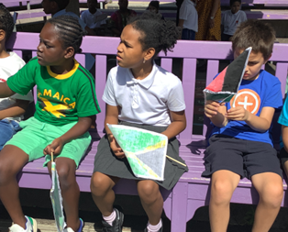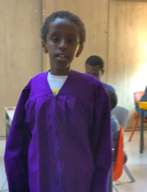

Green Class
This week Green Class had a fantastic time taking part in Sports Day! We enjoyed a variety of fun activities, including football, rolling the ball, bowling and hoop games. We also had a wonderful International Day. The children proudly took part in the flag parade, dancing around the playground with the beautiful flags they had created. In the afternoon, everyone enjoyed the exciting entertainment, including a magic show from Mr Ruffles and listening to the fantastic music from the Elm Court Band. It was a joyful day celebrating different cultures, with plenty of opportunities for shared experiences, music and fun.
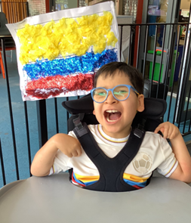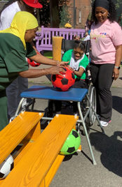

Rainbow Class
Rainbow Class enjoyed celebrating International Day. We loved making flags to represent our nationalities and we enjoyed talking about different places in the world and listened to music from them. We joined the parade in the morning and had fun dancing in our wonderful clothes and flags.
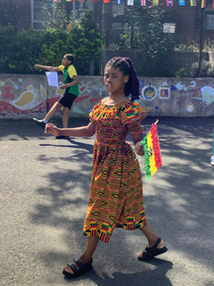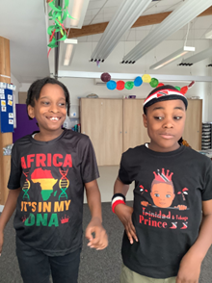

Purple Class
We have had a lovely week in Purple Class celebrating International Day and then we celebrated our friends in their year 6 Graduation ceremony. We are so proud of all they have achieved.
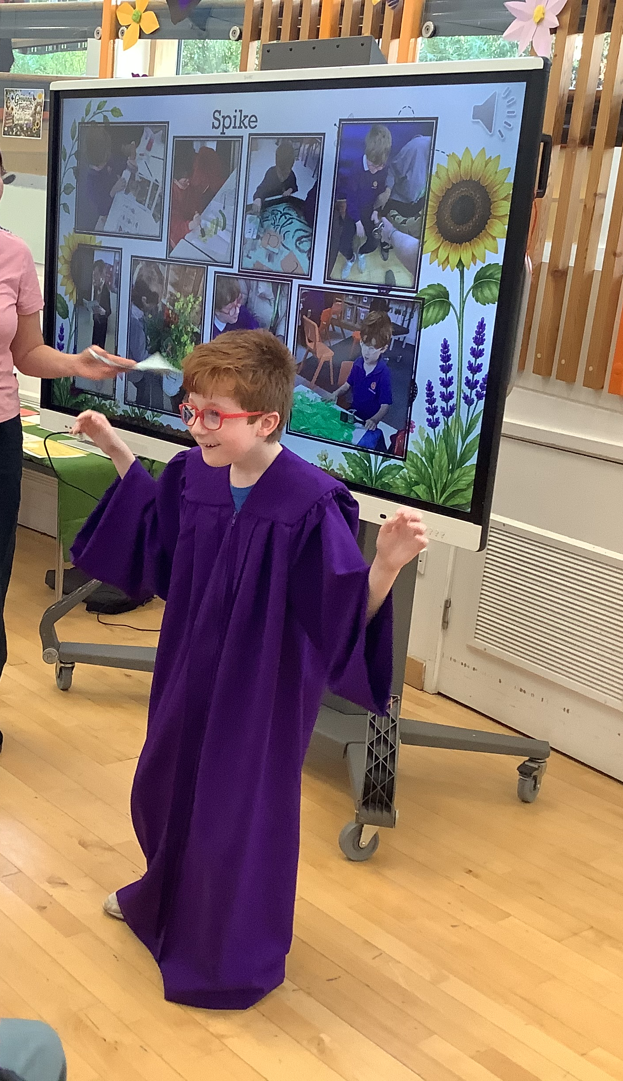
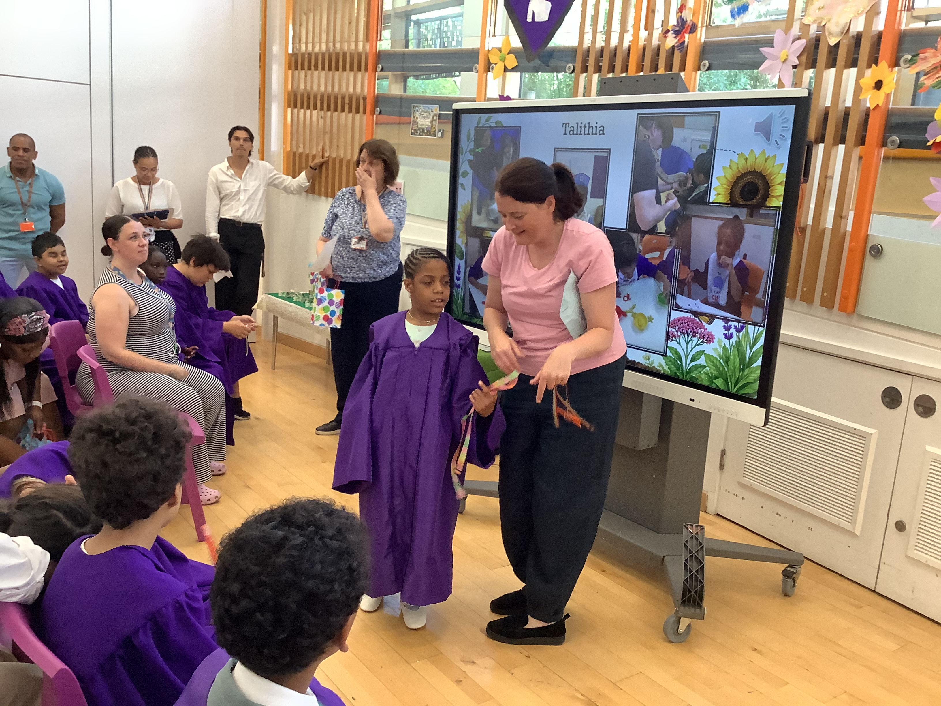

Butterfly Class
In Butterfly Class have been enjoying water play activities this week. We had a great parade in the playground in our traditional dress for International Day, waving our flags and dancing to the parading music! International Day was a day of fantastic fun watching Mr Ruffles and listening to the Elm Court band. We also liked being able to taste and explore lots of different food.
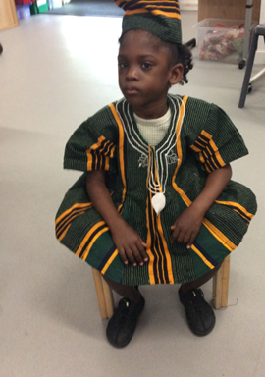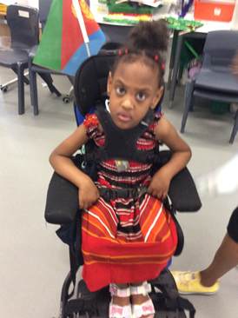

Silver Class
This week we have been celebrating a very special milestone as some of our Silver Class pupils reach the end of their primary school journey. It is a time to reflect with pride on all they have achieved and to look forward with excitement to the opportunities that await them in secondary school. To mark the occasion, the class enjoyed a special Graduation celebration filled with smiles, laughter and cherished memories. Pupils received certificates, shared reflections on their time in school and celebrated their many achievements together. We are incredibly proud of each and every one of them and wish them every success as they begin this exciting new chapter.
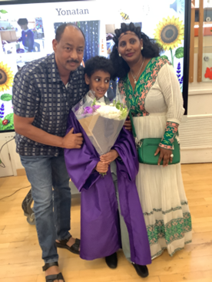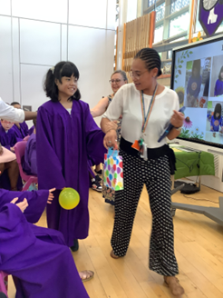

Unicorn Class
This week in Unicorn Class we have been celebrating the year 6 Graduation. The children have supported one another so nicely. In class we have been working on following multiple step instructions in Spanish. Combining a knowledge of Spanish numbers and colours to accurately draw South American flags.
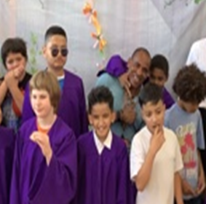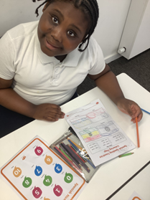

Ladybird Class
This week Ladybird Class have been engaging in water based activities related to their story ‘The Snail and the Whale’. The children have been exploring a sensory tuff tray created to represent an ocean and its waves. Ladybirds have also been demonstrating good attention and concentration whilst taking part in art activities. They have been developing their fine motor skills by spreading glue with a spatula to create different flavours of imaginary ice-cream.
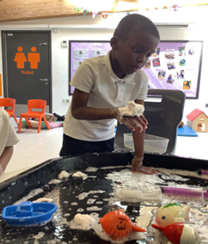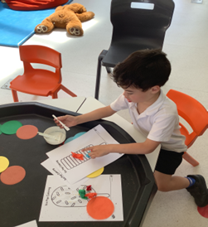

Don’t Forget
All our term dates are available on our website
https://www.thelivityschool.co.uk

Term Six Ends Friday 17th July at 1pm

School returns Thursday 3rd September for pupils

The postponed Sports Day will take place in September due to the contiuned hot weather.

