
24th April 2026
Livity Life
The Livity School Weekly Newsletter
School News
Please remember to call the school office at 8.15am if your child is going to be absent.

Red Class
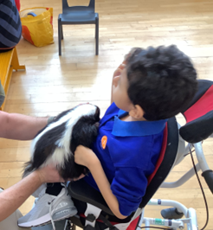
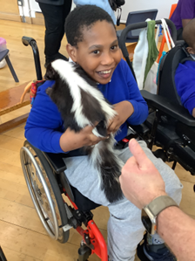
Red Class enjoyed a visit from Spirit of the Wild. The pupils interacted with a range of animals, including skunks, snakes and a husky, enriching their learning experience.

Yellow Class
We’ve had a busy week in Yellow Class. We’ve begun our new story ‘Who Rules the Rock Pool?’. In art we have started to make our own papier mâché rock pool, which we will be continually adding to through the next few weeks. We also had a visit from the team at the V&A Museum to teach us about Japan. We had a lovely time trying on kimonos as well as designing our own. Next week we will be visiting them and we can’t wait!
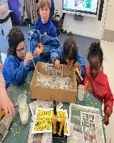
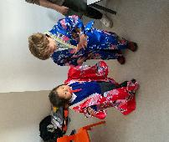

Dragonfly Class
This week, Dragonfly Class participated in activities related to Earth Day, where they cleaned a pretend ocean full of materials. The children picked up all the pieces and helped the fish swim in clean water. They also explored dry foods this week and had fun during the sensory cooking lesson, where they baked a Victoria sponge cake.
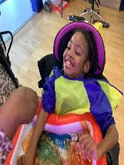
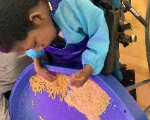

Pink Class
Pink Class really enjoyed a visit from Spirit of the Wild. The children got to meet a husky, skunk and snake. This week, we went on our class trip to the Brockwell Greenhouse. The children were able to explore the garden, plant seeds and smell different plants and flowers.
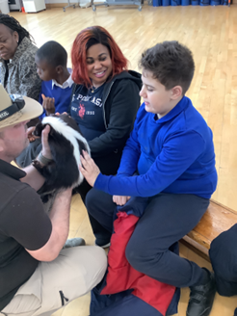
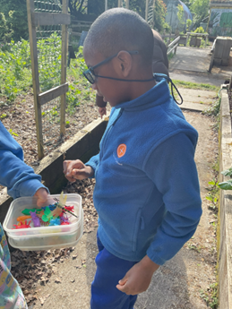

Blue Class
This week Blue Class have taken part in a sensory garden lesson, where they learned how to grow plants. The children were introduced to the basic needs of plants, such as sunlight and water. They also had the opportunity to plant their own seeds. In addition, Spirit of the Wild visited, giving the children the chance to learn about different animals. They were introduced to a snake and explored what its skin felt like, noticing its smooth, dry texture. The children were shown how to gently and safely stroke the snake, helping to build their confidence in a fun and engaging way.
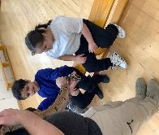
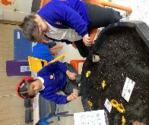

Orange Class
This week Orange Class made really good progress in their Movement Works session. They have been practising moving sideways, forwards and backwards along a line and this week they managed all three different movements in one session. Orange Class also loved completing their experiment this week. They learned about insulation through polar bears. The children used vegetable fat to recreate the blubber used by polar bears to keep warm in the arctic.
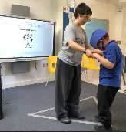
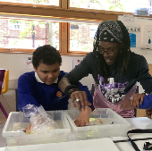

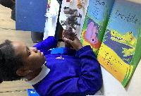

Bumblebee Class
This week Bumblebee Class have been getting familiar with their new book, ‘Walking Through the Jungle’. They have been learning about the habitats and animals of the book using their senses. They were introduced to lots of new vocabulary and have been practising their matching and tracing skills. In art, the pupils made their own colourful jungle snakes using various materials and used their fine motor skills when cutting the paper with scissors. Bumblebee Class also made a lemon drizzle cake in cooking and rainforest floor slime in experiments, carefully following the instructions.
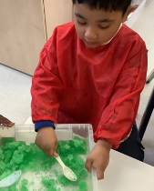
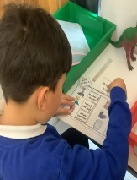

Gold Class
This week, the pupils in Gold Class enjoyed reading our story ‘Rumble in the Jungle’. The pupils read the story and recognized the animals. At story time, we acted out the different animals whilst making their sounds, hissing like a snake, stamping like an elephant and jumping like a gazelle. We had so much fun listening to the sounds in the jungle and matching the animals with the sounds.
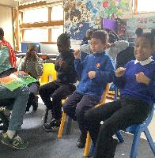

Green Class
Green Class had a wonderful experience with Spirit of the Wild. Everyone demonstrated great confidence when interacting with the animals and thoroughly enjoyed exploring their different textures. We also enjoyed our art session, where we used fruits, vegetables and flowers to produce some imaginative and colourful paintings.
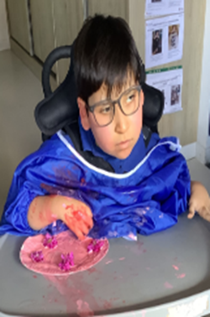
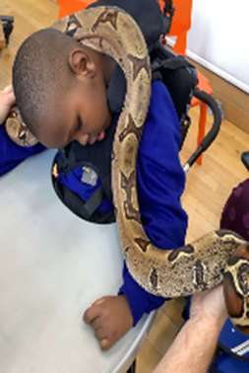

Rainbow Class
Rainbow Class have been enjoying different group building projects. In K'nex we have been working on different moving contraptions such as cars and buildings with moving parts. We have been focusing on resilience and group work skills, working as part of a team to create a final product.
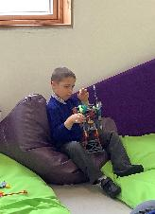

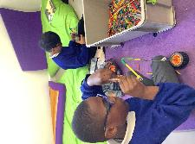
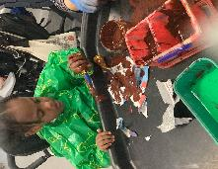

Purple Class
Purple Class have really enjoyed making slime this week. They melted starburst sweets in the microwave using a switch and then mixed in icing sugar to the cooled mix. It made a sweet-smelling slime that they then kneaded. Purple Class particularly enjoyed seeing how far they could stretch the slime.
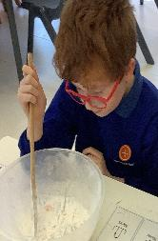
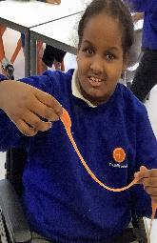

Butterfly Class
This week Butterfly Class have been making 3D mountains as part of the Habitats topic we are doing this term. The children explored the different materials and enjoyed the sensory experience, using their hands to hold, press, pat, push and stick to create the mountains.

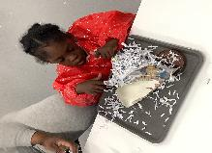

Silver Class
This week, the Silver Class pupils were introduced to their new topic, Habitats. The pupils explored different habitats through sensory and interactive experiences, including visuals, objects and discussion. Some pupils matched animals to habitats, whilst others engaged through textures, sounds and supported communication. These activities helped develop their communication, engagement and understanding of the world around them.
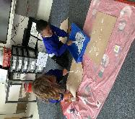
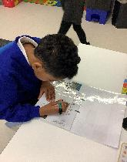
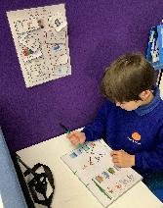

Unicorn Class
This week in Unicorn Class we have been working on writing full sentences using capital letters and correct punctuation. We have been trying to use a wider range of adjectives and improve our vocabulary. We have also been following a sequence of instructions to create different things in our K’nex sessions.
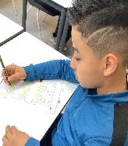
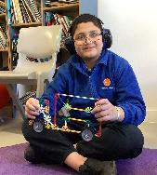

Ladybird Class
This week Ladybird Class have been working in pairs to create glitter stars using glue, spatulas and colourful glitter. The activity has been introduced as a part of Attention Bucket. Ladybirds have also been learning to name and recognise different sets of emotions. They have used a tuff spot full of sand to draw upset and angry faces.

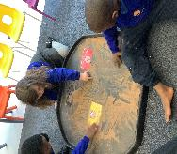

Don’t Forget
All our term dates are available on our website
https://www.thelivityschool.co.uk

Term Four Ends Friday 27th March at 1pm. Term Five Begins Monday 13th April.
Bank Holiday Monday 4th May – No school. Thursday 7th May – school closed to pupils as we are a Polling Station.
Term Five Ends Thursday 21st May.
Term Six Begins Monday 1st June.
Term Six Ends Friday 17th July.

Family Group Makaton training
We are holding three Makaton workshops on
1st May, 15th May and 12th June at 9.30 until 11.30am.
Spaces are limited so if you would like to attend, please contact Alberta or email admin@thelivity.lambeth.sch.uk

