
17th April 2026
Livity Life
The Livity School Weekly Newsletter
School News
Please remember to call the school office at 8.15am if your child is going to be absent.

Red Class
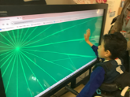
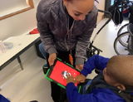
During our cause-and-effect lesson, the pupils explored and interacted with a variety of switches, demonstrating growing confidence and curiosity. The session placed a strong focus on developing hand–eye coordination, with pupils actively experimenting and responding to different stimuli. They showed great interest and engagement, making connections between their actions and the resulting sounds and visuals. This supported both their cognitive development and attention.

Yellow Class
We’ve had a great first week back in Yellow Class! We enjoyed a visit from Spirit of the Wild and had the chance to hold and stroke a snake, a tortoise, a skunk and a husky. We were all really calm and enjoyed the experience. In music we’ve been brushing up on our ukulele skills and have been making sounds reminiscent of the sea!
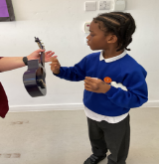
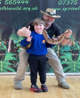

Dragonfly Class
This week, Dragonfly Class participated in the Spirit of the Wild session. The children had the opportunity to interact with animals such as a skunk, a husky and a snake. They also enjoyed their sensory writing session, where they explored different textures and communicated preferences.
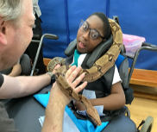
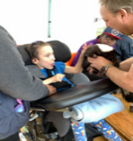

Pink Class
This week in Pink Class, the children enjoyed their dancing session with Movement Works. They have been working very well during these sessions and have started to learn a new song this week. The children used scarves to move to the music and ended the session by relaxing under the parachute.
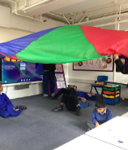
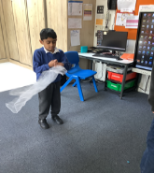

Blue Class
In Blue Class, we have settled back into our school routines very well. The children have been learning about shapes and enjoyed listening to the shape song. When the music stopped, they followed the instructions to stand, sit, or point to the shape that was called out, which they found great fun. They also took part in activities matching different shapes.
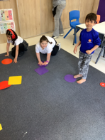
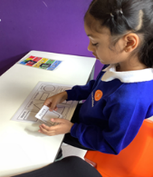

Orange Class
This week Orange Class really enjoyed interacting with different animals from the Spirit of the Wild’s visit to school. Our class got to meet a very soft chinchilla, a very smooth snake and some prickly tenrec all the way from Madagascar! We were very brave touching the animals gently and we showed good listening skills as we were shown how to properly stroke the animals.
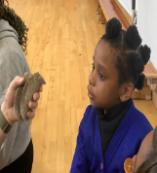
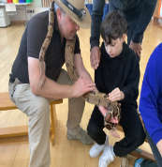

Bumblebee Class
This week Bumblebee Class have been settling back into the school routine by reflecting on their holiday break and what they got up to. They explored using the Zones of Regulation to communicate their feelings about their time off and how they feel being back at school.
Bumblebee Class have also begun to explore their new topic focus, ‘Habitats’ and created jungle leaves in art using various materials such as tissue paper, felt and their own handprints. They also looked at different types of animals that may be found within a jungle habitat and started creating their own animal puppets. In music the pupils had fun experimenting with microphones and instruments and learnt how to amplify the different sounds they were making.
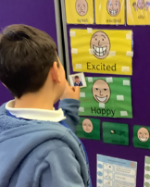
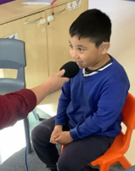

Gold Class
This week, the pupils in Gold Class enjoyed a visit from Spirit of the Wild to our school. The pupils had the chance to see and touch some animals from different habitats. They touched the soft fur of a chinchilla and the cold skin of a boa constrictor. The pupils also sequenced the steps of a magic milk experiment and saw how the fat in the milk breaks down and mixes with the food colouring when you dip a cotton bud with washing up liquid into the mix.
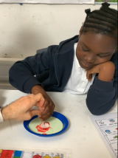
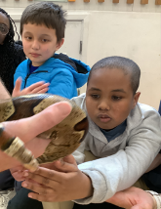

Green Class
This week, Green Class enjoyed exploring their new sensory story, ‘Big Brown Bear’s Adventure’. The pupils were particularly engaged when exploring the scent and texture of blossom. We also had great fun creating our own lava lamps. The pupils independently selected their preferred colours, with some choosing to enhance their lava lamps by adding glitter. They especially enjoyed shaking the bottles and observing the movement of bubbles, colours and glitter.
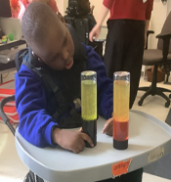
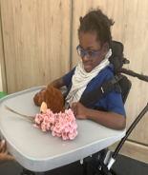

Rainbow Class
Rainbow Class have enjoyed exploring the different themes of Spring and in art we created bunny bonnets, using water colours to blend and sponge different colours together. We proudly wore our wonderful bonnet creations for the rest of the day. Next, we will begin to explore different weathers through art.
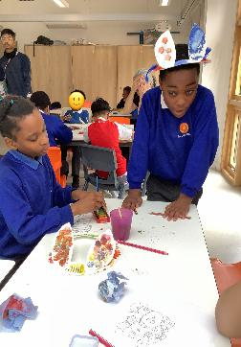
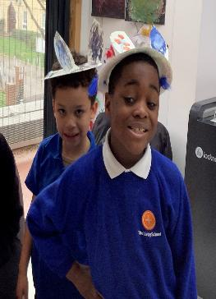

Purple Class
Purple Class really enjoyed the visit from Spirit of the Wild this week. We met lots of different animals, but the snake and husky were our favourites. We have also started our new story about a trip to the circus, it was great fun role-playing being clowns.

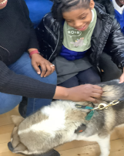
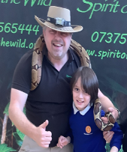

Butterfly Class
Butterfly Class have been keen to show off their singing skills! In our music session this week we have been vocalising brilliantly and impressed all the teachers with the use of our voices. We have started to explore our new topic of ‘Habitats’. As we have been learning about mountains, we have created large mountains for our display and story props. We aslo attended a Spirit of the Wild session and engaged with a number of different animals including a snake and a tortoise.
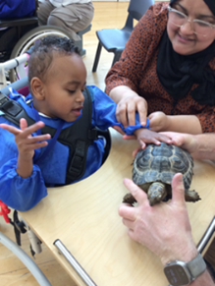
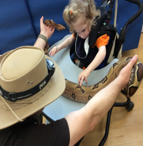

Silver Class
The children have settled back into the school routines well. Familiar routines help them feel safe, settled, and ready to learn. Clear routines support the children by reducing anxiety, improving focus and encouraging their independence. The children also worked hard on their individual targets, showing great effort and focus on their personal goals. We are very proud of how well they settled back into learning.

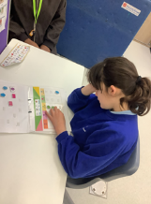
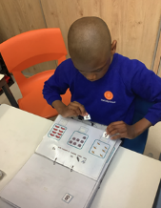

Unicorn Class
This week in Unicorn Class we have settled back really well and have been working very hard. We have been using Google maps to find a location and plan our route. In maths we have been working on doubling and halving, we have been sorting into odd and even and using repeated addition to solve multiplication problems.
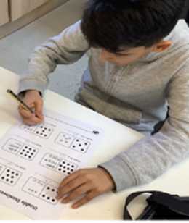
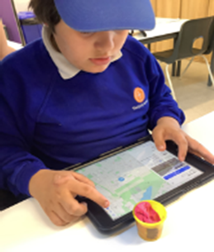

Ladybird Class
On the first week back to school, Ladybirds have been exploring the texture of cooked chickpeas and lentils. They have been using bowls and spoons to do filling, emptying and mixing. The children have also taken part in a Spirit of the Wild session where they have been stroking different types of wild animals and insects, e.g. a snake, a husky and a centipede.

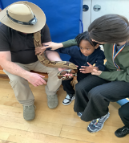
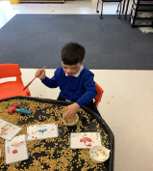

Don’t Forget
All our term dates are available on our website
https://www.thelivityschool.co.uk
admin@thelivity.lambeth.sch.uk

Bank Holiday Monday 4th May – No school.
Thursday 7th May – school closed to pupils as we are a Polling Station.
Term Five Ends Thursday 21st May.
Term Six Begins Monday 1st June.
Term Six Ends Friday 17th July.

