
26th June 2026
Livity Life
The Livity School Weekly Newsletter
School News
Please remember to call the school office at 8.15am if your child is going to be absent.
The year 6 pupils had a fantastic sleepover in school last Friday.

Red Class
This week, Red Class have been enjoying listening to ‘The Three Little Pigs’. The pupils have shown great enthusiasm when engaged in the story. They eagerly turned the pages and interacted positively with their peers during the shared reading. The pupils explored and selected a range of materials from the story, including bricks, clay, straw and sticks.
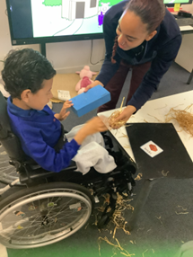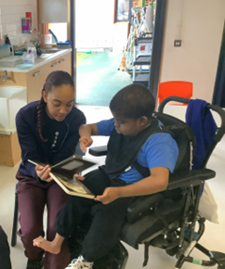

Yellow Class
We’ve had a great time in Yellow Class this week. In cooking we made a version of a Pina Colada. We blended pineapple and coconut milk with a squeeze of lime and poured it over ice to drink. It was the perfect remedy for the hot weather. On our trip to Brockwell Greenhouses last week we investigated minibeast habitats and looked at the type of tracks they leave. We then had a go at leaving our own tracks by stepping in water and walking along the path.
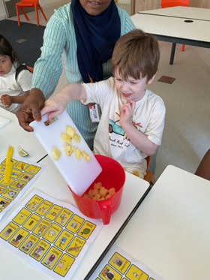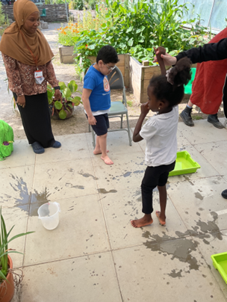

Dragonfly Class
This week, Dragonfly Class recreated the seaside and explored sensory resources related to it. The pupils particularly enjoyed the sand and water on their feet, as well as activities involving ice cream and frozen fruit. They also shared ‘A Day at the Seaside’ sensory book and used AAC communication devices to request turns and make comments during the reading.
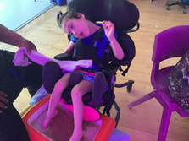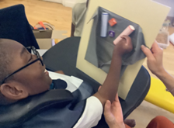

Pink Class
We have had another wonderfully busy week in Pink Class. This week the children tried a new recipe during their cooking lesson. We made ants on a log, which consisted of celery, cream cheese and raisins. The children really enjoyed spreading the cream cheese through the celery.
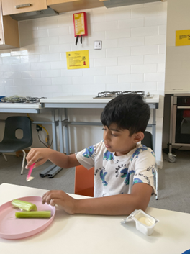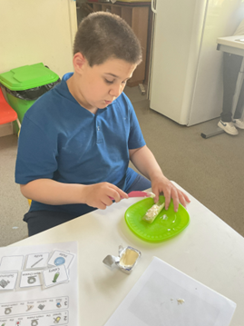

Blue Class
Last week in Blue Class, some of the children went to Hillside Gardens and had a lovely time playing outdoors. They enjoyed climbing on the equipment and exploring different areas of the park. The children were excited to be outside and showed interest in what they could see and do around them. They had fun trying new things and developing their physical skills through active play. The pupils liked activating toys using switches this week as part of our cause and affect work.
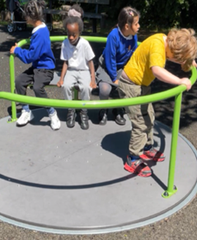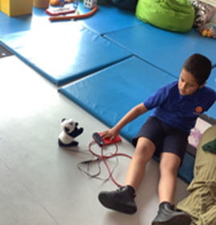

Orange Class
This week we really enjoyed creating art work using different tools. We used paint, rollers, brushes and templates made from bubble wrap to create sea creatures. We liked choosing the paint colours and creating different patterns.
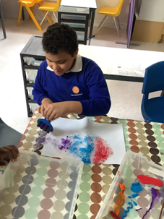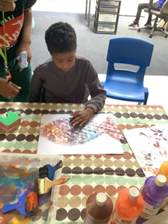

Bumblebee Class
This week Bumblebee Class carried on exploring some of the characters from the story 'Snail and the Whale'. The pupils were introduced to describing words and given different representational items of the Snail and the Whale characters. Some pupils had communication boards, whilst others used their Colourful Semantics learning to choose adjectives to describe the characters. The pupils have carried on exploring ocean themed activities, such as making ocean sensory bottles to support with regulation sessions. They also made under the sea bagels, using food colouring to dye the cream cheese blue before spreading it on. They then decorated their blue bagels with goldfish crackers to create an ocean scene.
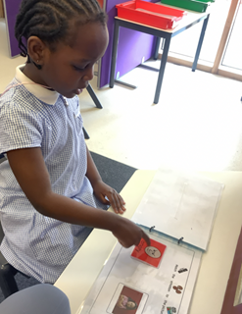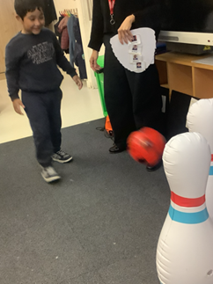

Gold Class
This week, the pupils in Gold Class used their phonics knowledge to write the names of the sea creatures from our story, ‘Commotion in the Ocean’. During our cooking lessons, the pupils are becoming more independent in following the steps to complete a recipe. They made an edible aquarium with crumbled cookies, soft cheese, vegan jelly and whipped cream. The pupils also chose a gummy sea creature to add to their aquarium.
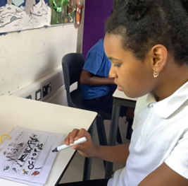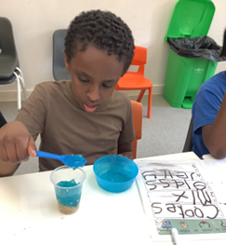

Green Class
This week, Green Class have been busy creating our flags for International Day. The pupils explored a variety of creative and sensory materials to represent the colours of their flags. We also enjoyed exploring the colour purple during our Fun with Food session. Pupils investigated a range of purple foods, including blackberries, purple spaghetti, red onions and blueberries. We explored the different textures, and flavours, showing great curiosity and engagement throughout the session.
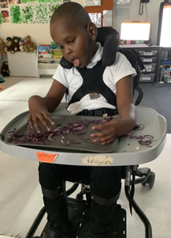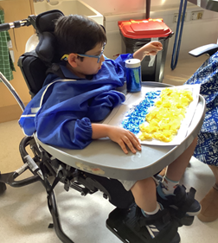

Rainbow Class
This week, we have been focusing on calming activities to help us stay regulated in the hot weather. We’ve done lots of activities based of different Zones of Regulation, such as collage, water colour painting and making cooking snacks such as fruit salads and ice lollies.
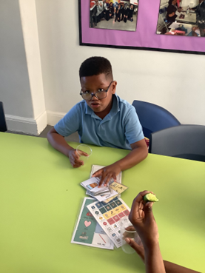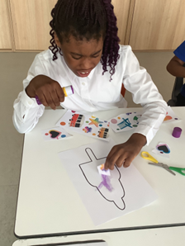

Purple Class
Some of Purple Class really enjoyed taking part in the year 6 sleepover. They particularly enjoyed playing with the giant bubbles, dancing at the disco and playing games with their friends.
We have also been practising for Sports Day and are getting very good at the relay races.
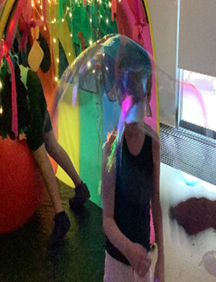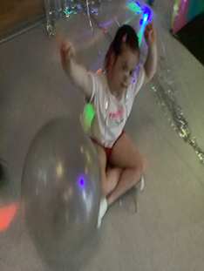

Butterfly Class
This week in Butterfly Class, the children have been exploring our ocean focus as part of our Habitat topic. They have thoroughly enjoyed engaging in the activities. The children showed great enthusiasm as they explored, played, and shared ideas, making this a very cool and memorable week for everyone!
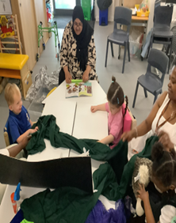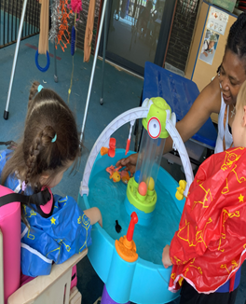

Silver Class
This week the Silver Class pupils enjoyed outdoor water play activities as the weather was very hot. The pupils thoroughly enjoyed taking part in a variety of fun and engaging water-based activities, which helped them stay cool whilst learning through play. The water play promoted social interaction as the pupils worked together, shared resources and took turns. In addition, the activities provided sensory experiences that helped develop curiosity, exploration and communication skills. It was wonderful to see the pupils smiling, engaging with their peers and making the most of the warm weather whilst learning in a fun way.
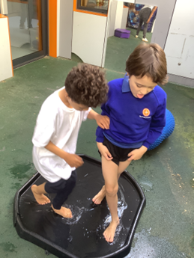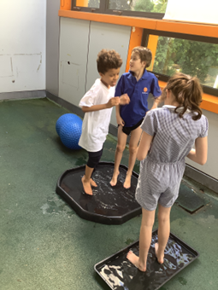

Unicorn Class
This week in Unicorn Class we have been working in small groups playing turn taking memory games. We have been using full sentences to say whose turn it is next. We have also been writing full sentences using adjectives to add description and extend our writing. We have been making sure our handwriting is clear, using capital letters and full stops.
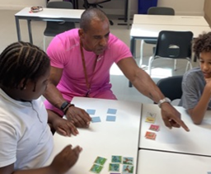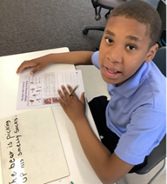

Ladybird Class
This week some children from Ladybird Class have focused on writing CVC words from Sounds Write phonics such as pot, mat and sit. The children have been practising this skill during their phonics session. Ladybirds have been developing their fine motor skills while threading shapes during the structured afternoon free flow session.
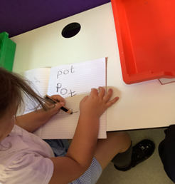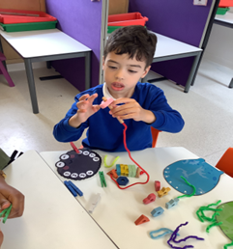

Don’t Forget
All our term dates are available on our website
https://www.thelivityschool.co.uk

Term Six Ends Friday 17th July at 1pm

School returns Thursday 3rd September for pupils
International Day 12.30 until 2.30 Friday 3rd July

Parents Evening for nursery to year 5 parents as this is an opportunity to meet your child’s teacher for next year. After school on Tuesday 7th July, more details to follow.

Graduation Ceremony for year 6 pupils
Wednesday 8th July at 9am

Sports Day
Wednesday 1st July
9.30 – 10.30 Red, Green, Dragonflies and Butterflies
11.00 – 12.00 Ladybirds and Bumblebees
1.15 to 2.15 Purple and Yellow

