

19th December 2025
Livity Life
The Livity School Weekly Newsletter

School News
School returns Monday 5th January.
Please remember to call the school office at 8.15am if your child is going to be absent.

Red Class
The pupils had an amazing time at our Disco Wonderland show! One child made a grand entrance into the hall using his walker, whilst another happily waved to friends and parents. The hall was filled with smiles, dancing and festive cheer as all the pupils joined in, enjoying every moment of the show. It was a truly fun-filled magical celebration!
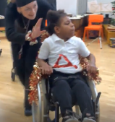
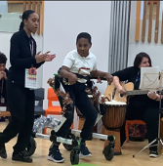

Yellow Class
What a week we’ve had in Yellow Class! We had a brilliant time performing our routine for everyone in our Disco Wonderland show. In class we’ve been making decorations, partying hard at our end of term class party and welcoming Red Class and Green Class into our room to enjoy Christmas lunch together!
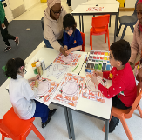
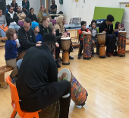

Dragonfly Class
This week, the Dragonfly children performed their physio programs adapted to the theme of Christmas. We reached and shared objects whilst doing movement activities on the mats. They also chose and explored their preferred Christmas smells and textures. All the children were great in the Disco Wonderland show and shared games and music in the afternoon.

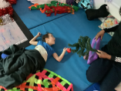

Pink Class
This week Pink Class enjoyed their Movement Works session. They really enjoyed the cool down section, with the adults wafting the parachute over them. Pink Class enjoyed wearing Christmas jumpers on Christmas jumper day.
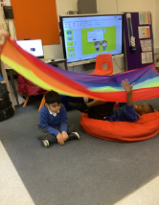
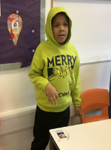

Blue Class
This week Blue Class have really enjoyed preparing for their Disco Wonderland performance. The pupils tried on different costumes and practised their routine with enthusiasm. They took part in playing the drums and dancing, showing great focus and effort. The children did an excellent job performing for parents and carers. It was lovely to see their confidence grow as they shared their routine.
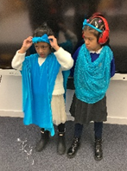
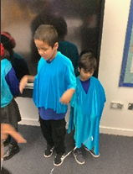

Orange Class
This week Orange Class enjoyed dancing in the school performance! The theme for Orange Class was the candy cane club and we loved making the candy canes for our routine. We practised our dancing in the classroom before the show and we really loved our song, ‘I Will Survive’ by Gloria Gaynor. Some of us felt a bit shy on the day but we were very happy to see some family members enjoying our performance.
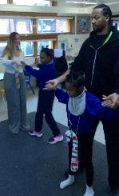
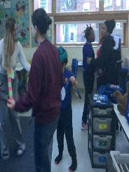

Bumblebee Class
This week Bumblebee Class have worked hard on their maths learning, using their senses to explore 2D shapes. They took turns handling different real-world objects and then practised sorting the items into the right shape category. Bumblebee Class have also enjoyed learning about the Zones of Regulation this week, going through each zone and noticing the different emotions. They have also had lots of fun taking part in the Disco Wonderland show and end of term festivities!
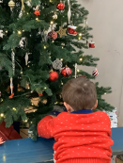
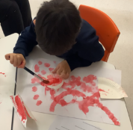

Gold Class
This week, the pupils in Gold Class worked on sequencing the steps to complete activities. The pupils used visuals to stay on task and identify the steps of the activity. During our cooking lesson, the pupils followed the recipe to make a chocolate stirrer and decorated them with festive sprinkles. The pupils enjoyed them in our class party in the afternoon.
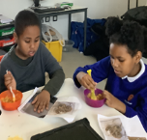
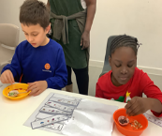

Green Class
This week, Green Class enjoyed performing in the school show! The children have all been practising hard for the performance and were amazing! The children loved sharing their Christmas lunch with their friends.
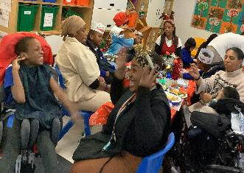

Rainbow Class
This week we had fun performing in the Disco Wonderland show. We have practised lots in the last couple of weeks and felt so proud afterwards! We have also enjoyed preparing for our Christmas lunch by making lots of decorations and working as a team to create a centre-piece for our table.
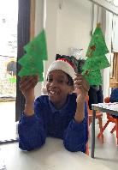

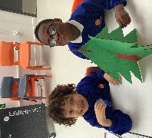

Purple Class
The Purple Class pupils have had a great week practising for their performance. We all loved sharing in the amazing event together with our friends. We had a great time at the Christmas lunch, laughing and enjoying the Christmas food!

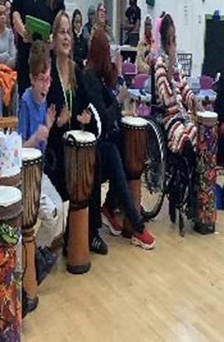
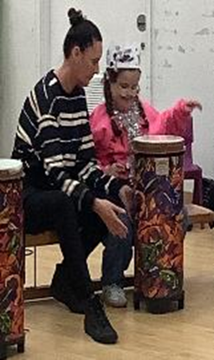

Butterfly Class
In the last week of term, we have had some memorable moments with a successful Disco Wonderland show. Butterfly Class had fun as the jingle bells jingled their way across the stage! We have had a lovely Christmas lunch, a fun Christmas party with friends and an enjoyable festive Whippersnappers session.
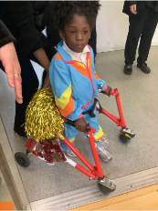
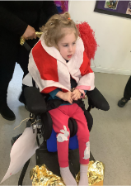

Silver Class
This week, the Silver Class children took part in the whole-school Christmas lunch. The children were supported to make choices about their meals, communicate their preferences and try new foods at their own pace. We would like to wish all our children and families a lovely break and a happy New Year. We look forward to welcoming the children back to school in 2026.

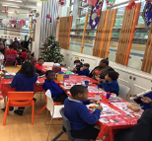
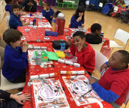

Unicorn Class
This week Unicorn Class have been enjoying all the festivities. We have been rehearsing and performing in the Disco Wonderland show, perfecting our moves. We have also enjoyed a wonderful Christmas lunch. We have been writing letters to Santa, listing three kind things that we have done and what we would like to get as a gift for a friend.
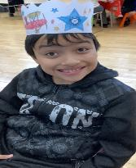
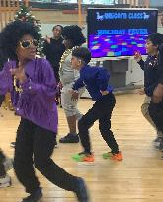

Ladybird Class
This week Ladybird Class have been engaging in Christmas learning activities. They have enjoyed making a little Santa by painting paper plates and sticking their own faces onto them. Ladybirds have also celebrated Christmas Jumper Day and participated in the Disco Wonderland show organised by the school.
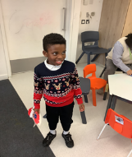
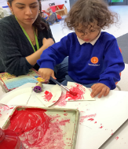

Don’t Forget
All our term dates are available on our website
https://www.thelivityschool.co.uk

School returns Monday 5th January.


