
Date 9th January 2026
Livity Life
The Livity School Weekly Newsletter

School News

Please remember to call the school office at 8.15am if your child is going to be absent.

Red Class
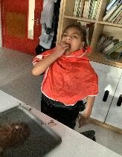
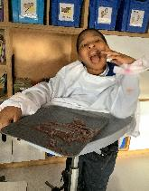
This week, Red Class have settled back into school beautifully. They especially enjoyed our sensory story ‘We’re Going on a Bear Hunt’, where they eagerly squeezed, rubbed and tasted the chocolate mousse, exploring the story through touch and taste. It was lovely to see their confidence, curiosity and enthusiasm as they joined in so happily.

Yellow Class
In Yellow Class we’ve settled back into our school routine really well. The children have been making each other laugh by dressing up in different costumes. In P.E. we’ve begun our topic of team sports and this week we played football!

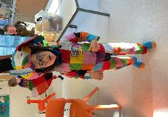
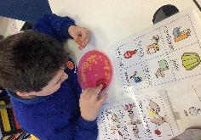
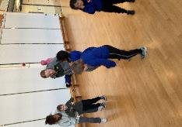

Dragonfly Class
This week, the Dragonfly children learned about Winter and played with real snow. They also participated in messy play activities, making playdough with different colours and scents. They enjoyed their first music lesson and ‘Little Red Riding Hood’ sensory massage story.
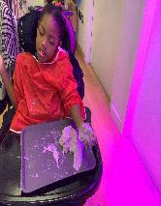
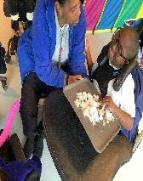

Pink Class
The children have been very happy to be back at school after the holidays. This week Pink Class enjoyed their Fun with Food session. The children enjoyed tasting different kinds of food and learning about new flavours. They explored different foods by tasting, touching and smelling them.

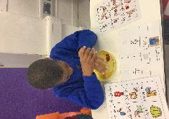

Blue Class
This week in Blue Class, the children sat together in small groups to create a bear inspired by the story ‘Goldilocks and the Three Bears’. They used a visual guide to help them identify where to place the nose, ears, feet, and mouth. This supported their ability to follow instructions, whilst developing their fine motor skills and creativity.
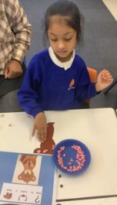
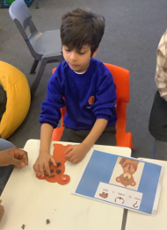

Orange Class
In Orange Class this week we really enjoyed experimenting with food colouring. We chose different colours to put into cups and then connected the cups with paper. It was really interesting to watch the colours spread and move up the white tissue. We have also been enjoying team games in P.E.
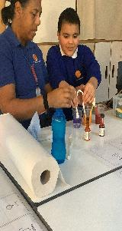
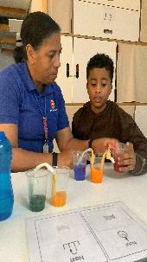

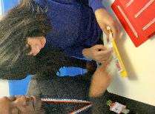

Bumblebee Class
This week, Bumblebee Class have been settling back into their school routines after a lovely holiday break. They have started to explore the story of ‘The Three Little Pigs’ in literacy using their senses and getting familiar with the key vocabulary. They have been looking at different types of materials in their lessons, exploring what the pigs used to create their houses. Furthermore, in their phonics learning the children been working hard on their individual targets, recognising sounds or building CVC words.
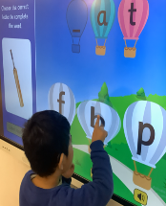
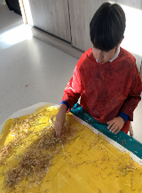

Gold Class
In this first week back to school, the pupils in Gold Class worked on making requests using their preferred communication system. The pupils selected their communication partner to direct their requests to and made more complex sentences. Gold Class is reading ‘Goldilocks and the Three Bears’. The pupils sequenced the story and answered comprenhension questions about it using visuals to prompt their voice.
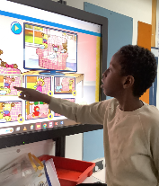

Green Class
This week in Green Class, the children had lots of fun developing their turn-taking skills whilst playing a dice game with a peer. They practised waiting, sharing and taking turns. They also enjoyed learning about cause and effect. They made things happen by using the interactive whiteboard and iPads. The children pressed buttons, touched the screen and watched what happened next.
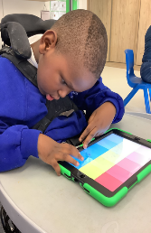
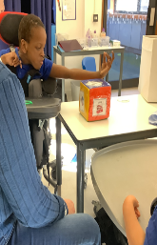

Rainbow Class
This week in Rainbow Class, we have enjoyed settling back into learning with lots of fun activities. We read the story of ‘Elmer’ and made artwork around belonging. We also enjoyed our K'Nex workshop led by the Elm Court pupils. Each week we have been adding to our K'Nex creations and we have even started to add motors into some of our inventions.
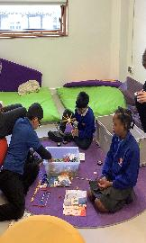
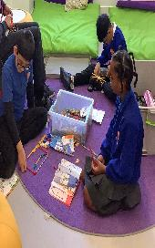

Purple Class
The Purple Class pupils have been happily settling back into their school routines and meeting up with their class friends. Their favourite activity is cooking and they particularly liked making gingerbread. They had fun creating different shapes with it.
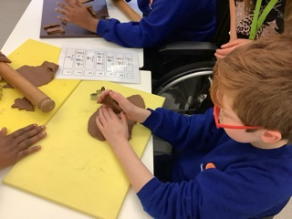

Butterfly Class
Butterfly Class have happily returned and they are excited to learn. They have enjoyed the introduction to our new topic of ‘Favourite Stories’. They have been engaging with the props and songs for ‘Goldilocks and the Three Bears’. The shared reading session this week was great, with lots of focus as the children shared various books.
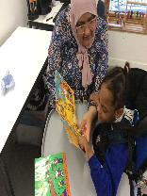
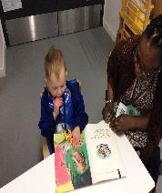

Silver Class
This week, Silver Class enjoyed settling back into school after the break. The children took part in reading activities to introduce our new topic, ‘My Favourite Stories’. Each child was encouraged to choose a book that interested them, helping to support engagement and independence. The children explored stories through shared reading and comprehension activities, developing their understanding in ways that suited their individual needs.
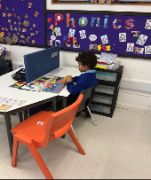
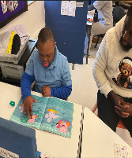

Unicorn Class
This week in Unicorn Class we have been using our knowledge of fractions and applying it to solve real world problems. We have been sharing amounts equally into halves and quarters. We have also been using comparative language around sizes and ordering objects based on size.
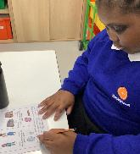
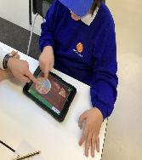

Ladybird Class
After the Christmas break, Ladybird Class have enjoyed being back at school. Some of the children have been practising their hand and eye coordination by spreading butter and jam on to toast during breakfast club. Ladybirds have also enjoyed exploring and experimenting with different food textures during their Fun with Food session.

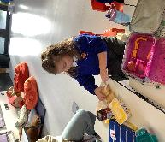
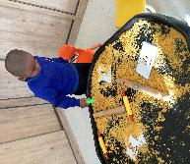

Don’t Forget
All our term dates are available on our website
https://www.thelivityschool.co.uk

Term Three Ends: Friday 13th February

