
Date: 28th November 2025 2025
Livity Life
The Livity School Weekly Newsletter

School News

Please join us for our Winter Production on Tuesday the 16th December at 9.30.

Please remember to call the school office at 8.15am if your child is going to be absent.

Red Class
Red Class have been busy exploring a variety of textures during our cooking activities this week. We investigated hard and dry ingredients, such as using oats and Weetabix. The children showed wonderful engagement as they explored and compared how each ingredient felt. We also focused on using switches to give pupils the opportunity to practise cause-and-effect skills. It was fantastic to see how attentive and involved the children were throughout the session!
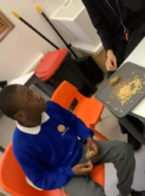
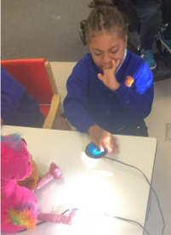

Yellow Class
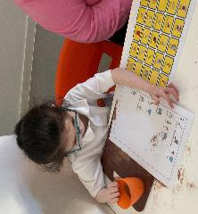
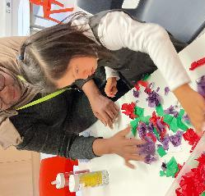
In Yellow Class we made some lovely hot chocolate during cooking. The children communicated for their choice of sprinkles, whipped cream and other yummy ingredients. We made Christmas decorations in art.

Dragonfly Class
The children have enjoyed their art session this week. They chose the resources they wanted to use, picked them up and stuck them. This activity supported their hand-eye coordination and fine motor skills development. The children also participated in active movement activities on the mats with Christmas props and had fun baking cinnamon bread in the sensory cooking lesson.
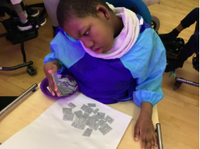

Pink Class
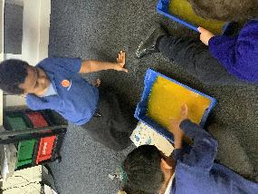
This has been a great week for Pink Class. The children were especially engaged in their dance class. We have also enjoyed experimenting with mixing colours and bubbles.
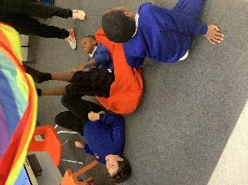

Blue Class
During our My Thinking lesson, the children practised number recognition by rolling dice and finding the matching number. They then used a sand filled glove to explore the numbers they rolled by pressing, squeezing and tracing the shape of each number to help reinforce their understanding through sensory learning. The children also did very well ordering numbers with a range of puzzles, threading and blocks. It was a lot of fun!

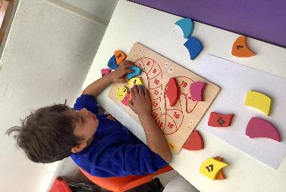
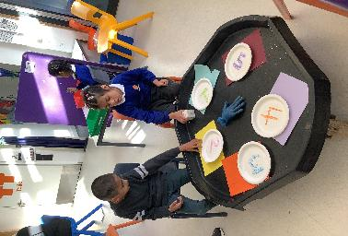

Orange Class
This week Orange Class have been very focused using paint, glitter and stamping paint pens to create disco balls, microphones, boots and musical notes. These will be combined to create a disco themed Christmas mobile. Orange Class have also worked hard planting herbs in the sensory garden. So far, we have planted basil, mint, rosemary and parsley.
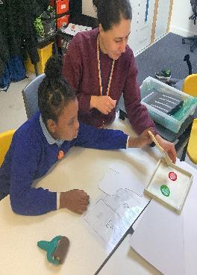

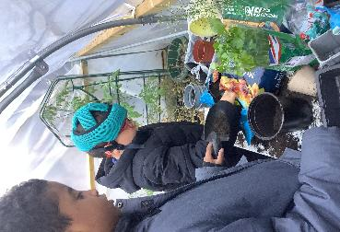

Bumblebee Class
This week Bumblebee Class explored making fizzy pretend planets in our Understanding the World lesson, using our tripod grip to squirt vinegar. We created our own Bumblebees by requesting and choosing various materials.
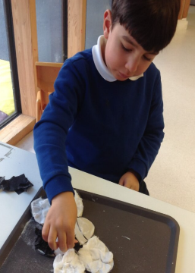
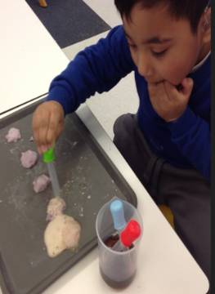

Gold Class
Gold Class practised handwriting in different media this week. The pupils engaged with tracing activities and used their preferred communication system to make requests and match the sound to the letter. The pupils worked on problem solving games during My Thinking lessons, staying on tasks and developing their resilience and ability to complete activities for longer.

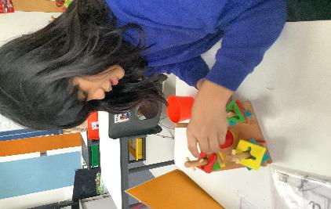
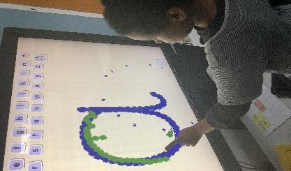

Green Class
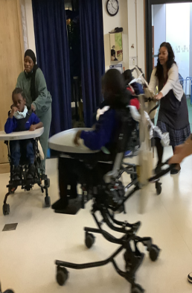
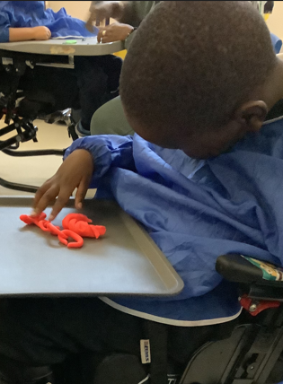
This week in Green Class we have been working hard on our fine motor skills by taking part in some super fun Disco Dough! The children loved squishing, rolling and shaping the dough with their hands while moving to the music. We also had a wonderful visit from the VI team. Together, we explored the weather song, and our favourite part was pretending it was icy. We had fun pretending to slip and slide!

Rainbow Class
This week in Rainbow Class we have been working on different skills in cooking. To start with we focused on peeling and chopping skills to make healthy snacks and dips. We then made gingerbread men. We followed multi-step instructions and shared our festive biscuits with our friends.

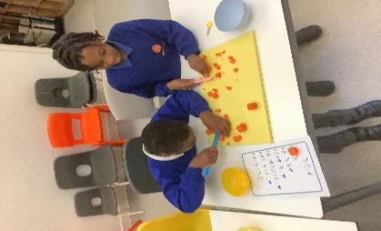
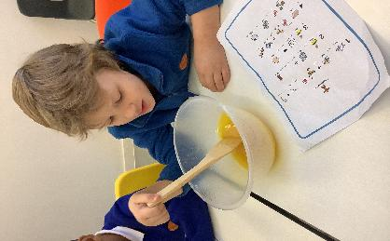

Purple Class
Purple Class have had a wonderful time this week. We have especially enjoyed the movement session with the dancers from the Movement Works. The children learnt to copy and extend their movement as they responded to music and they learnt sharing and turn taking skills too.
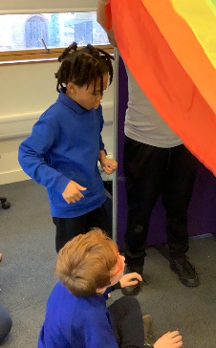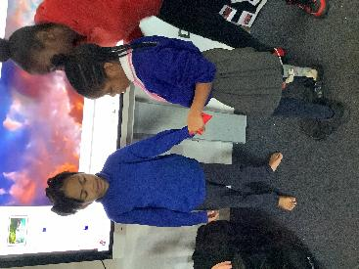
Butterfly Class
This week in Butterfly Class some of the children have engaged with cause-and-effect resources by exploring the functions of a variety of toys and other objects.
There has been brilliant interaction and engagement during music, exploring the guitar and playing the drums.

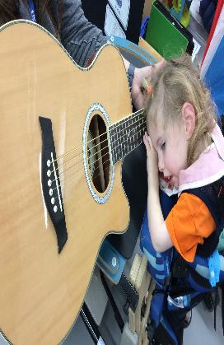
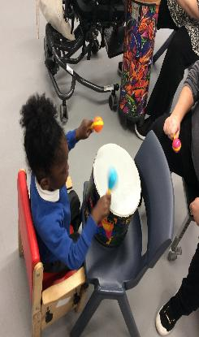

Silver Class
This week Silver Class enjoyed their Fun with Food session supported by the Speech Therapists and Occupational Therapist. Pupils were enthusiastic and used their communication systems to request and comment. The session helped them build positive relationships with food and reduce any anxieties about trying new foods. Pupils explored different textures by mixing, smelling, tasting, and cutting a variety of foods. Many showed great progress in tolerating food on their hands. These activities supported key learning areas such as sensory exploration, communication, and fine motor skills through actions like cutting, squashing, pouring, and mixing.
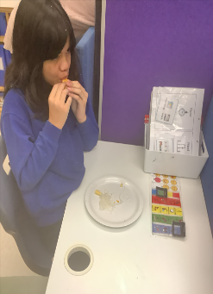
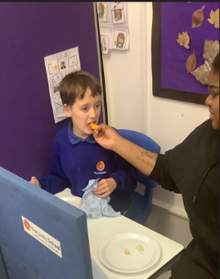

Unicorn Class
This week in Unicorn Class we have continued learning about forces. This week we have looked at buoyancy by making paper boats, trialling different shapes and testing how they float. In Numeracy, we have been working on 2 and 3 digit additions with some children moving on to exchanges while using the column method.
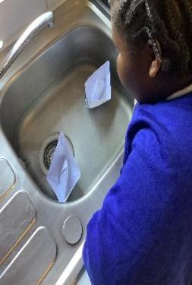
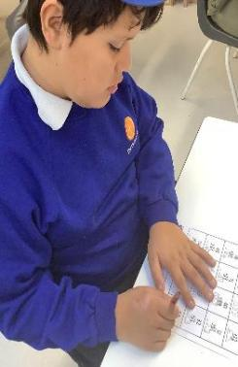

Ladybird Class
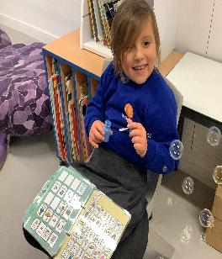
This week Ladybird Class sent two representatives to the school council meeting. The children made great choices about how they want to celebrate kindness in school. They used their communication boards and voices to express their choices. Ladybird Class have also worked with their keyworkers to learn to blow into a plastic bottle to create a Bubble Snake during the Attention Autism session.
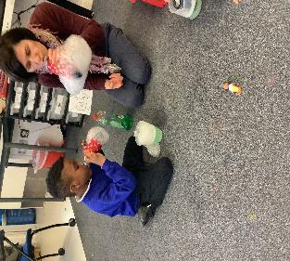

Don’t Forget
All our term dates are available on our website
https://www.thelivityschool.co.uk

Parent and Carers’ Wellbeing Group - 9.30 -10.30am
Friday 12th December
Mindfulness
Join us for an introductory session on Mindfulness, which will include a simple session for attendees.

Term Two Ends: Friday 19th December at 1pm

