
Date 13th February 2026
Livity Life
The Livity School Weekly Newsletter

School News
Please remember to call the school office at 8.15am if your child is going to be absent.

Red Class
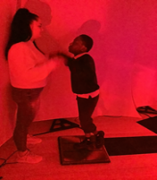
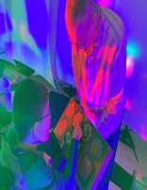
Red Class this week have enjoyed a Colourscape workshop. The children explored a sound and shape activity, pressing different shapes to create a variety of instrument sounds. They showed great curiosity and engagement, carefully pressing each shape and listening attentively to the sounds produced. In the second photo, the child is enthusiastically jumping on a music panel board to create his own sounds and rhythms. They thoroughly enjoyed it.

Yellow Class
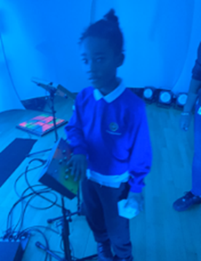
This week in Yellow Class we’ve been working hard at communicating and sharing during our How My World Works sessions. We have been exploring different colours and textures. We also all had a fantastic time making music in our music and colour workshop!
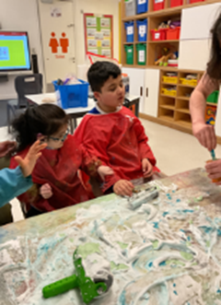

Dragonfly Class
This week, the Dragonfly children learned some of the steps of the handwashing sequence using their communication methods. They also enjoyed a session in the Colourscape workshop offered at school, where they explored colours and sounds. They also chose items to explore using their senses.
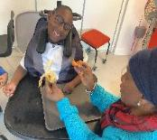
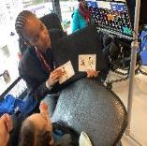

Pink Class
This week Pink Class showed their creativity during the art workshop. The children used acrylic paint to create their masterpieces. They poured the paint on to canvases and then moved the paint using diferent tools. They thoroughly enjoyed this learning experience.
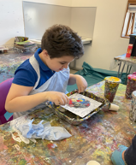
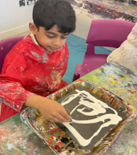

Blue Class
The children in Blue Class had a wonderful time taking part in the art workshop. They were fully engaged and showed great enthusiasm throughout the session. The children explored mixing colours by placing different colours into a cup. They then turned it upside down, allowing the colours to blend together. They also used their hands and a variety of tools to create different patterns. In addition, the children participated in a sensory music workshop, where they enjoyed using a dance mat and a keyboard to create different sounds. They were able to change the colours and use the microphone, which added to their excitement.
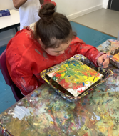
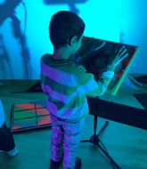

Orange Class
This week Orange Class have really enjoyed taking part in a light and music workshop. The class took part in small groups and were able to explore jumping on an interactive keyboard. We also got to make sounds into a microphone which echoed. The class have enjoyed making bird fat balls so the birds have something to eat during Winter time. After making them in class, we went to the sensory garden to place them up high in different places for the birds to find and eat.
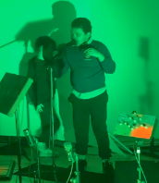
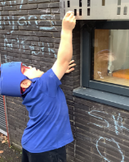

Bumblebee Class
This week Bumblebee Class have been taking part in lots of different activities for Wellbeing Week! The pupils made delicious shortbread biscuits in cooking class, decorating them with colours that represent the Zones of Regulation and then used icing to make faces showing different emotions. Bumblebee Class took part in a Colourscape light and music sensory workshop where the pupils got to create different colours and sounds. There was even time to turn take on a microphone! They made lanterns were made in art class, inspired by the Chinese New Year and in mindfulness club the pupils explored bubble breathing and animal yoga as soothing strategies to support their regulation and wellbeing!
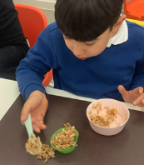
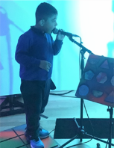

Gold Class
This week, the pupils in Gold Class joined our light and music sensory workshop. The pupils enjoyed activating different sounds and lights with their movements and touch. The pupils are working on mark making activities and handwriting before our phonics lessons. The pupils are developing patience, fine motor skills and their pincer grip as they have fun and enjoy engaging activities. The pupils also used felt tip pens to decorate paper coffee filters and a water spray to see how the colours spread. We will be making a bouquet of flowers for Valentine’s Day!
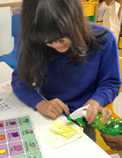
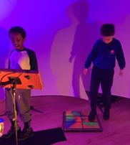

Butterfly Class
In the last week, the children in Butterfly Class have been exploring ingredients and made some bagel pizzas which they really enjoyed . We also had an opportunity to have a wonderful sensory and musical experience with light and sounds which was very exciting and enjoyable!

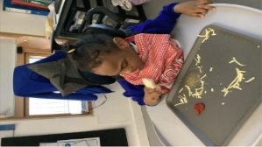
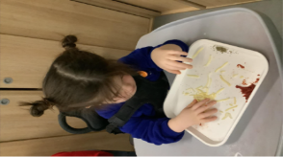

Green Class
This week, Green Class had a fantastic time taking part in a colour and music workshop. We explored a wide variety of sounds, discovered how they are made and watched the different colours. We also celebrated Chocolate Day by baking a delicious chocolate cake! The children did a great job identifying and choosing the correct ingredients at each step of the recipe, showing excellent focus and teamwork. It was a fun and tasty way to learn together!
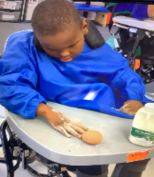
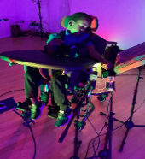

Rainbow Class
This week we have enjoyed taking part in a music and light workshop. We explored different ways of making sounds across the room by using our hands, feet and voices. We had fun chasing our shadows using the different lights and also controlling the lights and sounds with the sound of our voices.
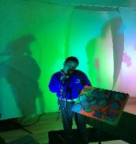
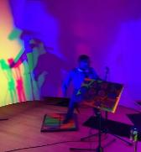

Purple Class
This week, Purple Class have been learning about different forms of transport. They also enjoyed the Colourscape workshop, where they controlled differnet coloured lights and sounds uisng switches.
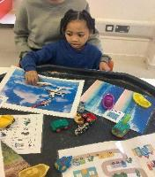
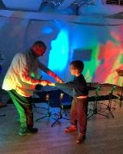

Silver Class
This week in Silver Class, our pupils have been focusing on developing their handwriting and reading skills. Some of the children visited the school library, where they selected books suited to their individual reading levels. After reading, they answered questions about their stories to help strengthen their understanding and comprehension skills. These activities support pupils in building fluency, improving vocabulary and developing confidence in expressing their ideas about what they have read. Meanwhile, another group of pupils remained in the
classroom to practise mark making activities. Through these activities, pupils are becoming more confident readers and writers, while also improving their concentration, independence and love of learning. We are very proud of their hard work this week!
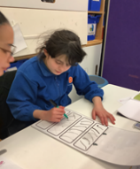
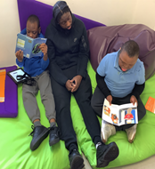

Unicorn Class
This week in Unicorn Class we have taken part in a sensory music session where the children explored different sounds and lights. We have also been working on inference questions, making sure to write our answers with a pincer grip, with correct spacing and punctuation.
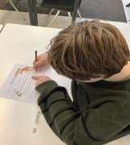
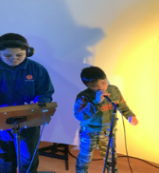

Ladybird Class
This week Ladybird Class engaged in reading our story ‘The Very Hungry Caterpillar’. They then chose to complete a learning activity related to the story. Some of the children decided to make a caterpillar using cucumbers, tomatoes and raisins. Ladybirds have enjoyed taking part in a light and music workshop organised by the school. The children have had fun making sounds using a microphone.

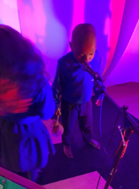
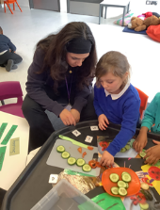

Don’t Forget
All our term dates are available on our website
https://www.thelivityschool.co.uk

Term Four Ends Friday 27th March at 1pm.
Term Five Begins Monday 13th April.
Bank Holiday Monday 4th May – No school.
Term Five Ends Thursday 21st May.
Term Six Begins Monday 1st June.
Term Six Ends Friday 17th July.
Family Group Makaton training
Three Makaton workshops on 17th April, 1st May and 15th May at 9.30 until 11.30am. Spaces are limited so if you would like to attend, please contact Alberta or email admin@thelivity.lambeth.sch.uk
Parents and Carers’ Wellbeing Group Mindfulness Colouring
Thursday 19th March 9.30 until 10.30

