
12th June 2026
Livity Life
The Livity School Weekly Newsletter
School News
Please remember to call the school office at 8.15am if your child is going to be absent.
Please see the back of the newsletter for important dates.

Red Class
In preparation for International Day the pupils took part in a creative art activity inspired by Nigeria. They used green and white tissue paper to create their own flag designs. The activity supported sensory engagement and fine motor skills as pupils selected, handled and arranged the tissue paper to build their artwork.
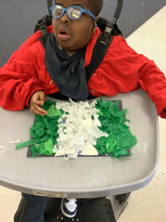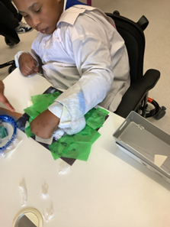

Yellow Class
Another busy week in Yellow Class! In cooking we made a delicious tropical fruit salad. We chopped up mango, pineapple, passion fruit and papaya and mixed it all together in a bowl. It was delicious. In art we have begun looking at habitats around the world. This week we explored the rainforest and made some great collages of rainforest animals.
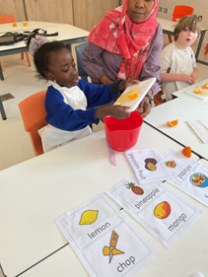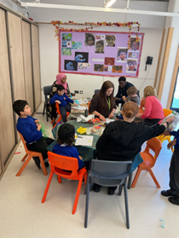

Dragonfly Class
This week, Dragonfly Class explored real objects related to the sea. They engaged in an immersive sensory activity where the children learnt about the ocean habitat. They also participated in a session with UV resources, where they could choose and explore them in small groups and request their turn to play.
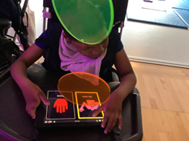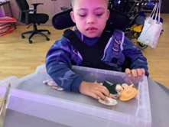

Pink Class
We have had another big week in Pink Class! The children have enjoyed creating fruit kebabs in cooking. They followed visual and verbal instructions, cut the fruit and placed them onto the skewer. They really enjoyed eating and trying different fruits.
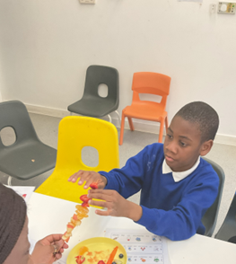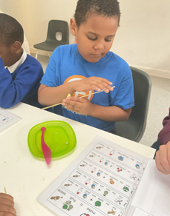

Blue Class
In Blue Class, the children enjoyed singing, clapping and playing the guitar during their music lesson. They worked together as a group and enjoyed the opportunity to make music with their peers. The children participated enthusiastically, exploring different rhythms and sounds whilst taking turns and listening to one another.
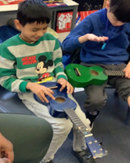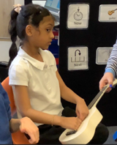

Orange Class
This week Orange Class have enjoyed exploring 2D shapes by making rockets out of rectangles, triangles, squares and circles. They enjoyed selecting the colours they wanted to use and seeing the rocket come to life by putting the shapes together. We have also been reading the story ‘Rumble in the Jungle’ and matching the animals from the story to pictures. We also love dancing to the ‘Rumble in the Jungle’ song!
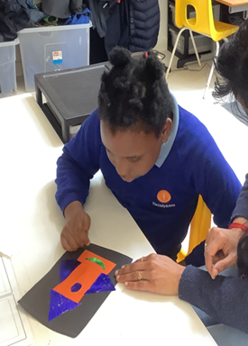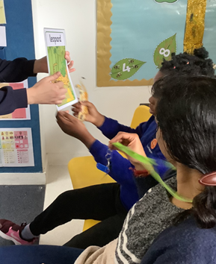

Bumblebee Class
This week Bumblebee Class have been exploring key vocabulary from the story 'Snail and the Whale'. The pupils have become familiar with some of the key characters and objects, as well as making their own ‘Snail and the Whale’ characters from tortilla wraps and dough. In cooking the pupils used lots of different ingredients to create individual pizzas. They explored smelling, tasting and touching the various food items, with some pupils even exploring new foods like olives! This week Bumblebee Class also began taking part in a play and social skills session. They explored maintaining their attention in whole class learning, using communication tools to request and turn take.
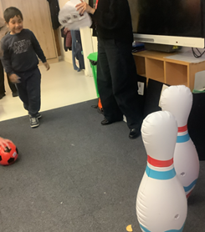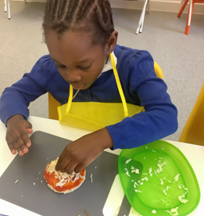

Gold Class
This week, the pupils in Gold Class created the Cartesian diver experiment with a recycled bottle. Pupils sequenced and followed the steps to make a jellyfish, cutting a plastic bag, threading it through a straw and clipping a paper clip to add weight in a bottle of water. The pupils explored that adding pressure makes the jellyfish dive down in the bottle. Gold Class has their own aquarium with some fish and snails. The pupils enjoy looking after them and observing how they swim, eat and grow.
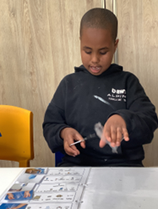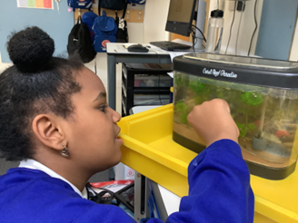

Green Class
This week, Green Class have been exploring the concept of requesting more through a variety of engaging and motivating activities. One of our favourite activities was asking for more bubbles. We all showed great excitement and anticipation when communicating that we wanted the bubbles to continue. We also enjoyed using switches to activate songs on the interactive whiteboard.
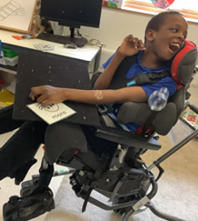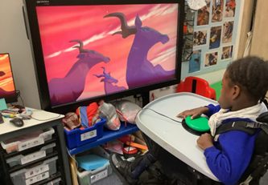

Rainbow Class
On Wednesday Rainbow Class visited the Oasis Nature Garden in Stockwell. We had lots of fun exploring different parts of the garden, including using different bikes and scooters, a tree house, playhouse and mud kitchen. We even searched for minibeasts using magnifying glasses.
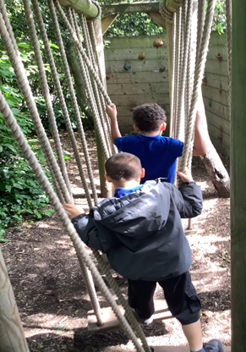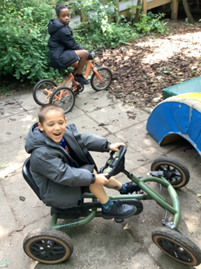

Purple Class
Purple Class have enjoyed cooking chocolate rice crispy cakes this week. The pupils followed the instructions to create their own cakes. Some of the pupils have been sorting lettered balls into the matching bowl whilst others created art using the letters from their names.
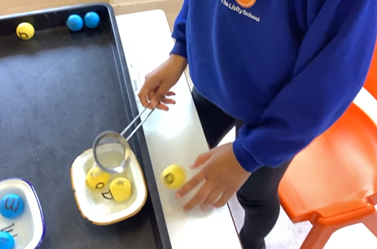
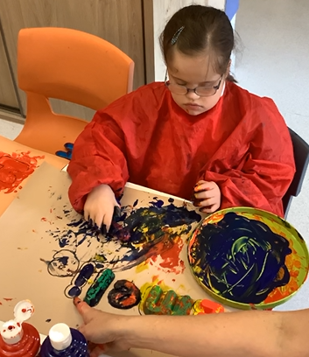

Butterfly Class
This week in Butterfly Class the children had a fantastic session with the VI team. This included working on our communication, anticipation and vision through different songs, rhymes and interactive activities. The children were really engrossed in the session.
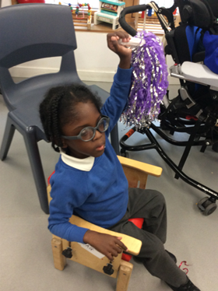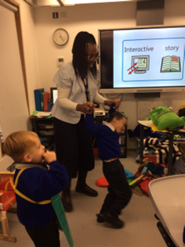

Silver Class
This week, Silver Class pupils enjoyed their soft play session, where they were able to explore, climb, slide and develop their gross motor skills in a fun and safe environment. The pupils enjoyed building their confidence and coordination. Throughout the week, the pupils also took part in a range of sensory and communication activities tailored to their individual needs. They continued to work on developing their independence, making choices and engaging with others through play and structured activities.
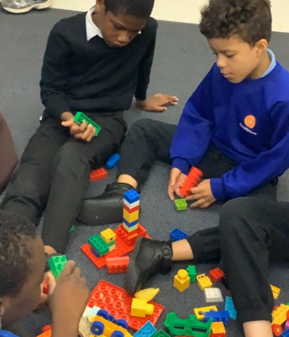
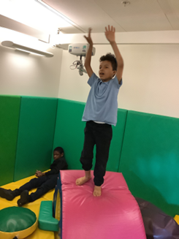

Unicorn Class
This week in Unicorn Class we went to Oasis Nature Garden. We explored the garden, role-played in the kitchen, searched for bugs and played with our friends. We have also been talking about what we would like to be when we grow up and role-playing different job roles.
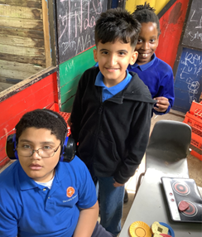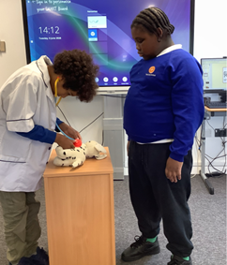

Ladybird Class
This week Ladybird Class have been focusing on developing their fine motor skills whilst taking part in various learning sessions and activities. The children have been building up their pincer grip by using tweezers to pick up the pompons placed in the spider web. Ladybirds have also been using scissors to do some cutting out activities.
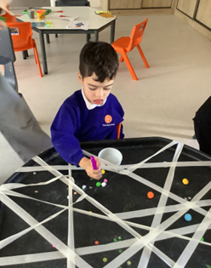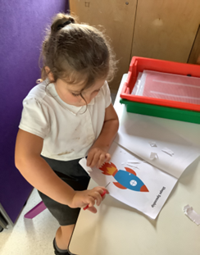

Don’t Forget
All our term dates are available on our website
https://www.thelivityschool.co.uk

Term Six Ends Friday 17th July

School returns Thursday 3rd September for pupils
International Day is the afternoon of Friday 3rd July.

Sports Day

Wednesday 24th June
9.30 – 10.30 Orange, Blue and Pink
11.00 – 12.00 Gold and Silver
1.15 to 2.15 Rainbow and Unicorn

Wednesday 1st July
9.30 – 10.30 Red, Green, Dragonflies and Butterflies
11.00 – 12.00 Ladybirds and Bumblebees
1.15 to 2.15 Purple and Yellow

Family Group
Phonics Learn about the phonics system used in school
19th June 9.30 to 10.15am

