
3rd July 2026
Livity Life
The Livity School Weekly Newsletter
School News
Please remember to call the school office at 8.15am if your child is going to be absent.

Red Class
Red Class enjoyed Sports Day. All the pupils involved themselves in football, bowling, hoops on cones and throwing. We were very proud of the medals we received.
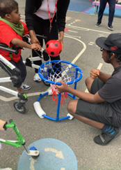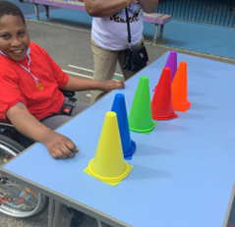

Yellow Class
We’ve had a wonderful week here in Yellow Class. We’ve spent some time outside on our balcony doing some experiments with water. We chose different objects to see which of them sank and which of them floated. On our trip to Brockwell Greenhouses this week we went searching for butterflies and found lots of different coloured ones. We then had a go at making our own butterflies out of card.
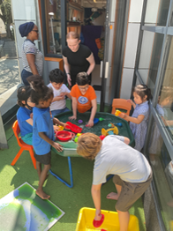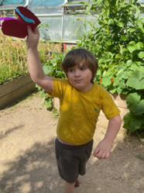

Dragonfly Class
This week, Dragonfly Class made cinnamon doughnuts. The children explored and mixed all the ingredients, then cooked them in the microwave, using switches to activate it. They also had fun during Sports Day and International Day celebrations. The children also extended Sports Day during the week with more movement activities and games.
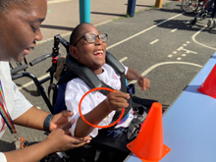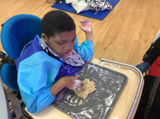

Pink Class
Pink Class have had another wonderful week. We have been enjoying listening to new story books and looking at all the different pictures. This week the children have been given opportunities to explore different sensory activities. They particularly enjoyed our experiment of mixing different ingredients together to see what would create a reaction.
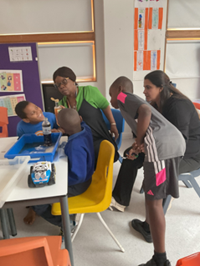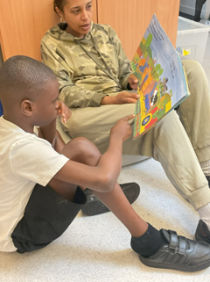

Blue Class
This week in Blue Class, the children enjoyed an outdoor tuff tray activity based on the story ‘The Rainbow Fish’. The tray included fish, an octopus, and a starfish, along with key words from the story to support their communication and engagement. The children showed interest by picking up the props, moving them around the tray and exploring the different textures. They also decorated their own rainbow fish using glitter, feathers and card.
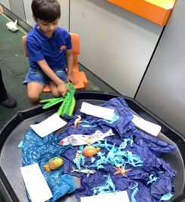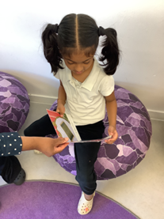

Orange Class
Orange Class have been working on the properties of shape this week. The class have gone on shape hunts to find different shapes around school. Their favourite activity was placing bears on the outline of shapes on the carpet. The have also been busy making flags for International day to celebrate their heritage.
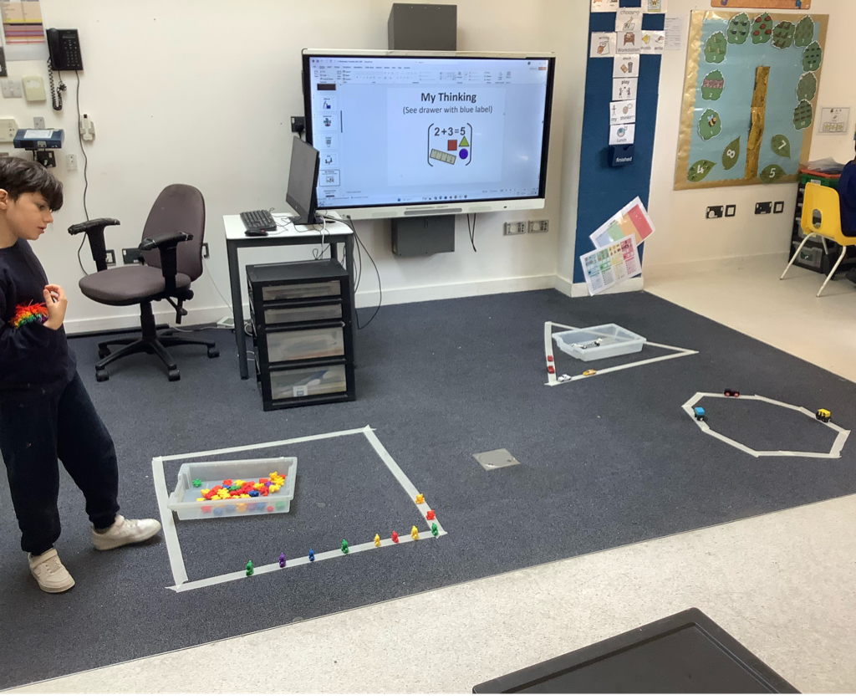

Bumblebee Class
This week Bumblebee Class had loads of fun taking part in Sports Day and International Day!
The pupils decorated their Sports Day t-shirts with bees to represent their class. Bumblebee Class also had lots of fun making flags that represent different countries from around the world for International Day. They got to explore and celebrate different cultures, communities and people, as well enjoy fun activities with their families and friends! The pupils made seashell cookies in cooking, using their fine motor skills to carefully decorate the biscuits with icing pens.
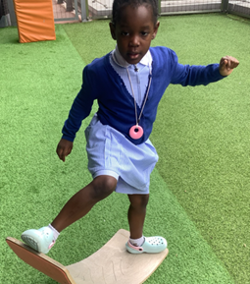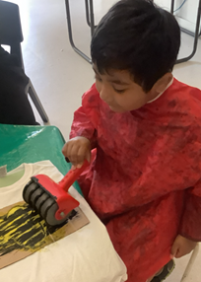

Gold Class
This week, the pupils in Gold Class worked on addition and subtraction. The pupils used objects and pictures to match with numbers and count all together to find the answer. They used their preferred communication system to write the number sentence and give the answer. Gold Class also got ready to celebrate International Day. The pupils decorated pieces of fabric with the colours of the flag that represent their background and learnt about the diversity in the school.
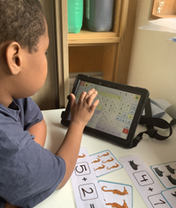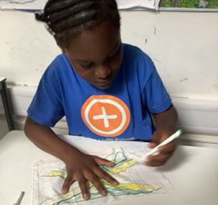

Green Class
This week, Green Class have been enjoying a range of fun sensory activities to help us stay cool during the warm weather. We explored water, ice and floating boats. We also enjoyed sensory exploration with a variety of fruits and ice in water. One of the highlights of the week was making our own ice lollies. Pupils were encouraged to make choices by selecting their preferred squash flavour and the fruits they wanted to include before creating their own refreshing treats.
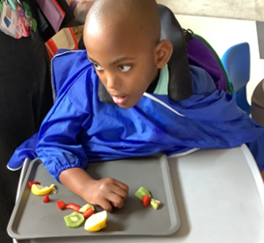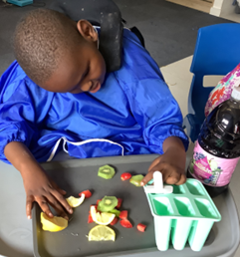

Rainbow Class
We have been enjoying exploring our nationalities and making flags for International Day! Last week we enjoyed learning about different modes of transport and playing in our own Rainbow Bus; picking up our friends at different stops on the way to school.
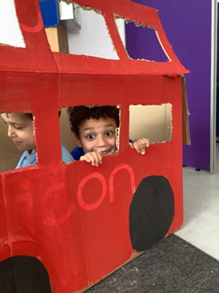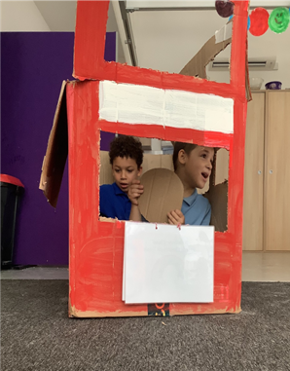

Purple Class
Purple Class had a fantastic Sports Day this week. We loved taking part in all the different activities but the relay race was our favourite. We have also been busy this week preparing for International Day, creating flags that represent our identities and trying different food.
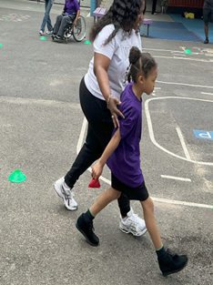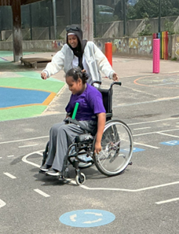

Butterfly Class
This week in Butterfly Class we have had a busy and enjoyable week. During our physical development sessions, we have been working hard to develop our skills through our physical programmes. We also designed and made our own Butterfly Class t-shirts in preparation for Sports Day. On Sports Day, everyone had a fantastic time taking part in the different activities, showing enthusiasm and perseverance.
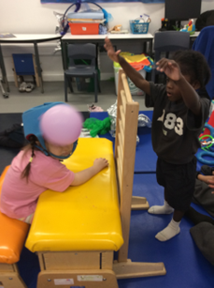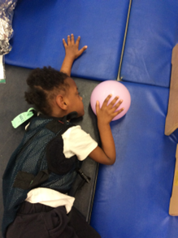

Silver Class
This week, Silver Class took part in the preparations for International Day. We painted and decorated national flags that represent our own cultural backgrounds. By sharing and displaying their finished flags, the children gained a better understanding of the diversity within the class. They practised self-expression through art and built their confidence in talking about their heritage. This meaningful activity supported creativity, cultural awareness and a strong sense of identity and pride.
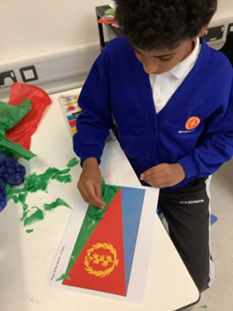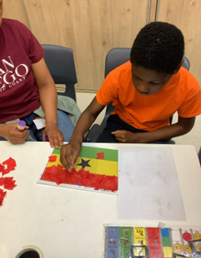

Unicorn Class
This week in Unicorn Class we have been to The V&A museum in South Kensington for a workshop on Japanese culture. This followed on from the museum’s visit to the school. We have been making windmills and planning routes to Japan. We have also been learning about other countries, capitals and cultures in preparation for International Day.
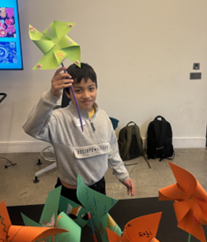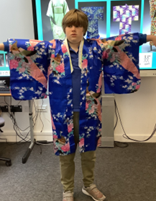

Ladybird Class
This week Ladybird Class have focused on naming and recognising their emotions. Some of the children have been able to spell and write down certain emotions. Ladybirds have enjoyed participating in Sports Day this week. All the children have been very competitive while taking part in bean bag and relay races.
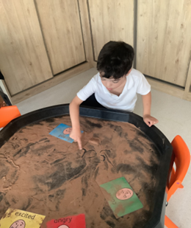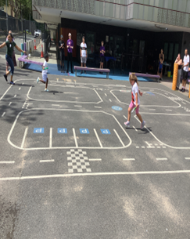

Don’t Forget
All our term dates are available on our website
https://www.thelivityschool.co.uk

Term Six Ends Friday 17th July at 1pm

School returns Thursday 3rd September for pupils
Parents Evening for nursery to year 5 parents as this is an opportunity to meet your child’s teacher for next year. After school on Tuesday 7th July.

Graduation Ceremony for year 6 pupils
Wednesday 8th July at 9am

