
Date 21st November 2025 2025
Livity Life
The Livity School Weekly Newsletter

School News

This week we have been focussing on Mindfulness as part of our Wellbeing Week.
Please remember to call the school office at 8.15am if your child is going to be absent.

Red Class
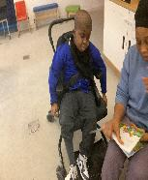
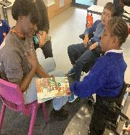
Red Class have enjoyed a wonderful, shared reading session with adults. In one photo, a child is pointing excitedly to the characters in the book, showing great awareness and curiosity about who is in the story. In the other, both the child and adult are fully absorbed, leaning in closely and talking about what might happen next when they turn the page. It was lovely to see how engaged everyone was, smiling, discussing the pictures and building confidence in early reading skills.

Yellow Class
In Yellow Class this week we’ve been continuing to explore the themes of Autumn. In art we collected some beautiful Autumn leaves and used them to paint silhouettes in Autumnal colours. The finished results looked outstanding! In P.E. we have been trying out different movements by doing yoga sessions!
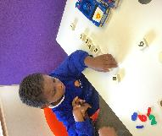
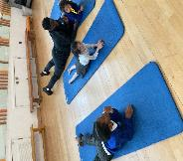
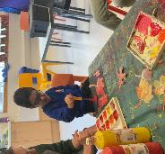

Dragonfly Class
This week, Dragonfly children started their sessions in the hydrotherapy pool, where they participated in active movement activities and games. They also used their communication methods to choose and describe photos. The children were very excited to explore their new Christmas sensory area in the classroom.
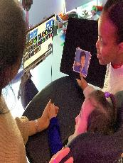
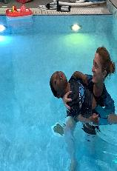

Pink Class
This week Pink Class have engaged in counting activities during their My Thinking lessons. The pupils were focused and on task. They used counters and numbers and were supported with the use of their visual aids and PECS. We also implemented counting during our cooking lessons, counting out the ingredients we used.

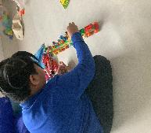

Blue Class
This week Blue Class visited Brockwell Greenhouses. The children took part in touching and smelling a range of plants and walked around the grounds to observe how different areas of the garden are cared for. They planted bean seeds, both outside and in a pot. This helped them to learn about what plants need to grow and how to use simple gardening tools safely and responsibly. They enjoyed smelling plants such as rosemary, sage and lavender, which can still grow and stay fragrant in this cooler weather.
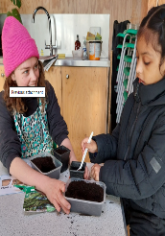
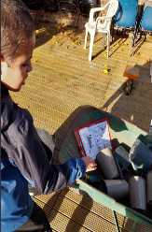

Orange Class
This week Orange Class have enjoyed making a magic milk experiment. The class combined food colouring, fairy liquid and milk to create marble effect patterns that they were able to create using cotton buds. Orange Class have been enjoying their Movement Works workshop, following movement routines involving a colourful parachute.
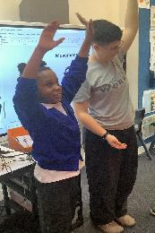
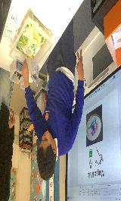

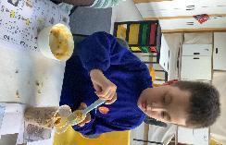

Bumblebee Class
This week Bumblebee Class have been working hard on recognising their numbers within 10 and practising their counting skills using different manipulatives. We have explored our story of ‘Beegu’, through our senses and looked at the different emotions our character feels throughout. We have also been creating some yummy space cupcakes this week, using our visuals to recognise ingredients and follow cooking instructions!
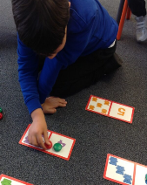
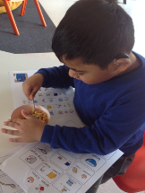

Gold Class
This week, the pupils in Gold Class read and followed the instructions to make a fat ball to feed the birds, with beef dripping, cornmeal and mixed seeds. The pupils enjoyed taking part in activities to explore the different textures and mixed the ingredients. We will be hanging their fat balls in our sensory garden to feed the birds on the cold Winter days. During our cooking lesson for How My World Works, the pupils sequenced the steps to make snowball snacks. They are gaining confidence in completing the tasks with less support and becoming more independent.
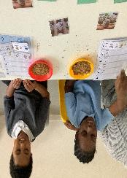

Green Class
This week, Green Class began exploring our festive sensory story, ‘It’s Beginning to Look a Lot Like Christmas’. The children loved listening to the festive music and had lots of fun investigating the snowman and sparkling snowflakes. We also enjoyed a green themed Fun with Food session, where everyone explored a variety of textures, smells and sounds.
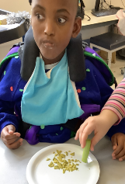
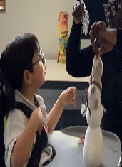

Rainbow Class
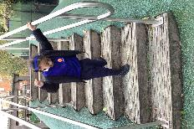
This week we worked on different relaxation poses during our Wellbeing Week. We explored different breathing focusses in the afternoons and in P.E. we worked on stretches and balances at different levels. We have used some of these techniques throughout the week to help us when we are in the blue or yellow zone.

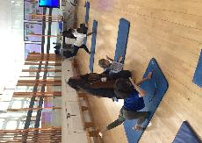
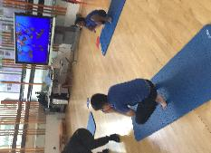

Purple Class
Purple Class have had another great week. We continued to work on our sharing and turn taking skills, this week using stickle bricks. We have also been practising our counting skills, matching the amount to the number of objects.

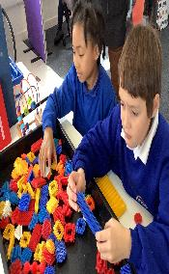
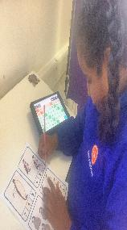

Butterfly Class
In the last week some of the children have been developing their physical skills, working on walking down steps and stepping up on to platforms. We made some colourful cards for our families as part of our kindness theme for Anti-Bullying week.
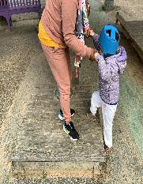

Silver Class
This week, Silver Class enjoyed taking part in Wellbeing Week. Pupils created and exchanged beautifully decorated cards, writing and sharing kind messages with one another. This activity offered our pupils a meaningful opportunity to practise important skills. Through giving and receiving kind words, pupils explored their own emotions, built empathy and strengthened social connections. Reading their messages aloud helped develop communication and confidence, while decorating the cards supported fine-motor and creative skills. Most importantly, the children experienced a strong sense of belonging and pride as they celebrated one another’s strengths.

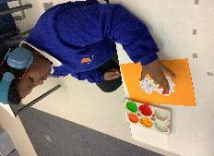
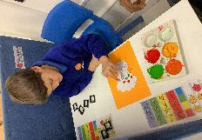

Unicorn Class
This week in Unicorn Class we made paper planes for Remembrance Day. This fed into our lessons on forces, where we looked at gravity, air resistance and why certain objects stay in the air for longer. We built ramps of different heights and tested how long it takes for a toy car to get to the bottom.
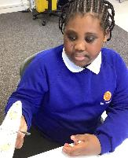
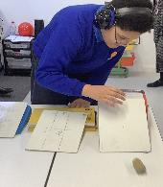

Ladybird Class
This week Ladybirds have been busy engaging in building CVC words during their phonics sessions. They have been making ‘bus’, ‘hen’ and ‘cat’ words by using letter puzzles. The children have also been developing their tripod grip while learning to form letters during their writing lesson.
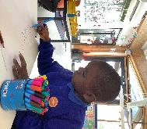
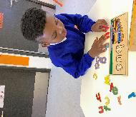

Don’t Forget
All our term dates are available on our website
https://www.thelivityschool.co.uk

Term Two Ends: Friday 19th December
Family Group – 9.30 -10.30am
Tuesday 2nd December
How to use visuals at home with the Speech and Language therapist

Parent and Carers’ Wellbeing Group - 9.30 -10.30am
Friday 12th December
Mindfulness
Join us for an introductory session on Mindfulness, which will include a simple session for attendees.

Tuesday 16th December in the morning
The Livity Show

