
Date 27th February 2026
Livity Life
The Livity School Weekly Newsletter

School News
Please remember to call the school office at 8.15am if your child is going to be absent. Please see the back of the newsletter for important dates such as World Book Day.

Red Class
This week in Red Class, the children enjoyed their Fun with Food session, exploring a range of different tastes and textures. The children showed excitement as they used their hands to explore and move the food around. They enjoyed the sensory experience of exploring and tasting a wide range of foods.
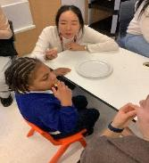
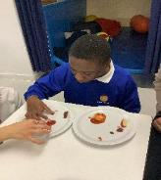

Yellow Class
We’ve had a busy first day back in Yellow Class. In our class OT session, the pupils had a go at playing tag rugby! We’ve also been looking at different ways of relaxing, which we really enjoyed!

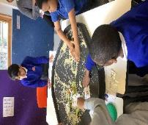
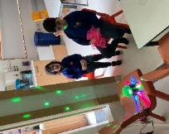

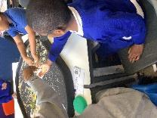

Dragonfly Class
This week, Dragonfly children enjoyed their sensory engagement sessions with UV lights to develop their attention and tracking skills. The children also made pancakes in their sensory cooking lesson and decorated them with their favourite toppings. We also began a block of sessions to develop our play and social skills.
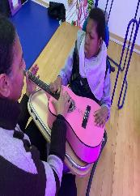
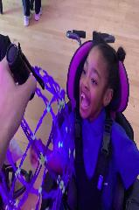

Pink Class
This week, the children in Pink Class enjoyed working in small groups. The children explored a sensory tray during phonics. They worked on sharing resources, letter sounds and matching the sounds to an object starting with the correct sound. The children enjoyed the feeling of the rice over their hands.
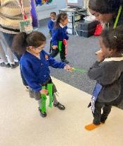

Blue Class
This week in Blue Class, we started a new story, ‘Hansel and Gretel’, written by the Brothers Grimm. During My Creativity, the children took part in a group activity where they made houses using various resources. They worked together to cut, stick and choose how to decorate their houses. The children really enjoyed the activity and were fully engaged. They showed excellent teamwork, creativity and enthusiasm throughout.
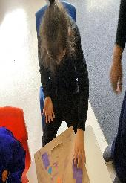

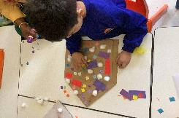

Orange Class
This week Orange Class have been focusing on extending their requests using PECS by asking “I want water” instead of only using the water PEC. Some children have been able to use this extended sentence to request food at snack time and to request a movement break. Orange Class have also been exploring numbers with Numicons and some pupils have successfully matched the Numicon piece to the correct number.
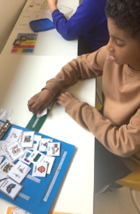
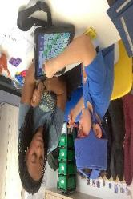

Bumblebee Class
This week Bumblebee Class have been exploring the story ‘We’re Going on a Bear Hunt’, as part of their new literacy learning. They used their senses to explore different materials found within the story and started to get familiar with the key vocabulary. Bumblebee Class also used their creative skills to make a large cave in their art lesson. They used various materials like tissue paper and cardboard to build a home for the bear in the story. Bumblebee Class this week practised 1:1 correspondence, exploring numbers with flour and foam and correctly matching objects and manipulatives.
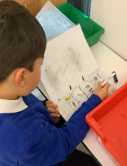
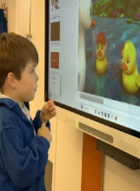

Gold Class
This week, the pupils in Gold Class worked on their numeracy skills. Some pupils looked for a number of pictures to complete addition activities and others matched number value to quantities. During our gardening lessons, the pupils watered their own grass hair pets. The pupils have been growing grass hair pets with their photo on it and can see how their hair is getting longer!
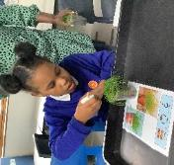
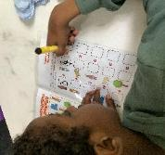

Butterfly Class
This week the children in Butterfly Class have been actively learning, moving and exploring using their walkers and following their physical programs. We had a great multi-skills session working with the therapists which had us all engaged and alert.
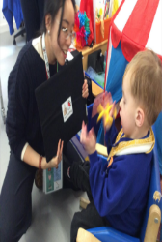
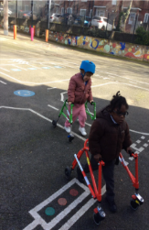

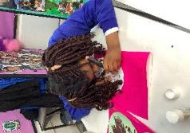

Green Class
This week, Green Class thoroughly enjoyed beginning our new sensory story, ‘Paddington’. The children particularly loved the interactive bubble bath experience, where they helped bring the story to life alongside Paddington. We also had a wonderful time celebrating Chinese New Year, we prepared delicious dragon puff pastry nibbles. The children explored the different ingredients, enjoying the opportunity to smell the tomato purée, nut free pesto and parmesan.
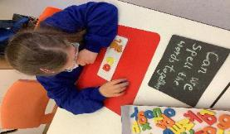
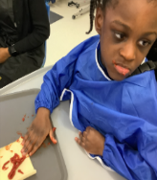
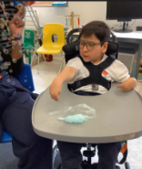

Rainbow Class
We have been enjoying our mix of steel pan lessons and art sessions at Elm Court every Friday. During our most recent session we made hearts using different paint mixing techniques and then added them to cards for the people we love. During our steel pan sessions, we have been learning the different sounds that different parts of the steel pans make.

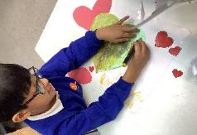

Purple Class
Purple Class enjoyed creating art work inspired by Vincent van Gogh’s The Starry Night painting this week. We thought about the different colours of the moon light as we created our painting. We also completed spellings by sorting the letters.

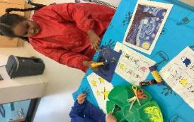

Silver Class
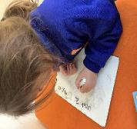
This week was our first week back after half term and the pupils returned to their class routines. The children have worked hard on their individual targets. They showed great effort and focus whilst working towards their personal goals. The children settled back into school well. We are proud of how calmly they returned to their learning.
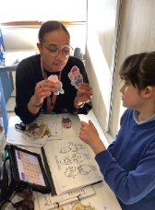
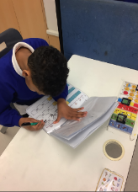

Unicorn Class
This week in Unicorn Class we have been using our knowledge of fractions to create paned glass patterns using different colours. We have also been writing bullet pointed descriptions and then using our ICT skills to edit and type these up into full sentences.
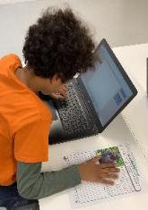
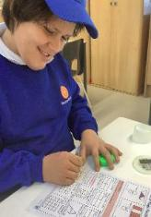

Ladybird Class
This week Ladybird Class have been practising their phonics awareness. They have been learning to say the sounds from Unit 1 and Unit 2 of Sounds Write. Then, they have been learning to write certain words down. Ladybirds have also enjoyed preparing their own bagels during breakfast club.

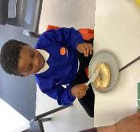

Don’t Forget
All our term dates are available on our website
https://www.thelivityschool.co.uk

Term Four Ends Friday 27th March at 1pm. Term Five Begins Monday 13th April.
Bank Holiday Monday 4th May – No school. Thursday 5th May – school closed to pupils as we are a Polling Station.
Term Five Ends Thursday 21st May.
Term Six Begins Monday 1st June.
Term Six Ends Friday 17th July.

World Book Day Thursday 5th March Pupils can bring in their favourite books from home to share and wear book related costumes if they would like to.
Red Nose Day Friday 20th March
Family Group Makaton training
We are holding three Makaton workshops on 17th April, 1st May and 15th May at 9.30 until 11.30am. Spaces are limited so if you would like to attend, please contact Alberta or email admin@thelivity.lambeth.sch.uk
Parents and Carers’ Wellbeing Group
Mindfulness Colouring Thursday 19th March 9.30 until 10.30.

