
27th March 2026
Livity Life
The Livity School Weekly Newsletter
School News
Please remember to call the school office at 8.15am if your child is going to be absent.

Red Class
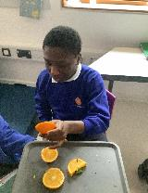
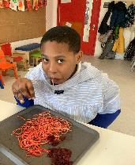
This week in Red Class, the children engaged in sensory activities involving oranges and red pasta. These experiences supported the development of their fine motor skills whilst encouraging exploration. The children explored the scent and texture of the oranges and had the opportunity to taste and handle red pasta.

Yellow Class
Across the last week there has been lots going on in Yellow Class! We all enjoyed Red Nose Day and looked great in our red outfits. We’ve also continued our hard work on our turn-taking and reciprocal play. Our pupils have really progressed in this area and should all be proud of themselves!
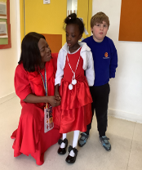

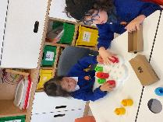

Dragonfly Class
This week, Dragonfly Class enjoyed decorating biscuits for Red Nose Day. The children enjoyed playing with the different ingredients and creating their own design. We also enjoyed taking part in lots of red activities.

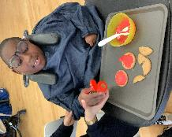
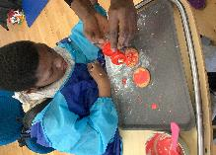

Pink Class
This week in Pink Class, the children enjoyed making damper in cooking. Damper is a type of bread from Australia. The children mixed and formed the dough. We tried it with butter and jam. We all had a wonderful time!
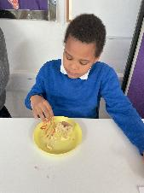
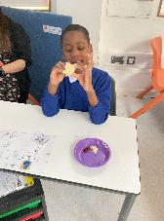

Blue Class
This week in Blue Class, we had lots of fun during our P.E. lesson, taking part in a beanbag and bucket race! The children worked in teams to see who could finish first, showing great excitement, teamwork and determination. We also got creative making our Easter cards. The children enjoyed cutting, sticking, colouring and decorating their cards using a variety of materials. Everyone worked really hard and had lots of fun creating their own special cards to take home.
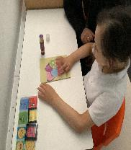
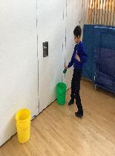

Orange Class
This week Orange Class are celebrating all things to do with Easter. Today we were interested in our Easter themed sensory tray. We were able to wear bunny ears and identify the soft toy bunny rabbits. We also looked at carrots and were able to match the soft toy carrots to real ones. We are looking forward to our Easter egg hunt later in the week!
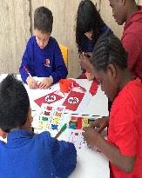
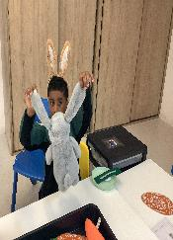

Bumblebee Class
This week Bumblebee Class have been taking part in a relay circuit in P.E. We had lots of fun matching hoops and bean bags to the right coloured cones and exploring moving safely in the space. Also, this week the pupils had fun creating springtime cards and pictures, using their fine motor skills to cut out shapes. Bumblebee Class really enjoyed making bear cakes in their cooking session. They also created fake snow in their experiment session!
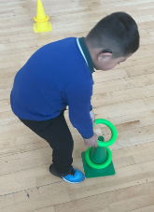
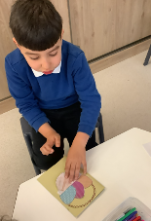

Gold Class
The pupils in Gold Class have enjoyed taking part in Red Nose Day activities to work on their fine motor skills. They also focused on their numeracy skills and number value. They solved additions and subtractions using number lines and used objects to support their understanding.
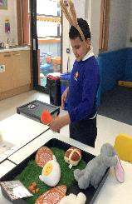

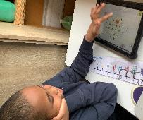

Green Class
This week, Green Class thoroughly enjoyed exploring ukuleles during their music session. They investigated the different sounds produced when gently touching and strumming the strings and showed great curiosity in discovering that the instrument vibrates as it creates sound. Some of us have been practising sitting independently as well this week.
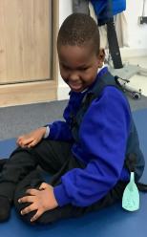
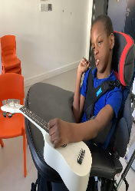

Rainbow Class
We have been enjoying learning and performing different songs on different instruments during our music sessions, last week we were playing ukuleles! We have also been working on a large collaborative piece of artwork at Elm Court, adding different paintings each week. This week we added flowers and grass to the sky and clouds we had made the week before.

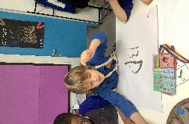
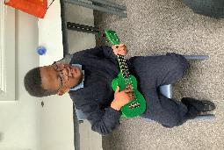

Purple Class
Purple Class had their last session at Brockwell Greenhouses this week. We collected herbs from around the garden such as rosemary, mint and the leaves from a curry plant. We hung them on some sticks to create a mobile along with butterflies we made. We have also brought back the plants we have grown from seed and will care for them in the school polytunnel.
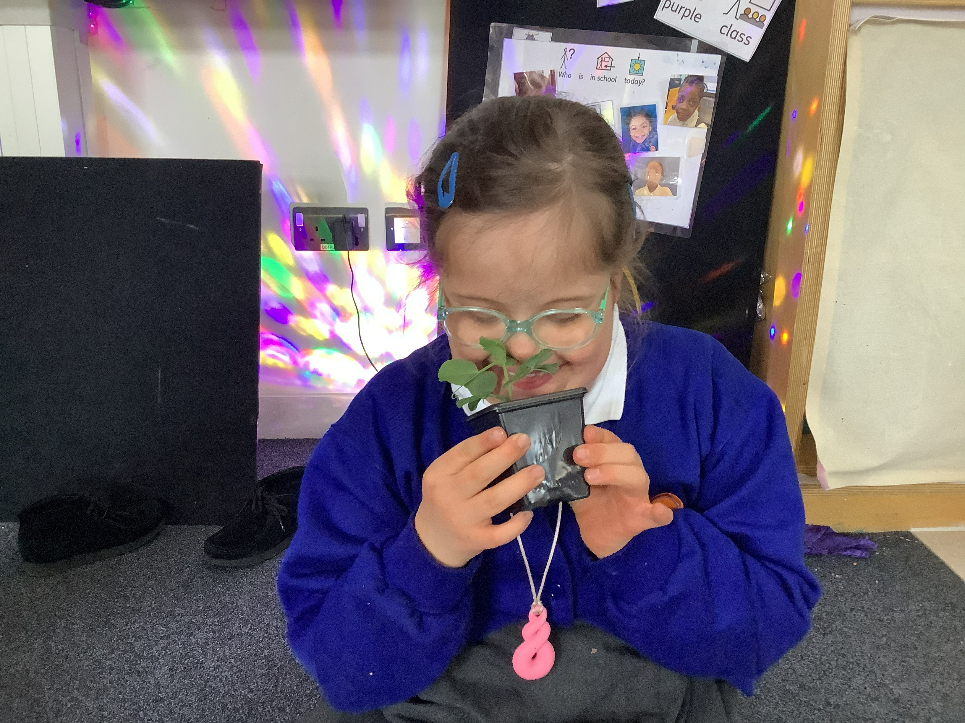
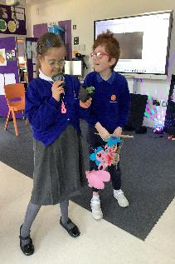

Butterfly Class
In the last week the children in Butterfly Class have been celebrating Red Nose Day through sensory activities and showing off our red clothes! The children explored a variety of red objects and also did some printing and mark making with red paint and collage.
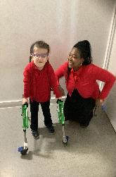

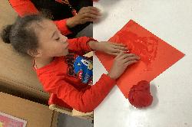

Silver Class
This week Silver Class pupils continued their weekly community trips, where they consistently develop important life skills and grow in independence. At the supermarket, the pupils followed a shopping list. With regular practise, they are becoming more confident in locating items, making choices and working collaboratively as a group. At the checkout, pupils practised paying for their items, developing their understanding of money and real-life transactions.
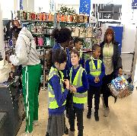
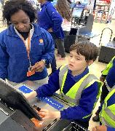

Unicorn Class
This week in Unicorn Class, we have been at Elm Court for Art Week. We have been taking part in a sensory story about the life cycle of frogs where we role played the different stages of a frog’s life. We also learned about the science behind ice cream and made mosaics out of bottle caps.
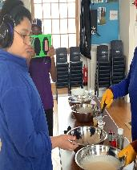
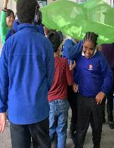

Ladybird Class
This week Ladybird Class have enjoyed engaging in an experiment called rain in a cloud. They filled a cup with water, squeezed some shaving foam on top and added a few drops of food colouring using a syringe. The children have also demonstrated very good concentration and hand and eye coordination whilst engaging in an abstract painting activity.

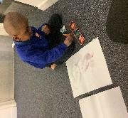
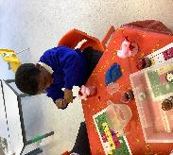

Don’t Forget
All our term dates are available on our website
https://www.thelivityschool.co.uk

Term Four Ends Friday 27th March at 1pm. Term Five Begins Monday 13th April.
Bank Holiday Monday 4th May – No school. Thursday 7th May – school closed to pupils as we are a Polling Station.
Term Five Ends Thursday 21st May.
Term Six Begins Monday 1st June.
Term Six Ends Friday 17th July.

Family Group Makaton training
We are holding three Makaton workshops on 17th April, 1st May and 15th May at 9.30 until 11.30am. Spaces are limited so if you would like to attend, please contact Alberta or email admin@thelivity.lambeth.sch.uk

