
1st May 2026
Livity Life
The Livity School Weekly Newsletter
School News
Please remember to call the school office at 8.15am if your child is going to be absent.

Red Class
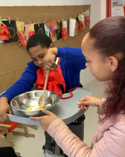
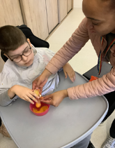
Red Class pupils enjoyed cooking this week, cracking eggs and mixing ingredients with great enthusiasm. These activities help develop their fine motor skills through careful hand movements. The pupils attended really well, focussing on each step of the process. It’s been fantastic to see their confidence and independence grow!

Yellow Class
This week the whole school really enjoyed a sensory theatre production. There was some incredible dancing, lots of water and Yellow Class thoroughly enjoyed it. In art we continued making our paper mâché rockpool by adding paint and details to it. We will finish it next week and start using it as part of our new story ‘Who Rules the Rockpool?’
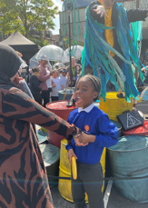
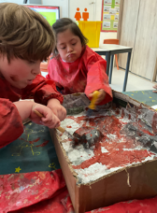

Dragonfly Class
This week, Dragonfly Class celebrated Space Day. The children learned about space through their senses, exploring resources related to the theme with movement and music. They also participated in art activities with natural resources to create a collage. The children worked on cause-and-effect activities with switches in small groups and individually.
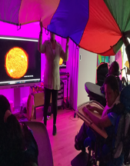
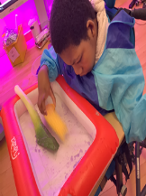

Pink Class
This week Pink Class enjoyed our second trip to Brockwell Greenhouses. Since this was the childrens second visit they were very confident when walking around the gardens, on their search for plastic bugs. They enjoyed planting seeds in small pots and using the watering cans to water the plants.
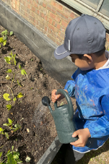
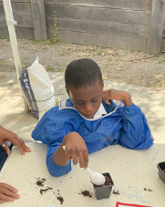

Blue Class
This week in Blue Class, there was a theatre performance titled The Flood. The children thoroughly enjoyed watching the show. At the end, the children were invited to join in if they wished. A range of sensory elements were used, including water and smoke which made the experience even more engaging. The children were laughing throughout the experience. Well done, Blue Class!
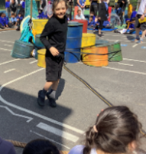
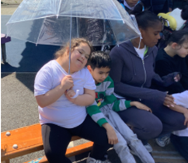

Orange Class
This week Orange Class really enjoyed watching a theatre performance which included lots of fun sensory play including water and bubbles. Some of us got very wet enjoying the cool water! We have also enjoyed making creative work to match our habitat theme, the Arctic! We made polar bears using paint, paper and different types of tools.
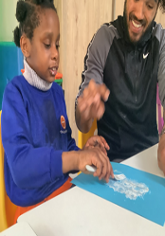
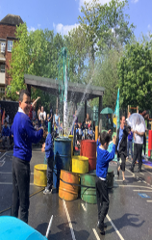

Bumblebee Class
This week Bumblebee Class have been learning about different types of habitats found around the world. They explored the rainforest, Arctic, desert, mountain and ocean habitats through various sensory trays and learnt about the different animals found in each one. In art the pupils created polar bears using different textured materials and, in their cooking lesson, they made a fruit salad using various tropical fruits from around the world. They made sure to carefully follow adult instructions using their visuals aids for support and explored using knives and other tools to cut, dice and peel the fruit.
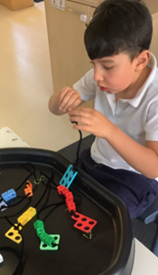
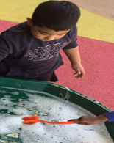

Gold Class
This week, the pupils in Gold Class enjoyed reading our story ‘Rumble in the Jungle’ and re-told the story with the actions of the animals using Colourful Semantics. During our cooking lesson, the pupils made cookie dough and chose their favourite animal to create a biscuit of. The pupils measured ingredients and followed the steps to complete the recipe.
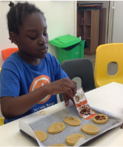
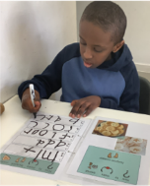

Green Class
This week, Green Class have had a fantastic time exploring a variety of fruits, including lemons, limes, grapefruits and pineapple during our sensory engagement. We particularly enjoyed using the colander to create big splashes, encouraging cause-and-effect exploration and lots of shared laughter. We also had great fun experimenting with lemons, adding different colours and watching them explode, which created exciting visual and auditory effects.
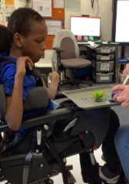
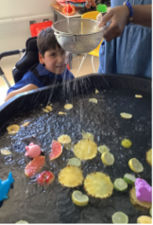

Rainbow Class
This week we enjoyed working on a creative, immersive theatre performance where we made our own sting-ray puppets and then took part in a whole school performance. The performance included dancing, drama and water fun. We took part throughout the performance as the captain of the ship and also held up umbrellas to stop us getting covered in water!
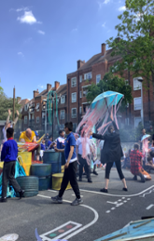
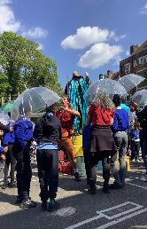

Purple Class
Purple Class have had another great week. Their favourite activity this week has been to make vegan marshmallow slime. They followed the step-by-step instructions to make the slime and then explored how stretchy it could be. They also enjoyed watching a theatre performance, The Flood in the playground. Purple Class especially liked it when the large sparkly fish appeared.
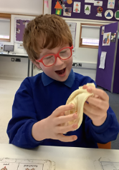
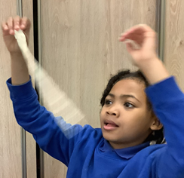

Butterfly Class
This week some children from Butterfly Class have had some fantastic hydrotherapy sessions. Making lots of independent body movements in the water. The children have been interactive and vocalising a lot this week through our various activities which has been great to see! There was an exciting performance from Bec Britain which was lovely to experience outdoors in the sunshine.
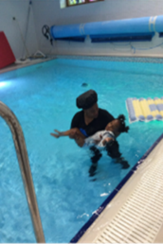
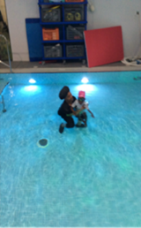

Silver Class
This week, Silver Class pupils had a fantastic week filled with exciting learning opportunities both in and out of the classroom. Some of our pupils enjoyed taking part in a very special bus day trip, which provided an excellent real-life learning experience. This trip was carefully designed to support the children, by building their confidence, independence and life skills whilst learning how to travel safely on London’s bus network. This real-life experience helped pupils build communication, problem-solving and social skills while encouraging greater independence. We are very proud of their enthusiasm and excellent learning this week. Well, done, Silver Class!
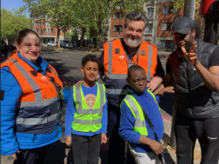
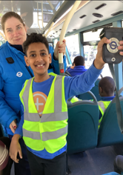

Unicorn Class
This week in Unicorn Class we have been working on answering ‘who, what and where’ questions on books that we have read. We have been working on interpreting the story and giving our answers in full sentences. We have also been using concrete manipulatives to gain an understanding of division as equal sharing.
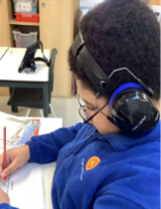
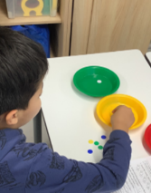

Ladybird Class
This week Ladybird Class have been practising their hand eye coordination whilst working in small groups to create cactuses for our desert habitat display. Ladybirds have enjoyed taking part in a Whippersnappers session where they have been engaging in pretend role-play activities whilst singing ‘Miss Polly had a dolly’ song.
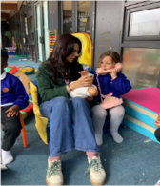
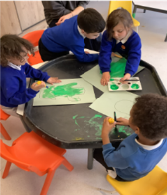

Don’t Forget
All our term dates are available on our website
https://www.thelivityschool.co.uk

Bank Holiday Monday 4th May – No school. Thursday 7th May – school closed to pupils as we are a Polling Station.
Term Five Ends Thursday 21st May.
Term Six Begins Monday 1st June.
Term Six Ends Friday 17th July.

Family Group Makaton training
We are holding three Makaton workshops on
1st May, 15th May and 12th June at 9.30 until 11.30am.
Spaces are limited so if you would like to attend, please contact Alberta or email admin@thelivity.lambeth.sch.uk
International Day
Will be the afternoon of 3rd July.

